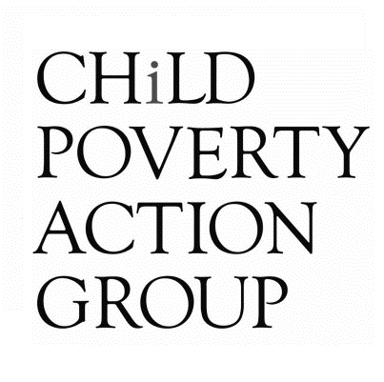

Submission on the Budget Policy Statement for the Budget 2022

This submission is from:
Alan Johnson (admin@cpag.org.nz)

Child Poverty Action Group
PO Box 5611
Wellesley St
Auckland 1141

Child Poverty Action Group (CPAG) is an independent charity working to eliminate child poverty in New Zealand through research, education and advocacy. CPAG believes that New Zealand’s high level of child poverty is not the result of economic necessity, but is due to policy neglect and a flawed ideological emphasis on economic incentives. Through research, CPAG highlights the position of tens of thousands of New Zealand children, and promotes public policies that address the underlying causes of the poverty they live in.

To the Finance and Expenditure Committee,
There is a sameness about the Government’s budget policy statement which is quite daunting. Daunting because the more things change, the more they stay the same – they have the same plot regardless of the settings or context.
On the eve of the Covid-19 pandemic Government’s Budget Statement of December 2019, the Government announced:
‘The Government will take a prudent approach to ensure expenditure is phased, controlled and directed to maximise its benefits. The Government will maintain its expenditure to within the recent historical range of spending to GDP.’
Almost 12 months after the pandemic began and following a $20 billion spending spree to support corporate profits and the livelihoods of middle New Zealand, the Budget Policy Statement of February 2021 declared:
‘Our fiscal strategy takes a balanced approach to supporting current and future generations by managing debt prudently and reducing the deficit caused by COVID-19, while growing the economy sustainably and investing in important public services like health and education’
Most recently and following almost $30 billion in spending on corporate and middle-class welfare the 2022 Budget Policy Statement announces:
‘Our fiscal strategy continues to take a balanced approach to supporting current and future generations by managing debt prudently and reducing the deficit caused by COVID-19, while growing the economy sustainably and investing in important public services like health and education. Given the nature of the COVID-19 global economic shock and the need to support the economy, debt remains at prudent levels throughout the forecast period, and there remains space in the Government’s fiscal strategy to respond to future shocks’
The consistent script is that of a need to balance the Government’s wellbeing ambitions with an apparent prudence around debt management. Regardless of what wellbeing story is being told in the front-end of any recent Budget Policy Statement, the back end always comes back to the same of story of fiscal conservatism which has dominated our political discourse for more than a generation.
This fiscal conservatism is apparent in several of the indicators reported in Treasury’s Half Yearly Economic and Fiscal Update 2021 (HYEFU21) and is despite the big talk of extra spending on health and infrastructure (see p.16 and pp.26-27 of BPS). Figure 2.1 of the HYEFU21 shows Crown expenses falling between the 2021/22 and 2022/23 fiscal years by an expected $7.8 billion while forecast offered in Figure 2.4 suggest that Crown debt will be lower than expected by almost $30 billion by the middle of 2025. All of this is being achieved while tax revenue remains at less than 30% of GDP (see Figure 2.7) which has been a long-held benchmark of fiscal conservatives.
This fiscal conservatism is unnecessary especially in an era of unprecedented challenges around climate change, housing costs and deepening inequality. Government debt remains at relatively low levels in comparison with other countries as the graph below (which is Figure 4 of the BPS 2022) indicates.
International comparisons of Government’s debt positions
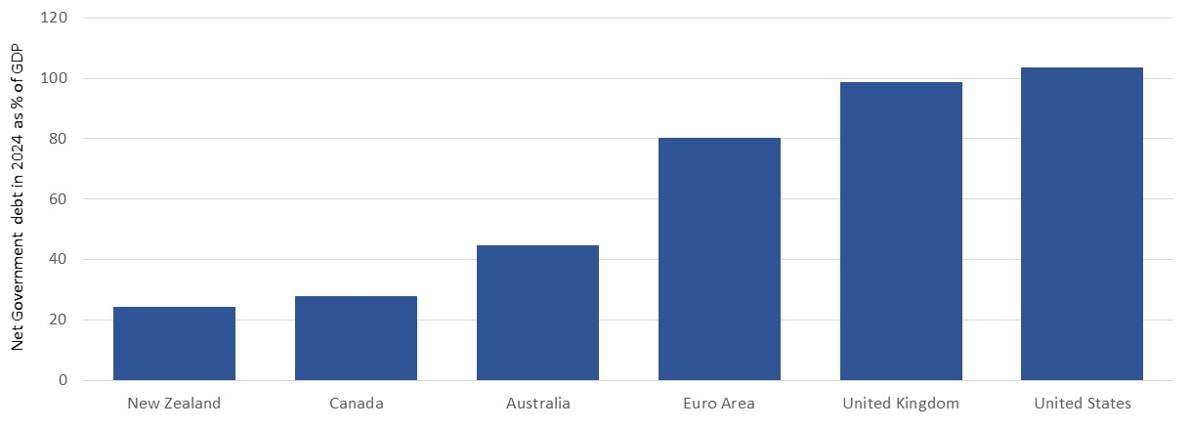
An irony in making debt comparisons in terms of GDP is that it undermines the Government’s intention not to see budget setting processes as simply about economic growth but instead within a broader wellbeing context. CPAG agrees with taking a wellbeing approach to all of Government’s policy processes. However, half measures being served up in the BPS tend to undermine the good intentions to shift the focus away from narrow measures of progress such as GDP. It appears here that the various wellbeings matter as long as they still sit within the framework where everything is counted in terms of money.
CPAG believes that questions like those around optimal levels of Government debt need to be seen within a framework of opportunity costs. Such costs aren’t just measured by such indicators as the cost of interest on debt or measures such as debt to revenue ratios but also by what could otherwise be achieved with more or less borrowing. The idea of prudence should be seen in this context and not in some Mr Micawber-ish way where debt is equated to misery.
Here CPAG is not advocating a ‘borrow and hope’ approach to Government’s finance but instead one of taking a much longer-term perspective which sees debt as well as taxes and public spending in generational terms. We welcome the move to budgets being about making longer-term and perhaps more flexible allocations although the continuing three-to-four-year timeframe explicit in actual Government budgets still limits this longer-term perspective.
We acknowledge the recent efforts of Treasury to consider our longer-term fiscal future in He Tirohanga Mokopuna 2021. The report’s title is however somewhat paradoxical as much of its focus is not on considering the world from the perspective of our mokopuna but how they will be able to afford their grandparents’ pensions and health care costs.
Even when such a document had an opportunity to be expansive and optimistic about the role of the state in New Zealand society and the value investing forward into the next generations, Treasury has remained captured by its pre-occupation with debt and its narrow take on what prudence actually means. It states:
’The Public Finance Act 1989 requires governments to ‘reduce debt to prudent levels’ and maintain it at those levels. Defining ‘prudent’ requires both analytical and value judgements, including considering the value of additional expenditure, how decisions to allocate resources affect current and future wellbeing (which can be done using the Treasury’s Living Standards Framework and He Ara Waiora), how much fiscal resilience New Zealand needs to respond to future shocks, and the impact of higher debt on future generations. The Government views current debt levels as prudent, an assessment the Treasury supports.’
Fiscal policy is not just about debt it is also about public spending and taxation. These other two dimensions are missing both from Treasury’s attempt at longer term analysis in He Tirohanga Mokopuna and the Budget Policy Statement.
An example of this failure to fully consider the potential impact of taxation policy is illustrated in Treasury’s summary conclusion offered in He Tirohanga Mokopuna.
‘The Treasury has considered options to increase tax revenue and modelled the impact of increasing revenue from the personal income tax system. Raising additional revenue has economic costs, as it reduces individuals’ and businesses’ ability or incentives to work, save, or invest in businesses, the economy, themselves, or their whānau, which could reduce financial and human capital. The net impact on New Zealand’s wellbeing depends on who ends up paying and how additional revenue is spent.
This is simplistic and trite. Of course - our wellbeing depends on who pays the taxes and on the quality of public spending - but so what? The points being missed here are that there are forms of taxation other than personal income tax to consider especially over longer timeframes. Furthermore, the absence of these taxes in the current tax mix is itself distorting incentives and skewing the economy. The obvious missing tax in CPAG’s view is one on wealth and within this housing.
This distortion is somewhat illustrated by recent rapid increases in house value – a trend reported in the graph below for the six years through to June 2021. This data shows that the total value of the housing stock rose 29% or by $360 billion over the 15 months between the beginning of the Covid-19 pandemic in March 2020 to June 2021. Virtually none of this massive gain in wealth has been taxed or is likely to be taxed and has of course accrued to the 60% or so of adult New Zealanders who have a stake in the housing market. Is it small wonder that housing is middle New Zealand’s preferred asset class contributing about 52% household wealth.

Value of New Zealand’s housing stock -2015 to 2021 – in $billions
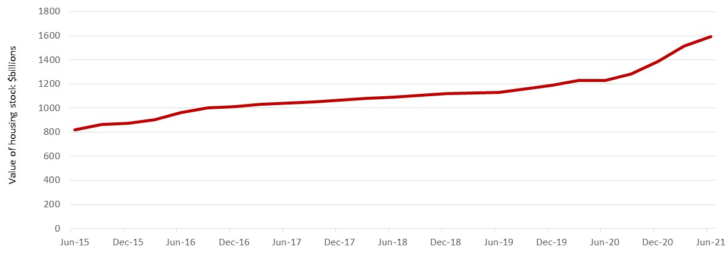

In hindsight it is not difficult to identify the drivers of this huge increase in house values and of course the related widening of wealth inequalities. These were an expansive fiscal policy alongside an expansive monetary policy. Government’s spending in response to the economic threats posed by Covid lockdowns alongside the Reserve Bank’s expansion of the money supply, combined to exacerbate our already unaffordable housing market. For example the monetary base grew almost 80% between March 2020 and December 2021 and by almost $24 billion to $53.6 billion. It is small wonder that we are now facing a short-term inflation rate 5% to 6% annually.
Somewhat disappointingly – at least from CPAG’s perspective, is that much of the Covid Response and Relief Fund (CRRF) expenditure has ended up in corporate coffers when it was apparently intended to support struggling New Zealanders. This wealth transfer is illustrated in the following graph which reports the value of non-financial corporates’ bank deposits from the end of 2016 to the end of 2021. This data shows that corporate cash grew 18% between March 2020 and November 2021 or by $17.6 billion. This is almost exactly the same as the $18 billion of subsidies paid to corporates through the Covid wage subsidy scheme over the same period.

Non-financial corporate sector bank deposits – 2016 to 2021
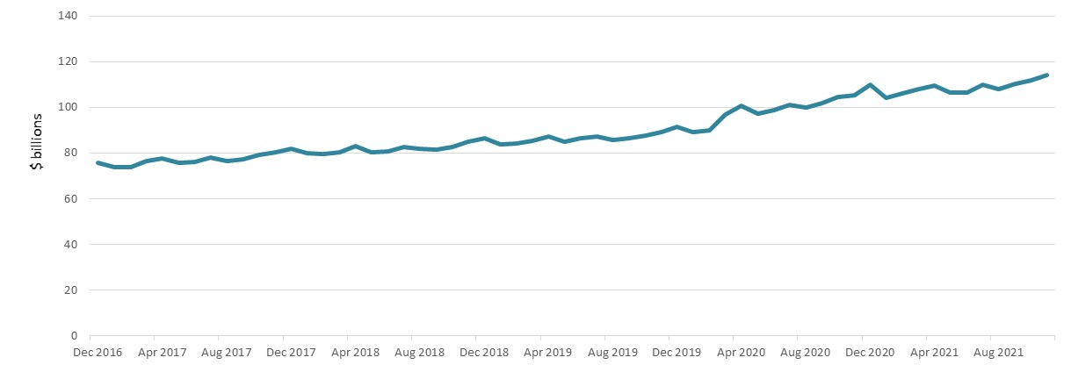
This wealth transfer perhaps points to the poor quality of public spending during the early part of the Covid response. Of course, any judgement of quality depends upon what the actual intended purpose and on who the intended beneficiaries of this spending were.
In CPAG’s submission, Government can spend more wisely and productively by targeting its spending directly at the poorest New Zealanders. A recent article in the New York Times on such an approach in the United States illustrates the value of such. The article highlighted a tentative finding that short-term and modest payments to poor mothers with babies changed their infants’ ‘brain activity in ways associated with stronger cognitive development’ One of reviewers of the study – a neuroscientist from the University of Pennsylvania stated, ‘This is a big scientific finding, …It’s proof that just giving the families more money, even a modest amount of more money, leads to better brain development’.
CPAG acknowledges Government’s current efforts in raising the real value of benefits. We are however puzzled as to why it wasn’t done sooner. That is why beneficiaries needed to wait until April 2022 when the Welfare Expert Advisory Group’s (WEAG) report was handed to Minister Sepuloni in early 2019. Claims made in the BPS that these belated increases are ‘in line with a key recommendation of the Welfare Expert Advisory Group’ are incorrect as the three-year delay in implementing the Group’s proposed benefit increases have eroded around 8-10% of their value due to inflation. In the shadow of an $18 billion handout to corporate New Zealand in wage subsidies it is difficult not seeing such penury simply as penny pinching.
The world has of course moved on since WEAG’s recommendations were published and it would be wrong to accept that the benefit increases due to be completed in April 2022 have finished the business of welfare reform and addressed the issue of income adequacy for people living on benefits. Such an assumption seems to have been taken in the forecasts offered in the Half Year Economic and Fiscal Update. The following graphs illustrate how much or how little has changed since the WEAG report in terms of the wellbeing of the most vulnerable New Zealanders - whom of course include at least 200,000 children.
Key points to note in these graphs are:
- Little reduction in child poverty numbers - depending on the poverty measure used these numbers were steady through 2019 and 2020 at around 160,000 to 210,000 children although forthcoming estimates for 2021 may show a modest reduction.
- A rise in the numbers of children living in benefits dependent households – from 173,000 in March 2019 to 208,00 in September 2021.
- Rents rising faster than wages -the lower quartile median rent rose 16% between March 2019 and September 2021 while average weekly wages for employees rose 11%
- Rapid increase in social housing waiting lists – in March 2019 there were just over 11,000 households on the social housing waiting list and by September 2021 this had more than doubled 24,500.
Estimates of child poverty numbers – 2009 to 2020
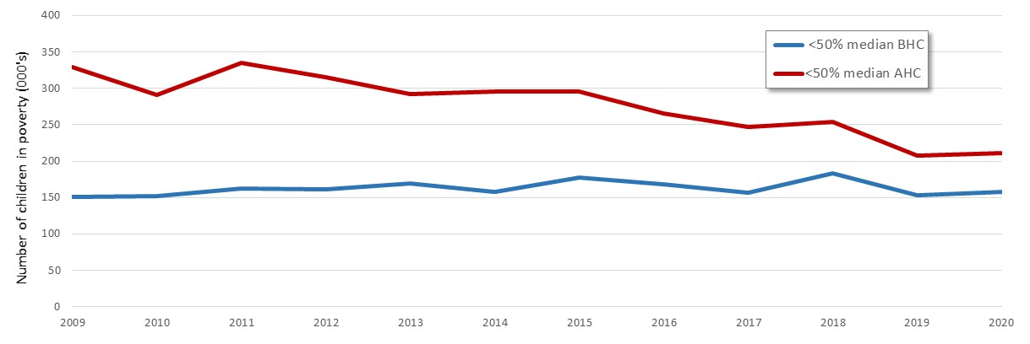
Numbers of children living in benefit dependent households 2013 to 2021
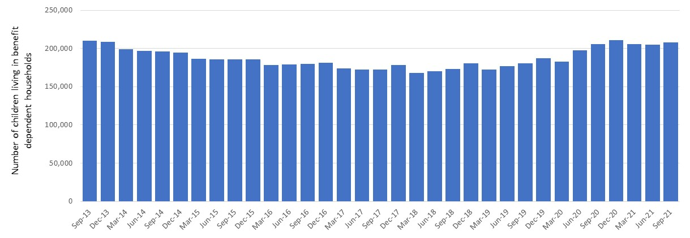

Indicators of changes in rents and wages – 2011 to 2021
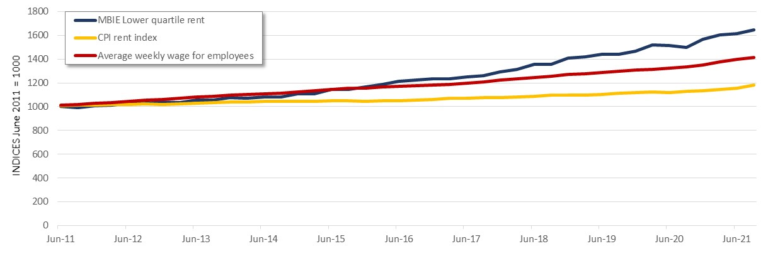
Social housing waiting list 2014 to 2021
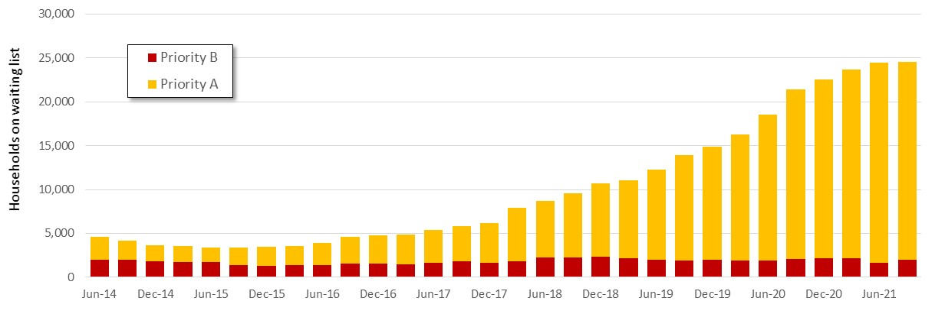
For CPAG two simple conclusions can be drawn from this data and the lived experiences they illustrate. As a country we need to spend far more to quickly lift a greater number of children out of poverty and we need to more urgently address the question of access to affordable housing.
CPAG acknowledges the current and planned efforts Government is making to increase the supply of social housing. It has taken four years to get to this stage where the social housing stock is growing by 2500 to 3000 dwellings per year. It is progress but it is slow and still not adequate to the task for finding adequate housing for 25,000 households and perhaps as many as 100,000 people. An accelerated social housing programme is required in order to meet this challenge. However, as the BPS and HYEFU point out, the economy generally and the construction sector particularly are facing significant capacity constraints. Simply throwing money at the housing problem probably won’t be sufficient in the short-term which means we can only adopt a medium-term perspective to address current shortages. CPAG encourages Government to do this and in doing so to make longer-term budgetary commitments to infrastructure development and the construction of public housing. Such longer-term commitments will signal to businesses and workers in the construction sector that there is an assured pipeline of work around which they can plan their investments and training decisions around. Having a more productive and stable construction sector with substantially more skilled workers is critical to addressing our infrastructure and housing deficit.
CPAG also believes that substantially more investment in our poorest children is needed both to improve their prospects and to secure a more prosperous future for all New Zealanders. Using deficits and debt to do so should not be as unconscionable as Treasury seems to think. In CPAG’s view, a clear opportunity cost of a conservative approach to debt are the enduring effects of child poverty and of the stunted potential which emerges from this. We urge Government to lift its commitment to reducing child poverty above the quite pedestrian approach which is implied in the BPS.
Finally, while it is probably too late now to shift the focus of the policy settings for Budget 2022, we ask members of the Finance and Expenditure to insist that fiscal policy settings move beyond a narrow focus on debt and begin to consider questions around the distorted nature of our current tax mix and the social and economic value of good quality public spending.
Thank you for your time in considering this submission.

Budget Policy Statement 2020 (treasury.govt.nz) (p.28)
Budget Policy Statement 2021 (treasury.govt.nz) (p.21)
Budget Policy Statement 2022 (treasury.govt.nz) (p.32)
Treasury’s Half Yearly Economic and Fiscal Update 2021 (treasury.govt.nz)
Budget Policy Statement 2022 (treasury.govt.nz) (Figure 4, p.31)
He Tirohanga Mokopuna (p.6)
Ibid (p.7)
Source: Reserve Bank of New Zealand and Quotable Value
Reserve Bank Statistics – Analytical Accounts Table R5
Budget Policy Statement 2022 (treasury.govt.nz) (p.8)
Reserve Bank Statistics – Banks Liabilities Deposits by Sector (Table S40)
Cash Aid to Poor Mothers Increases Brain Activity in Babies, Study Finds –by Jason DeParle, New York Times, 24/01/2022.
Treasury’s Half Yearly Economic and Fiscal Update 2021 (treasury.govt.nz) (Table 5.2, p.140)
Source: Statistics New Zealand
Source: Ministry of Social Development – Benefit Fact Sheets
Source: Statistics New Zealand and Ministry of Business Innovation and Employment – Tenancy bond data
Source: Ministry of Social Housing and Ministry of Housing and Urban Development – Public Housing Quarterly reports

