Submission on the Inquiry into school attendance

This submission is from:
Child Poverty Action Group
PO Box 5611
Victoria St West,
Auckland 1142

Child Poverty Action Group (CPAG) is an independent charity working to eliminate child poverty in New Zealand through research, education and advocacy. CPAG believes that New Zealand’s high level of child poverty is not the result of economic necessity, but is due to policy neglect and a flawed ideological emphasis on economic incentives. Through research, CPAG highlights the position of tens of thousands of New Zealand children, and promotes public policies that address the underlying causes of the poverty they live in.
We are grateful for the opportunity to submit on the Inquiry into school attendance and would like to request that our submission is heard orally.

Recommendations
In order to make attendance at school more meaningful, manageable and possible for children living in poverty and hardship, CPAG recommends the following:
- Ensure all families have adequate incomes, in order to reduce material inhibitors (such as lack of nourishing food, clothing and equipment) to full attendance at school, and enhance confidence and related feelings of community belonging which support full participation in education.
- Extend current “fee removal” support for schools, so that no school donations, fees or participation costs for school trips are charged to families, in order to further remove household cost barriers to full attendance at school.
- Ensure full digital inclusion to optimise school attendance by guaranteeing cost-free devices, connectivity and broadband provision for all children, including those living in housing insecurity.
- Talk directly with children, caregivers, family and whānau, and community workers, groups and representatives to gain a first-hand appreciation of the personal, economic and social reasons why children living in poverty and hardship make the decision to not attend school, and how best to mitigate these.
- Ensure that schools in lower decile areas are funded to provide comprehensive youth health, well-being and social services hubs for students and family and whānau.
- Ensure that schools in lower decile areas are funded to provide comprehensive before school, after school and holiday activity programmes run by community groups.
- Establish demonstration schools regionally that engage in evidence-informed best educational practices to reduce non-attendance at school.
- Provide evidence-informed Professional Learning and Development (PLD) programmes nationally on student-centred multisystem approaches to improving non-attendance.
- Develop refreshed national guidelines on managing school attendance that prioritise the rights, needs and aspirations of children and young people.
- Seek co-ordinated interagency, hapū, rūnanga, and NGO multisystem solutions to support students, families and whānau dealing with non-attendance.

School attendance and absence are linked to poverty
Educational attainment is a key pathway out of poverty, assisting in breaking the cycle of inter-generational poverty. However, attainment is linked to attendance, and non-attendance at school disproportionately affects children and families already living in the most socio-economically disadvantaged circumstances. At the system level, socio-economic status of census meshblocks in the local school community is a major predictor of school attendance. In practical terms, this means communities with the highest concentrations of households with income in the lowest 20% nationally, of employed parents in the lowest skill level occupational groups, of household crowding, of parents with no qualifications, and of parents receiving income support payments. Responses to non-attendance at school therefore must seek to mitigate the material effects of household and community socio-economic disadvantage. This cannot be left to schools alone.
Ministry of Education (MoE) time series data for 2011-2021 confirm that on average children living in poorer households and communities attend school significantly less regularly than children in wealthier communities. This inequity has increased since the onset of Covid-19. Māori and Pacific children, who are overrepresented in low decile school communities, attend significantly less regularly than Pākehā and Asian children. Non-attendance is a chronic schooling system issue.
A 2014 CPAG study of housing insecurity reported high levels of school transience linked to involuntary household mobility. In poorer areas, attendance may also be affected by illnesses associated with income poverty and material hardship, inclement weather, transport difficulties, inadequate or inappropriate clothing, lack of food, equipment, the need to care for family members, to contribute to household income, unhealthy housing, and so on. These issues are chronic and systemic. They require an all of government approach in order to eradicate involuntary school non-attendance that is due to poverty and hardship alone, and over which poor children and their families and whānau have little influence.
Hence our recommendations:
- Ensure all families have adequate incomes, in order to reduce material inhibitors (such as lack of nourishing food, clothing and equipment) to full attendance at school, and enhance confidence and related feelings of community belonging which support full participation in education.
- Extend current “fee removal” support for schools, so that no school donations, fees or participation costs for school trips are charged to families, in order to further remove household cost barriers to full attendance at school.
- Ensure full digital inclusion to optimise school attendance by guaranteeing cost-free devices, connectivity and broadband provision for all children, including those living in housing insecurity.
Student rights, and student-informed responses, are critical
Adults are understandably concerned that non-attendance at school is harmful to the child’s attainment, progression to further education and work, and subsequent life chances. Several jurisdictions, including our own, have adopted the mantra ‘every day counts’ in their official strategies to reduce non-attendance.
For children themselves, however, the decision not to attend is generally taken for reasons that make sense to them at the time. Even if it may not be a ‘good’ choice educationally, in their minds it may well be the ‘least bad’ personal choice they have. If we want to reduce non-attendance at school, we therefore need to understand the reasons why it occurs, particularly when and how it starts, so that we may intervene early in the process.
Understanding non-attendance requires active listening to children themselves. As the Office of the Children’s Commissioner has observed, children are experts of their own experience in education. When we take the time to genuinely listen to them, children provide us with unadorned insights about what makes them want to attend school and engage in class, and what does not.
We also have an obligation to listen to children about their views and experiences of attendance and non-attendance at school. Aotearoa New Zealand ratified the United Nations Convention on the Rights of the Child (UNCRC) in 1993. According to UNCRC, in actions concerning children the best interests of the child shall be the primary consideration (Article 3), the child has the right to express their views freely on matters affecting them and to be heard in any proceedings affecting them (Articles 12 & 13), and the right to an education that develops their personality, talents and mental and physical abilities to their fullest potential (Article 29). More broadly under UNCRC, children enjoy ‘provision’, ‘protection’ and ‘participation’ rights. A meaningful response to the problem of non-attendance at schools requires serious attention to all three, and active listening by adults to children’s views on and experiences of non-attendance at school.
In a recent New Zealand study of 13 adolescents, non-attendance was described as ‘wagging’. Four reasons for wagging were given by the children. First, a response to perceived disrespect in class, involving either a sense of injustice due to the actions of teachers or parents, or bullying from fellow students. Second, wagging was a communal activity with friends, to have fun, to avoid wasting time in class, to feel freedom and to enjoy oneself (including engaging in risky activity). Third, to be alone in order to deal with issues or situations that were bothering them, in other words wagging as a personal wellbeing strategy. And fourth, wagging as a habit that develops over time but begins with disengagement inside the classroom. As the authors note, wagging can be an understandable response to problems in class or at home and therefore “students who wag should be recognised as students who need particular support in relation to inclusion” (p. 12).
The fact that ‘wagging’ is a rational response by children behoves adults to make every effort to understand the child’s everyday and schooling worlds, and the many interactions between these, and to respond to their non-attendance in supportive, constructive and enabling ways. This is particularly the case for children living in income poverty and material hardship households given that they are significantly overrepresented in statistics on non-attendance at school.
In one summary of British research with children, for example, boys as young as nine were reported to be disengaging from school. Disengagement was attributed to a combination of growing up in poverty, the difficulties faced by teachers in disadvantaged schools, and socialisation differences between boys and girls. Less advantaged children were more likely to feel a lack of control in their learning, be less accepting of the curriculum, and to feel more anxious and unconfident at school. Children in disadvantaged schools were more likely to report being shouted at by teachers. They were more aware of their social position and the limitations it placed on them (including participation in school and out of school activities). They were more likely than their better off peers to describe discipline and detention experiences at school.
Hence our recommendation:
- Talk directly with children, caregivers, family and whānau, and community workers, groups and representatives to gain a first-hand appreciation of the personal, economic and social reasons why children living in poverty and hardship make the decision to not attend school, and how best to mitigate these.

If appropriately resourced, schools could be community hubs
In seeking to mitigate the adverse effects of poverty and hardship on attendance, schools can play a useful role as community service hubs – if they are equipped with the right resources and support - offering comprehensive youth-friendly health and social services, support for pregnant and parenting students, after school and holiday activity programmes, and before and after school programmes.
Hence our recommendations:
- Ensure that schools in lower decile areas are funded to provide comprehensive youth health, well-being and social services hubs for students and family and whānau.
- Ensure that schools in lower decile areas are funded to provide comprehensive before school, after school and holiday activity programmes run by community groups.
Issues are complex, and require a multi-pronged approach
At present, Ministry of Education guidelines for schools place a predominant emphasis on legislation, regulation, data collection and sanction in managing attendance. These administrative elements are important contributors to an overall strategy to identify and reduce the incidence of aggregate non-attendance. Nevertheless, compared with some other jurisdictions overseas our local guidelines place insufficient emphasis on understanding the reasons why children make the decision not to attend school, together with the coordinated, evidence-informed responses by adults in their lives that are most likely to encourage increased attendance and productive (re)engagement in formal learning by the child.
Discussions of non-attendance require clarity of scope, focus and terminology, for example: forms of non-attendance may include school dropout, chronic truancy and absenteeism from school, selective class attendance within school, or selective disengagement within class (Kim & Streeter, 2016). Each may have distinctive antecedents and consequences, and each requires a particular response that is customised to the needs of the child, and their family or whānau.
Successfully addressing the issue requires a detailed and nuanced understanding of the reasons why children ‘wag’, ‘skip’ or have ‘justified’ or ‘unjustified’ absences from school. These reasons are multidimensional and complex. They include but are not limited to household and community factors. Classrooms and schools also play a part.
According to the 2015 PISA survey of 15-year-olds, New Zealand ranks around the OECD average (12/35) for self-reported student motivation, but among the worst countries for schoolwork-related anxiety (31/34), belonging (29/34) and bullying (34/35). MoE analysis of the data found a complex relationship between the number of self-reported days of school ‘skipped’ in the previous fortnight and various indicators of wellbeing. A higher number of days’ non-attendance “predicts worse average outcomes in terms of schoolwork-related anxiety, sense of belonging, bullying, motivation, and experiences with unfair teacher behaviour” (MoE, 2020, p. 8). However, these indicators are weakly correlated with each other and attendance on its own is not a strong predictor of student wellbeing. Rather, the causes and effects of non-attendance differ according to the individual circumstances of the student. To give a more complete and differentiated figure, we suggest further analysis of the links between attendance and wellbeing is required to take into account: (i) ethnicity; and (ii) socio-economic status.
Related MoE analysis using e-asTTle and NCEA data confirms a well-established strong relationship between attendance and attainment but in this instance the report identifies more pronounced adverse effects for children from poorer school communities and for Māori and Pacific students. For these children, any absence, justified or unjustified, however short, may impair attainment. Again, this reinforces the need for adults, institutions and agencies to understand the reasons why children do not attend, and the particular impacts of non-attendance on their learning and wellbeing. It also reinforces the imperative to develop effective, holistic and well-resourced responses to non-attendance. These responses must be specific to the needs and aspirations of children living in poverty and hardship, and their family and whānau.
In their review of the evidence on successful strategies and interventions to improve attendance, Kim and Streeter (2016, p. 6) argue that school attendance must be viewed as: (i) ‘everyone’s responsibility’ (i.e. school, family, and community); (ii) understood from multiple perspectives; (iii) realised through what they call a student-centered multisystem approach to improve school attendance; and (iv) involve differentiated tiers of action, depending whether the intervention focus is: the whole school, classroom or individual child (below).
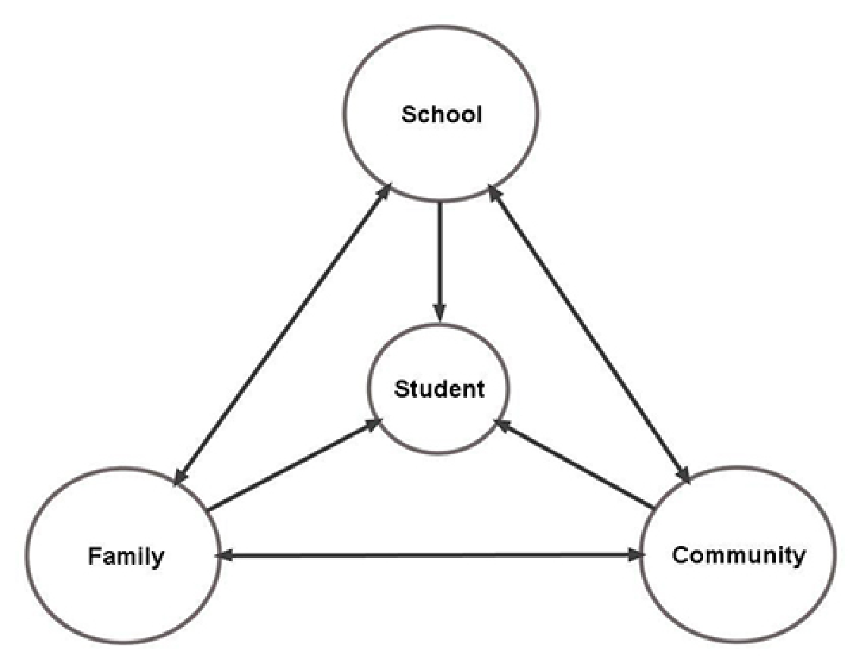
(Source: Kim and Streeter, 2016, p. 6)
According to Kim and Streeter, student factors that impact on school attendance may include drug and alcohol abuse, mental health problems, poor physical health, teen pregnancy and family responsibilities, student employment and a lack of understanding of the long-term consequences of school failure’ (p. 6). Additionally, the New Zealand sociologist, Roy Nash, analysed how peer groups are of primary importance to adolescents. Those who disengage often just get ‘tired of trying’ to keep on accommodating the demands of school and parents to stay engaged in learning, alongside the more immediate gratifications to be gained through same age friendships. In short, the relationships between youth identity formation, schooling, family and attendance are complex and not amenable to rule or procedurally oriented solutions.
Kim and Streeter also point out that “sometimes the school itself is largely responsible for truancy” (p. 5). More specifically:
School factors often include the school climate, such as school size and attitudes of teachers and administrators, lack of flexibility in meeting the needs of students with diverse learning styles and different cultural experiences, inconsistent policies and procedures for dealing with chronic truancy, inconsistent application of those policies, lack of meaningful consequences, a chaotic school culture and/or unsafe school environment, and a curriculum that is perceived as boring, irrelevant, or unchallenging. (p. 5)
This summary is consistent with the voices of 209 Australian student informants who had dropped out of school and were interviewed by John Smyth and colleagues (2004). Smyth and colleagues referred to this phenomenon as the cultural geography of the school around early school leaving, in which there were three ideal type school cultures: ‘aggressive’, ‘passive’, and ‘active’ (Chapter 6).
A distinguishing feature of each school culture type was how power was exercised. In the aggressive school, power was exercised through the administrative structure and apparatus of the school, with both teachers and students relatively powerless. In the active school, “there was a pronounced attempt in the direction of negotiating power with students” (p. 163). Other features of active schools were a school climate that valued student voice, agency and independence; a welcoming approach to students who traditionally do not fit; a curriculum that was negotiable around students interests and lives, connected to their lives, respectful of popular culture and socially critical; students were listened to in an atmosphere of trust; behaviour management was framed as largely a curriculum issue and students participated in setting the framework; timetabling was flexible and respectful of student commitments; teachers treated students like adults, negotiated content and assessment with them and enlarged the ‘cultural map’ for many; and pastoral care in active schools actively connected with students’ lives and acknowledged the importance of re-entry to school and alternatives (pp. 162-163).
Many similar features were identified in a more recent major study of Queensland primary, secondary and P-12 state schools (Mills, et al, 2017). The authors reported cumulative disadvantages for attendance rates in schools with higher indigenous proportions of student populations, lower socio-economic index scores, and located in remote areas.
In the study years, attendance generally increased in the state across all schools. However, principals of schools with lower attendance rates and higher year levels were more likely to emphasise voluntary student absence and negative aspects of family and household, including ‘family issues’ and ‘parent apathy’, in explaining non-attendance. They appeared to view these as beyond the school’s sphere of influence. These schools whose data suggested they were less effective at improving attendance had a higher number and diversity of strategies to respond to non-attendance, “those of improving, supporting as well as controlling/punitive character” (p. xvi).
In contrast, among the schools whose data suggested successful strategies, significant efforts were made to mitigate the effects of out of school factors, such as support for students from high poverty households and those who faced transport problems. Many principals reportedly sought to be culturally sensitive without lowering expectations. Diverse award structures, often in combination with denial of privileges, were in place. Data were used by principals to monitor class and individual student attendance data and student tracking against targets. A major emphasis was placed on school culture and a positive learning environment (p. xvii).
Research case studies demonstrated the importance of highly skilled school leadership teams, including the capacity to listen as well as to act, consistency and commitment to the strategies from school staff, and the importance of working with school communities. Successful strategies were also school specific and comprehensive in the sense that they had to address all the factors that contribute to non-attendance: “school, life and personal factors” (p. xviii).
In terms of family factors related to non-attendance at school by children, Kim and Streeter identify various factors associated with household poverty and hardship and sequelae of poverty: “domestic violence, alcohol and drug abuse, inadequate parental supervision, poverty and low-wage jobs that require the parents to work long hours, lack of awareness of attendance laws, and parental attitudes toward education and the school” (p. 6).
Kim and Streeter also identify community level factors that contribute to non-attendance by children:
They can hurt attendance when they present few opportunities for young people or lack affordable childcare or accessible transportation systems. Communities with high mobility rates and large numbers of single- parent households tend to have high truancy rates. Also, differing cultural attitudes toward education can make a difference in whether a child wants to attend school. (p. 7)
What should be clear from our submission to this point is that comprehensive strategies are required to address the complex and multi-layered reasons why children living in poverty and hardship make the decision not to attend school. Some of these, certainly, are personal and individual but many more are institutional, social, economic and societal. Focusing narrowly on the fact of whether or not the child is physically at school and in class is not enough if children are to be supported and enabled to make a decision to be at school because they both: (i) recognise that schooling is in their best interests; and (ii) experience daily learning as fulfilling.
Hence our recommendations:
- Establish demonstration schools regionally that engage in evidence-informed best educational practices to reduce non-attendance at school.
- Provide evidence-informed PLD programmes nationally on student-centred multisystem approaches to improving non-attendance.
- Develop refreshed national guidelines on managing school attendance that prioritise the rights, needs and aspirations of children and young people.
- Seek co-ordinated interagency, hapū, rūnanga, and NGO multisystem solutions to support students, families and whānau dealing with non-attendance.

McAllister, J., Neuwelt-Kearns, C., Bain, L., Turner, N., & Wynd, D. The Most Important Task: Outcomes of our collective care for low-income children in Aotearoa New Zealand in the first year of Covid-19. Child Poverty Action Group. Auckland: New Zealand. https://www.cpag.org.nz/assets/CPAG_2021_1st_year_of_Covid_Initial_outcomes_of_our_collective_care_for_low_income_children_in_Aotearoa_NZ.pdf
https://www.educationcounts.govt.nz/statistics/attendance
Wynd, D. (2014). The revolving door: Student mobility in Auckland schools. https://www.cpag.org.nz/news/new-report-student-transience-in-auckland/
Baskerville, D. (2021). Truancy begins in class: student perspectives of tenuous peer relationships. Pastoral Care in Education, 39(2), 108-124.
New Zealand School Trustees Association & Office of the Children’s Commissioner. Education matters to me: Engagement. https://www.occ.org.nz/assets/Uploads/Engagements2.pdf
Baskerville, D. & Loveridge, J. (2020). Nature of truancy from the perspectives of secondary students in New Zealand, Educational Studies, DOI: 10.1080/03055698.2020.1834356
Hirsch, D. (2007). Experiences of poverty and educational disadvantage. https://www.jrf.org.uk/sites/default/files/jrf/migrated/files/2123.pdf
Expert Advisory Group on Solutions to Child Poverty. (2012). Solutions to Child Poverty in New Zealand: Evidence for Action. Office of the Children’s Commissioner.
Ministry of Education (2011). Attendance matters. Guidelines for implementing an effective attendance management plan. https://www.education.govt.nz/assets/Education-and-Training-Act-2020/AttendanceMatters-updated-legislation.pdf
Kim, J., & Streeter, C. (2016). Strategies and interventions for improving school attendance. Encyclopedia of Social Work. https://doi.org/10.1093/acrefore/9780199975839.013.1227
https://www.educationcounts.govt.nz/__data/assets/pdf_file/0010/198019/He-Whakaaro-School-attendance-and-student-wellbeing.pdf
https://www.educationcounts.govt.nz/__data/assets/pdf_file/0004/198013/He-Whakaaro-What-is-the-relationship-between-attendance-and-attainment.pdf
Nash, R. (2016). Explaining inequalities in school achievement. A realist analysis (Ed. H. Lauder). Routledge.
Smyth, J. & Hattam, R., with Cannon, J., Edwards, J., Wilson, N., & West, S. (2004). ‘Dropping out’, drifting off, being excluded. Becoming somebody without school. Peter Lang.
Mills, M., Howell, A., Kubler, M., Tomaszewski, W., Lynch, D., Phillips, L., Carroll, A., Dungan, J., Hallens, A., & Sheppard, K. (2017). Making Every Day Count: Effective strategies to improve student attendance in Queensland state schools. https://espace.library.uq.edu.au/view/UQ:0d04c8a

