The first year of Covid-19: Initial outcomes of
our collective care for
low-income children
in Aotearoa New Zealand

About Child Poverty Action Group
Child Poverty Action Group (CPAG) is an independent, registered charity founded in 1994 which works to eliminate child poverty in Aotearoa New Zealand through research, education and advocacy. CPAG highlights that the country’s high rate of child poverty is not the result of economic necessity, but is due to policy neglect and a flawed ideological emphasis on economic incentives, exacerbated by racism and discrimination. We envisage an Aotearoa where our society shows respect, generosity and care for all children; and where all children can flourish free from poverty.
We focus on eliminating poverty for children because:
- Overall effects of poverty are worst for children: Child development is adversely
affected by poverty, and poverty can lead to detrimental effects for an entire life.
- Children are more likely to experience poverty: Children are over-represented among those in deprived households.
- Children don’t get a say: Decisions affecting children are made without their input; only adults can vote for parliamentary representation

Acknowledgements
Thank you to: Innes Asher, Laura Bond, Gerry Cotterell, Tiny Deane, Claire Gardner, Phoebe Eden-Mann, Tania Henderson, Aaron Hendry, Alan Johnson, Keri Lawson-Te Aho, Jane Lee, Sonya Masoe, John McKenzie, Michael Naera, Talavao Ngata, Mike O’Brien, Teuila Percival, Colin Riseborough, Susan St John, Pooja Subramanian, Jen Triggs, Brook Turner, Micaela van der Schaaf, Natalie Vincent, Megan Weir – and several anonymous contributors and analysts.
Thank you to Helen Leahy and Te Pūtahitanga o Te Waipounamu for permission to use the #Manaaki20 survey results images used in Chapter 1.

McAllister, J., Neuwelt-Kearns, C., Bain, L., Turner, N., & Wynd, D. The Most Important Task: Outcomes of our collective care for low-income children in Aotearoa New Zealand in the first year of Covid-19. Child Poverty Action Group. Auckland: New Zealand. www.cpag.org.nz/publications
ISBN 978-0-473-58223-4
CC BY-NC July 2021
Child Poverty Action Group
PO Box 5611 Wellesley St Auckland 1141 New Zealand www.cpag.org.nz
Disclaimer: This publication is intended to provide accurate and adequate information on the matters contained herein and every effort has been made to ensure its accuracy. However, it has been written, edited and published and made available to all persons and entities strictly on the basis that its author, editors and publishers are fully excluded from any liability or responsibility by all or any of them in any way to any person or entity for anything done or omitted to be done by any person or entity in reliance, whether totally or partially, on the contents of this publication for any purpose whatsoever.

Ensuring we love, care & nurture all our children & young people throughout their lives is the most important task we have.
- Child and Youth Wellbeing Strategy 2019, NZ Government

The COVID-19 pandemic is expected to have short- and longer-term negative effects on the wellbeing of children, young people and their whānau…. The most severe negative effects are likely to be felt by those who are already disadvantaged.
- Official Briefing to Jacinda Ardern, Incoming Minister for Child Poverty Reduction, November 2020

Mahia te mahi hei painga mo te iwi
Do the work to make things better for the people
- Te Puea Hērangi, 1883-1952

Foreword

As we enter the time of Matariki, the mahi to seed/plant, tend to the gardens, hunt and preserve food would have already been completed in preparation to make it through the expected harsher realities that colder times can bring.
While our Covid-19 national strategies saw Aotearoa as leaders in the world in terms of pandemic response, this CPAG report confirms the severe impacts our low-income children faced during COVID. Some of these experiences also compounded by already existing entrenched systemic inequities and institutional racism.
This exposition highlights the mahi the government needs to address with urgency now, to close the gaps in poverty to ensure our most vulnerable do not continue to bear the highest burden in times of pandemic.
The whakatauki below is from my iwi Ngati Kahungunu mē Rangitāne ki Wairarapa
Pai atu te aria atu i te mate i te rongoa i te mate
It is better to act early in prevention of crisis/illness, than to find solutions in a time of crises/illness
Ngā mihi manaakitanga,
Leah Bain
Acting CEO
Public Health Association of New Zealand
June 2021

Contents
Timeline: March 2020 to March 2021 6
Executive summary 7
Introduction 12
Scope of the report 15
Initial Lockdown Level 4 16
Issues of family poverty during the initial lockdown 16
Children with disabilities, and/or in households with a member with disabilities 20
Children’s assessment of lockdown 21
Iwi, hāpū and community responses 21
Income 24
Income poverty rates 25
Increase in numbers of children in families receiving benefits 26
Inadequacy of core income support 27
Hardship and supplementary assistance 28
The Covid-19 Income Relief Payment 29
Sole Parents 30
Food Insecurity 32
Cost of living 34
Housing & Homelessness 35
Youth homelessness 36
Family homelessness and emergency housing 38
Education 40
Attendance and Absence 40
NCEA attainment 43
Student perception 43
Digital access and exclusion 45
Whānau, community & friends 47
Health 51
Conclusion and Looking Ahead 57
Reference list 61
Appendix 1: Estimating child poverty rates - methodology and results 69

Timeline: March 2020 to March 2021
Including approximate periods of data collection for some of our key sources
s
Data collection
Government
19/3: border closure
2020
Benefit recipient interviews
(Humpage & Moore, 2021)
Wellbeing & labour survey (Prickett et al, 2020)
Financial wellbeing survey (Galicki, 2020)
Manaaki20 whānau survey (Leahy, 2020; Te Pūtahitanga o Te Waipounamu, 2020)
Student survey (OCC, 2020)
ECE leader interviews (ERO, 2020a)
First teacher & student survey (ERO, 2020b)
2nd teacher & student survey (ERO, 2020b)
28/2-7/3: Auckland L3 lockdown
14/2-17/2: Auckland L3 lockdown
11/8-30/8:
Auckland L3
lockdown
27/4-13/5:
national L3
lockdown
25/3-27/4: national L4 lockdown
21/8-3/9: wage
subsidy available
25/5: Covid-19 Income Relief Payment announced
27/3-9/6: wage
subsidy available
M

A
M
J
J
A
S
O
N
D
2021
J
F
M

Executive summary
As a society, we aspire to care for our children, and to place them at the heart of all our decision making. This was articulated clearly in the current Government’s Child and Youth Wellbeing Strategy: “Ensuring we love, care & nurture all our children & young people throughout their lives is the most important task we have.” (our emphasis; DPMC, 2019). Yet disadvantaged children – particularly disadvantaged tamariki Māori and Pacific children – are among those being made to bear the heaviest Covid-19-related burdens.
In the year to March 2021, some children and young people were placed in extreme and dangerous situations due to lack of support for those made homeless. More families than ever were forced to experience the deep-seated stress of ongoing food insecurity due to income inadequacy. Inequity grew between children on lowest incomes and others, and our modelling suggests around 18,000 more children may have been pushed into poverty (even before housing costs are considered).
The drivers for this situation included post-Covid-19 government policies which continued to keep hundreds of thousands of children in income poverty, and to neglect the safety and wellbeing of homeless families and young people – all while those who have wealth became even richer via property value increases. Loss of income for many was probably inevitable; loss of income to the point of (further) inadequacy was not.
Outcomes for whānau Māori were worse on average than for the population overall in the year to March 2021, on poverty-related indicators including income, homelessness digital exclusion and chronic school absence. Modelling indicates tamariki Māori were 2.5 to 3 times more likely than Pākehā children to have been pushed into poverty during that time. In Northland and Waikato, no Māori households were assessed as financially “secure” during lockdown, and in Auckland it was only 3.5% - in contrast to 30% of all Pākehā nationally (Galicki, 2020). Just over half the households on the social housing waiting list are Māori reflecting racism in the rental market and barriers to home ownership for Māori. Emergency housing numbers increased faster for Māori young people up to age 24 than for Pākehā young people (MSD, 2021c). Chronic absence of Māori students in decile 1 schools increased by more than a third to over 30% in 2020 term 2, compared to 2019; for Pākehā, the increase was smaller, from a lower base, increasing by around a quarter to just under 20% (Min. Ed., 2020).
Many of these outcomes indicate past and ongoing breaches of Te Tiriti o Waitangi, in particular the Crown’s obligation of oritetanga: ensuring Māori can live as equal citizens in Aotearoa. The Government’s Covid-19 response reflects the State yet again using whānau Māori as “shock absorbers of the economy” (Rua et al, 2019). In one example, Māori (and Pacific) applicants were much less likely than Pākehā to be awarded the relatively generous Covid-19 Income Relief Payment, partially due to its design. The Race Relations Commissioner criticised this as a breach of human rights (Cardwell, 2020). The Covid-19 Income Relief Payment was also considered a possible breach of children’s rights, as it was based not on children’s needs but on how and when jobs were lost (Children’s Convention Monitoring Group, 2021). The omission of benefit recipients from those eligible for this payment “had a significant, negative impact” on the mental wellbeing of many in severe poverty (Humpage & Moore, 2021).
Financial distress and food insecurity remained at elevated levels for the entire year to March 2021 compared to previous years, indicated by foodbank use, government supplementary assistance and hardship assistance, and the number of children in benefit-receiving households. MSD hardship assistance alone totalled 2.7 million transactions in the year to March 2021, totalling $860 million (MSD, 2021a). Modelling showed that core entitlements alone would keep most children in benefit-receiving model households in poverty, even with the doubled Winter Energy Payment. Shortfalls in the summer for model households paying lower-quartile rent could reach over $200 a week (McAllister, 2020). Annual inflation for people receiving benefits was almost three times higher than for all households overall in 2020, a greater gap than in recent years, partly driven by higher rents (Stats NZ, 2021a).
Young people aged 16 and 17 were specifically excluded from emergency accommodation, forcing some to stay in situations of sexual exploitation. This may have been avoided if a Youth Homelessness Strategy had been in place, as the sector requested since at least 2018. On the other hand, there were grave concerns about the “inhumane” state of emergency housing, including reports of intimidation of vulnerable families, women and children (Patterson, 27/04/21). The number of households with children waiting for social housing increased by 40% in the year to December 2020 to 9,599, representing around 17,000 to 18,000 children. In December, 3885 children were in emergency housing (mostly motels) (Coughlan, 28/04/21), with 45% of them having been there for 3 months or more. By March 2021, that number had risen to 4368 children (an increase of 12% in 3 months) (Blake-Persen, 05/07/21).
Compared to 2019, chronic school absence increased more sharply in low-decile schools than in high-decile schools, and stayed elevated in low-decile schools for longer. The increase in chronic absence was highest for Māori and Pacific students attending lower decile schools (Min.Ed, 2020). Surveys suggest approximately 34,000 children had no access to the internet during the initial lockdown, with tamariki and rangatahi Māori more likely not to have access (OCC report, 2020). However, one positive outcome was that low-decile schools overall had good levels of NCEA attainment compared to previous years (assisted by a Covid-19-related change to credits calculation), and for most qualifications the attainment rate gap closed between low and mid/high decile schools (NZQA, 2021).
Between 2018 and mid-2020, gaps grew between low-decile and high-decile secondary school students’ perceptions of getting enough family/whānau time, having fun, feeling safe at home and in the neighbourhood, having good friends and feeling fit and healthy (OCC, 2020). Inequity of loneliness has also increased for the adults in children’s lives (Walker, 2021). Women’s Refuge reported a surge in demand of about 30 per cent more than normal for their services during initial lockdown (Franks, 07/10/20).
Concerningly, child immunisation rates decreased overall, and decreased faster in the most deprived quintile than for children in general (MoH, 2021). One positive outcome of Covid-19-related health precautions was that hospitalisations of young children with respiratory infections temporarily reduced. However, hospitalisations of children with rheumatic fever –associated with household crowding - increased in 2020 (Duncanson et al, 2020).
Along with tamariki Māori, heavy burdens were inequitably pushed onto Pacific children, children with disabilities, and children in sole parent families, among other minorities. Modelling suggests Pacific children, like tamariki Māori, are around 2.5 to 3 times more likely than Pākehā children to have been pushed into poverty in the year to March 2021. Around 11% of Pacific workers lost their job during lockdown – the highest percentage of any ethnicity (Prickett et al., 2020). In lockdown, over half of all Pacific people were found to be in financial difficulty compared to around a third of all Pākehā people (Galicki, 2020). Emergency housing grant numbers increased at a faster rate for Pacific young people up to age 24 than for Pākehā (MSD, 2021c). Rates of chronic absence among Pacific students in Decile 1 schools increased by over a half to almost 23% (Min. Ed., 2020). However, Pacific students (from all deciles) recorded particularly sizeable increases in NCEA attainment rates (NZQA, 2021) which dovetails with findings that Pacific students in low decile schools were more positive about being able to learn from home than other groups (ERO, 2021b).
An unknown number of families with disabled members had to leave jobs due to vulnerability to Covid-19. Lack of access to personal protective equipment (PPE) in the initial weeks of lockdown created distress for many (as, for example care workers could not enter homes and carry out personal cares without PPE), while lockdown also increased public waiting lists for therapies. A number of children with disabilities (including but not limited to those in low-income families) are likely to have been deeply affected by disruption of routine and/or anxiety due to lockdown, on a long-term basis (see Good & Lee, 2021).
Sole parents were particularly likely to experience financially insecure circumstances and hardship during lockdown (Galicki, 2020; Prickett, 2020), and to experience loneliness (Walker, 2021). Around 27% received help from a foodbank or similar, in the 12 months to March 2021, compared to ~3%-7% of other groups (StatsNZ, 2021e).
Iwi, hapū and other Māori organisations responded superbly to community and whānau need right from the initial lockdown, as did Pacific organisations; other service providers, schools, and community health workers; whānau Māori and families; and children and young people themselves.
“Us adults will only eat small portions so that our kids are feeling full or content, we are walking almost every day to catch some fresh air and clear our minds.”
- Manaaki20 survey response to “What’s helping your whānau to get through this?” (in Leahy, 2020)
But the significant resources of the State need to be better deployed to ensure ongoing structural support as well as to enable further local responses. We strongly recommend the Government more deeply considers and centres Māori guidance (for example, Rua et al, 2019; de Lore et al, 2020) in order to best increase the likelihood of success when striving to ensure the long-term wellbeing of all whānau Māori and families in Aotearoa New Zealand.

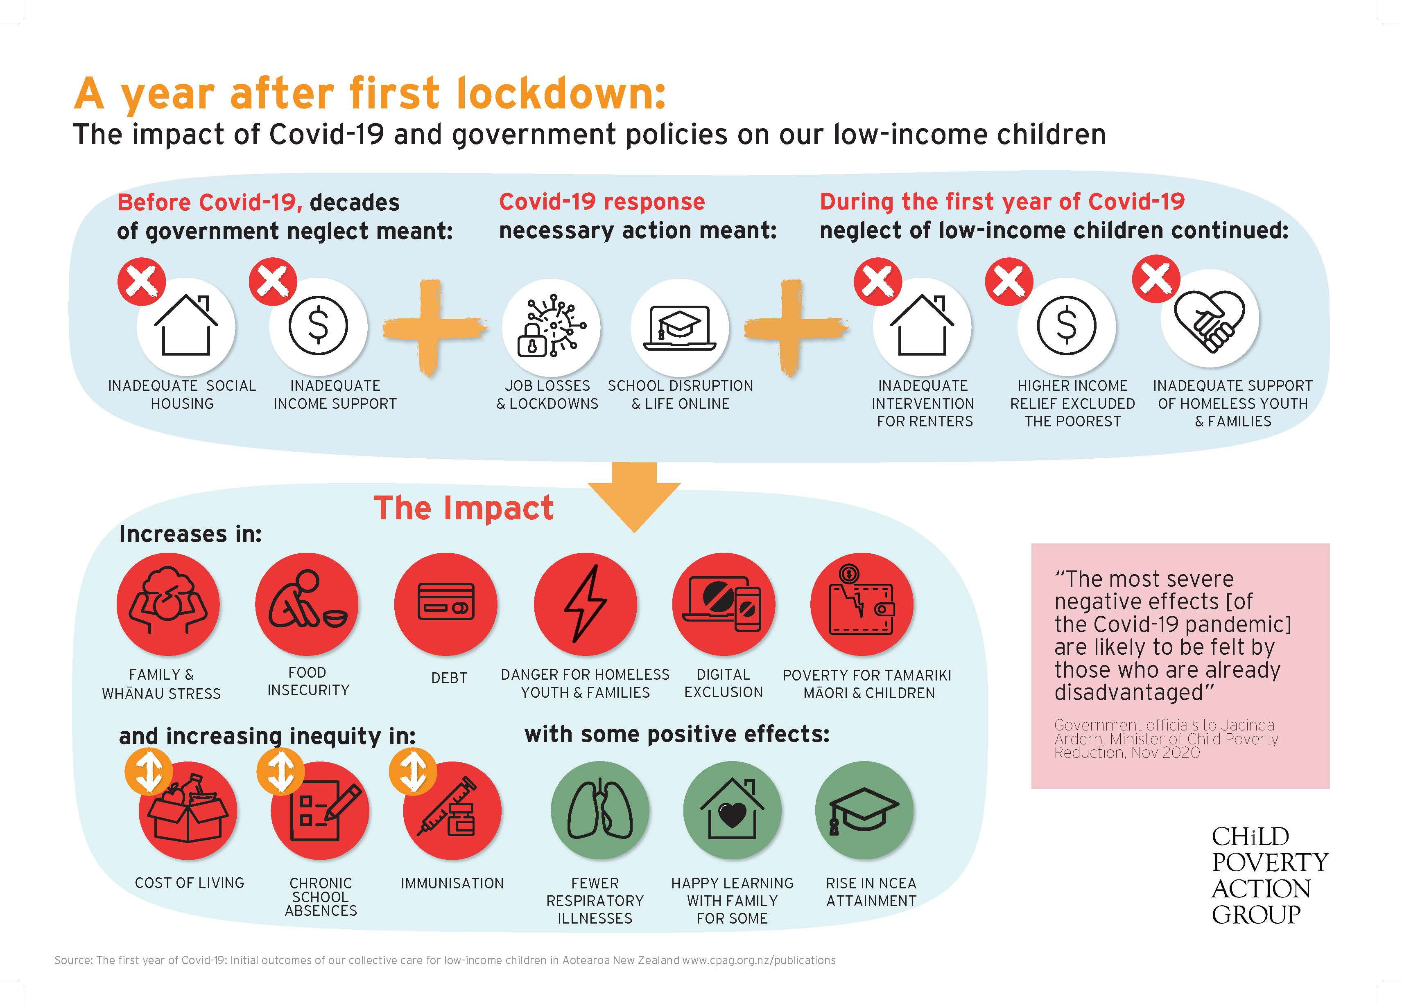

The First Year Impact of Covid-19 and Government Policies: Examples
Family Stress | - Low-decile students were 6% less likely to agree “I have a stable and loving family/whānau”. High-decile students were more likely to agree. (OCC, 2020).  - In June 2020, 11.4% of sole parents reported feeling lonely “most/all of the time” – almost double the rate in 2018 (6.1%) (Walker, 2021).
Food Insecurity | - Food bank demand spiked in lockdown and remained roughly double pre-Covid-19 levels throughout the year to March 2021 (see Ch. 3)
Debt | - The value of new benefit advances (MSD loans) was at a record high of $87M in the January-March 2021 quarter (MSD, 2021a).
Danger for homeless youth & families | - Lifewise had nearly 120 requests for support from homeless people under 18 over Winter 2020, but could house only 4. (Corlett, 2020).  - There were 4368 children in emergency housing in March 2021 (Blake-Persen, 05/07/21) and multiple reports of intimidation, leaving families in motel rooms vulnerable and scared. (Patterson, 27/04/21).
Digital exclusion | - Around 3% of children had no access to a device with access to the internet during initial lockdown (~ 34,000 children) (OCC, 2020).
Poverty for tamariki Māori & other children | - Poverty is likely to have increased by ~10% (~18,000 children) in year to March 2021 on a Govt target indicator (BHC50). Modelling suggests tamariki Māori & Pacific children are ~2.5 to 3 times as likely as Pākehā to have been pushed into poverty (see Appendix 1).
Growing inequity: cost of living | - Annual inflation for benefit-receiving households was almost 3 times higher than for households overall in 2020, a greater gap than in recent years, in part due to increases in rents (Stats NZ, 2021a)
Inequity: chronic school absences | - Chronic absence increased in decile 1 schools for Term 3 from 16.1% in 2019 to 19.9% in 2020. In contrast, it decreased for decile 10 schools: from 4.4% in 2019 to 2.8% in 2020 (See Ch. 6)
Inequity: child immunisations | - Between March 2020 and March 2021, the 6-month immunisation rate dropped off by ~5% for least-deprived quintile, but by ~12% for most deprived quintile (MoH, 2021).
Less respira-tory illness | - Temporary effect: In winter 2020, Middlemore Hosp respiratory-infection admissions for under-2s dropped from usual ~1000 to < 200 (Duncanson et al, 2020)
Learning at home | - Pacific secondary students in decile 1-3 schools were in general more positive about learning from home than other groups (ERO, 2021b)
Rise in NCEA attainment | - In 2020, Decile 1-3 schools combined had their best “current year” attainment rate for NCEA levels 2 & 3, and University Entrance, since records began in 2011. For most qualifications the attainment rate gap closed between low and mid/high decile schools. (NZQA, 2021)

Introduction
On 2 November 2020, nearly eight months after the New Zealand Government took the impressive, unprecedented and courageous steps required to respond to the Covid-19 pandemic, newly re-elected Prime Minister Jacinda Ardern received a briefing as the returning Minister for Child Poverty Reduction. Officials warned that rates of material hardship for children were likely to rise “strongly” due to the economic downturn, and went on to say:
The COVID-19 pandemic is expected to have short- and longer-term negative effects on the wellbeing of children, young people and their whānau, and the communities in which they live.
The exact nature of these effects are somewhat uncertain at this point in time, but are likely to be significant and wide-ranging, despite measures taken to date. They include the impact of job losses and reduced earnings on child poverty and wellbeing, increased anxiety and mental distress, financial and family stress, increased social isolation, and long-term effects on the education and employment of young people. The most severe negative effects are likely to be felt by those who are already disadvantaged.” (Ward, 2020; emphasis added)
This report is an attempt (as far time and resource constraints allow) to ascertain to what extent the grave predictions of the Prime Minister’s officials are likely to be correct, and to give details about some of the situations facing our low-income children and young people, and their parents and caregivers, families, whānau and communities. We have also included just a few of the many, many examples of iwi, hāpu, Pacific and community organisations stepping up to support families and whānau in these challenging times.
What we found is evidence that the Prime Minister’s officials are indeed correct: disadvantaged children are among those bearing the heaviest burden of the economic recession. The gap between children on lowest incomes and others is growing. More children will have been pushed into poverty – and modelling suggests tamariki Māori and Pacific children are more likely than others to have been pushed into poverty in the first year since Covid. We identify three main drivers of this increasing inequity:
- Decades of government neglect of incomes and housing before Covid-19 hit, meaning that financial resilience and shelter were more difficult to come by when disaster struck than they may otherwise have been
- The disaster itself, and the lockdown required to contain it, leading to job loss and educational disruption (among other probably-inevitable effects)
- Covid-year government policies which failed to ensure adequate income support for hundreds of thousands of children, and the safety and wellbeing of homeless families and young people.
As Māori leaders have asserted for decades: as a State, we are using low-income whānau Māori – and low-income children more generally – as “shock absorbers” of the economy, disproportionately bearing the economic and human costs of hard times, while others are rewarded in the good times (Rua et al, 2019).
As mentioned above, the Government’s current Child and Youth Wellbeing Strategy notes: “Ensuring we love, care & nurture all our children & young people throughout their lives is the most important task we have” (DPMC, 2019). If the wellbeing of disadvantaged children and young people had been at the centre of the Government’s Covid-19 response (or its policy settings prior to Covid-19), they would not currently be facing such high additional disadvantage – and dangerous and extreme situations in some cases – while people without disadvantage face fewer negative (or even some positive) effects. While the Government is to be commended for ensuring overall employment did not collapse, “inequality has almost certainly worsened thanks to the economic response to Covid-19... Skyrocketing house prices, rising faster than in most other comparable countries, have stoked inequality and caused untold social problems” (Coughlan, 2/06/2021; see also Taylor, 29/10/2021; Hickey, 25/06/2021).
Through collating this data, we have identified certain themes and patterns:
- Poverty, discrimination and inequity before Covid-19 intensified the severity of the Covid-19 impact for whānau Māori and families.
Even prior to Covid-19, many children and young people were facing deprivation. Levels of food insecurity (an indicator of severe income inadequacy) were already deeply troubling: 20% of children were living in households which sometimes or often ran out of food, including 30% of Māori children and 46% of Pacific children (DPMC, 2021). The Youth19 survey found that 29% of high school students had experienced housing deprivation in the previous 12 months, including 10% whose family had needed to split up because their home was too small and 10% who had experienced inadequate housing such as sleeping in a car, in a garage, on the floor, or in emergency accommodation; couch-surfing; or sharing a bed due to lack of adequate places to sleep/live (Clark et al, 2021). Of children and young people aged 0-19, around 15% lived in crowded homes at the time of the 2018 census, including approximately one in four tamariki and rangatahi Māori, and over four in every ten Pacific children and young people (Stats NZ, 2020). If the Government had introduced adequate levels of income support, and ensured emergency housing and other services were accessible for all ages and fit-for-purpose before Covid-19 hit, then a large number of the most serious and extreme situations facing children and young people (hunger, homelessness and personal danger) would have been greatly reduced. While it was useful that people could access temporary hardship assistance, we expect more families than ever are falling through the cracks, given the complexity of the system and the number of different payments they need to access in order to have a chance of scraping by.
Looking even further back, if housing stock more broadly, and social housing specifically, had kept pace with our population over the last three decades, then people would have been able to weather the (continuing) storm more easily.

- There are a number of children and young people in extreme and dangerous situations due to homelessness.
Children and young people experiencing homelessness need suitable and safe accommodation with wraparound support that is subject to oversight. Emergency accommodation, in the form of motels, is often unsafe and unsuitable. The needs of homeless rangatahi Māori and young people on their own (some aged 16 and 17 or even younger) are distinct from adults experiencing homelessness, and these needs were overlooked prior to the pandemic: hence they fell through the cracks when Covid-19 arrived on our shores. The Government must take decisive and swift action to ensure young people, as well as families, have more appropriate housing support.
- There was a diversity of experience for low-income children and their parents & caregivers, depending on how individual families, whānau and communities were affected by job losses, increased job demands, housing losses, and (during lockdowns) “bubble” configuration.
Low-income children were more likely than other children to be worse-off after Covid-19 hit, but some of them kept or even enhanced their wellbeing: increasing school attendance and/or attainment, and/or enjoying spending more time with family during lockdown (for those whose parents weren’t even busier than before in essential jobs).
- As much as they were able to, people looked after each other – but many found it hard to ask for and receive help.
People were pleased and proud to assist each other, organising multiple flaxroots and grassroots responses, or going above and beyond for the organisations they worked for. However, if they also required help themselves – whether it was the first time they needed assistance, or because they were already in a position where they were constantly forced to beg for their children – they were often subjected to feeling whakamā/shamed or embarrassed.
- Poverty for children is likely to have increased.
It is almost certain that hardship for children has increased since the onset of Covid-19 (Ward, 2020). In addition, CPAG analysis (outlined in Appendix 1) suggests income poverty is also likely to have increased, by around 18,000 children (~10%) for the year to March 2021 on one of the Government’s primary target indicators (BHC 50% moving). Modelling suggests tamariki Māori and Pacific children are likely to have suffered a particularly high increase in poverty, and are around 2.5 to 3 times as likely as Pākehā children to have been pushed into poverty in the year to March 2021. This is an effect of discrimination, institutional racism, and multiple, ongoing breaches of the Treaty of Waitangi, in particular the Crown’s obligation of oritetanga in terms of providing and ensuring the ability for Māori to live as equal citizens in Aotearoa. Avoiding policy which has the outcome of further disadvantaging tangata whenua relative to others is a State responsibility: policies which particularly disadvantage and deprive tamariki Māori are directly in opposition to Te Tiriti o Waitangi and the Child and Youth Wellbeing Strategy.
At a time when those who are already privileged enough to own property have seen the value of their assets rocket to dizzying heights, we are literally making tamariki Māori and other children pay for others’ profit, by not ensuring that they have what they need to meet their needs, to participate in their community, and to lead joyful lives, free of the fear and distress of poverty.
“Communities like ours are used to pulling ourselves up by our boot strings and working out solutions for ourselves, and we’re used to there not being much support. But just because we’re resilient, just because we are good at that, it doesn't mean that’s OK…. If we don’t prioritise the impact of poverty, nothing else matters – not even education.”
– Haley Milne, Kia Aroha College principal, quoted in Biddle, 16/08/20

Scope of the report
This report focusses on the 12 months from the beginning of the first lockdown in late March 2020 to the end of March 2021. Its data sources and methodologies include interviews with some social service providers, but we’ve largely drawn from publicly available reports and articles, and have analysed public data sets. Since March 2020, a number of reports have touched either on the pandemic experiences of children, or on one or more effects of Covid-19 (including government responses to the pandemic) on low-income communities. This current report is an attempt to shine a light on the intersection between these two subjects: i.e. on the specific experiences and effects for children and young people in low-income whānau Māori, families and communities over the whole year from the beginning of the first lockdown on 21 March 2020.
The report is limited by data sources currently available; and therefore cannot be considered comprehensive. In particular, there is a scarcity of data on children with disabilities, children in refugee communities, and rainbow young people, and data which parses the grouping of “Asian” into different ethnicities. We note that the Youth19 survey conducted in 2019 found 15% of South Asian young people and 10% of East Asian young people had parents who often or always worried about money for food (Peiris-John et al, 2021). We do not know if that distress has changed or not, since the onset of Covid-19.
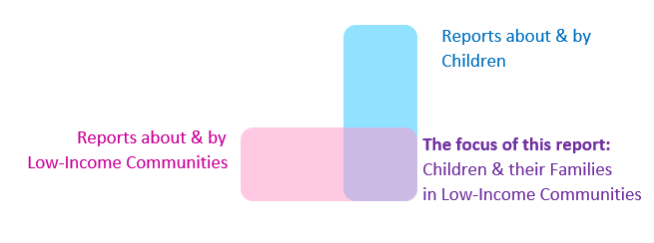

Initial Lockdown Level 4
Lockdown: What were some of the ways in which those children already disadvantaged faced the most severe effects?
Higher food prices
tipped those already in food insecurity into food lack – and also exacerbated related feelings of shame for parents and caregivers
Job losses
were linked to household income: the lower the household income, the more likely a member of the household would lose their job
Vulnerability to Covid-19
meant compounding negative financial effects for families with disabilities and health issues
Lack of online access
due to poverty, which exacerbated educational inequities
However:
People helped each other
as much as possible; and organisations stepped up for many.

Issues of family poverty during the initial lockdown
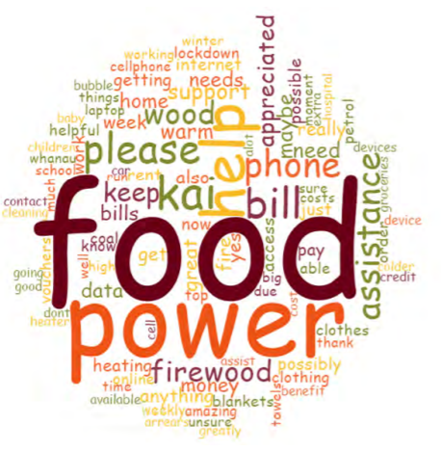
Word cloud of responses to the Manaaki20 Survey (Leahy, 2020)
Difficulty accessing immediate assistance: Initially, there was confusion, fear, stress and panic throughout the country – particularly for those parents and caregivers who were unclear how they were going to access and pay for food. It was difficult to get through to the Ministry of Social Development (MSD) for a food grant – and often the need was urgent. Issues of access to groceries were exacerbated for sole parent families as lockdown rules meant that no other adult assistance was available:
“I have tried WINZ online for food advance, but it says I need to call them and I don’t have a phone to do this... I have tried a couple of times to use the phone box down the road, but to have all my kids wait in the van whilst waiting on hold for an hour....can’t do that.”
– Manaaki20 response (quoted in Leahy, 2020)
Income loss: The lower a household’s income was, the more likely one of its members was to lose their job during lockdown according to a weighted survey of 2000 adults conducted in the third week of lockdown (Prickett, 2020). The survey also found that 11% of Pacific workers lost their job during lockdown – the highest percentage of any ethnicity. The percentage of job loss for Asian respondents (excluding Indian respondents) was 10%; for Māori, around 8%. Māori respondents were most likely to be essential workers, closely followed by Pacific respondents. Overall, during lockdown, low income families on $30,000pa or less (16%) and sole parents (20%) were most likely to report material hardship (Prickett, 2020).
Low overall financial resilience: The Commission for Financial Capability conducted a survey in the last 2 weeks of level 4 lockdown, providing “a snapshot of New Zealand at the most difficult moment” (Galicki, 2020). It found that those with dependent children were more likely to be in financial difficulty (39%-45% depending on the age of the child) than the national average of 34%, and far less likely to be financially secure (12%-17% compared to a national average of 26%). The Commission’s “in difficulty” profile included single adults with children, while its “exposed” profile included couples with children. More people in NZ were in financial difficulty (34%) than in the UK (28%) and in Norway (8%) – the other two countries in the study – due to NZ’s “low social welfare benefits” and “high levels of insecure employment” defined as casual, online platforms (eg Uber), self-employed, temporary contract and labour hire agency, as well as low levels of pre-Covid19 household savings and the economy’s reliance on tourism and international students (Galicki, 2020).
Inequities in financial security: The same survey found significant ethnic disparities in experiences of financial difficulty in lockdown. Over half of all Māori and Pacific people were found to be in financial difficulty (51-52%), compared to around a third of all Pākehā (31%) and Asian people (33%). In Northland and Waikato, no Māori households were in the financially “secure” category, while in Auckland only 3.5% of Māori households were found to be in that category. In contrast, nationally, 30% of all Pākehā were considered to be financially secure. In Waikato and the Lower North Island, Māori households were more likely to be in difficulties than to be secure or exposed (Galicki, 2020).
Figure 1: Financial status by ethnicity: In difficulties vs exposed vs secure. (Source: Galicki 2020)
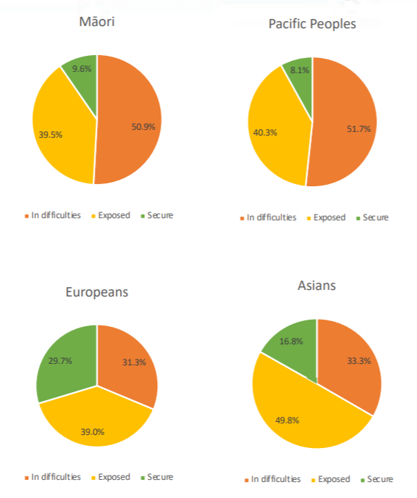
Māori Pacific
Pākehā Asian
Food insecurity: As well as potential income loss, lockdown conditions meant families struggled (further) to pay for food. Reported problems included:
- the loss of free school meals (Franks, 02/03/2021)
- the unavailability of lower-priced grocery lines and cheaper supermarket staples, possibly due to others panic buying (Humpage & Moore, 2021)
“I’ve probably never felt quite as stressed as I did at that time — even when we were visiting foodbanks — because there was nothing there in budget [food lines]. Literally nothing. You’d go in and, you know, where you’d be used to buying a 70c tin of baked beans from Countdown, the cheapest ones were three times that price. There were no specials on in the beginning of lockdown.”
- Ryan, Supported Living Payment-Carer, 2 children, (Humpage & Moore, 2021)
Others struggled to access supermarkets due to having vulnerable household members or young children (Robson, 22/04/2020). During the initial Level 4 lockdown, supermarkets did not allow young children inside, making it difficult for sole parents in particular to secure the food they need for their families, particularly if they had no money to pay for grocery delivery (Davison, 2020; Humpage & Moore, 2021).
Energy & communication insecurity: For those already struggling, “ramped up prices” for food had knock-on effects on their ability to pay power bills and phone credit (Leahy, 2020). These impacts exacerbated social isolation for some who were unable to make contact with friends and family during what was already a potentially isolating time.
Key concerns recorded by Te Pūtahitanga o Te Waipounamu – the South Island Whānau Ora commissioning agency – in their Manaaki20 online survey (Leahy, 2020) included:
- “not having enough food for my children as I hadn’t planned them being home 24/7 and seem to be eating me out of the little that I do have. I am also very worried about receiving a huge power bill due to us all being at home.”
- “Nappies and food due to raised prices and being a sole parent standing in line for over 2 hours with two children under 4 years is sort of a joke”
- “We barely have enough food to survive, our cupboards are near empty, while we struggle to pay rent and power plus food for all of us. We do not have credit on our phones to call and keep in touch with our whānau.”
- “We run out of wood on cold nights, we run out of hygiene products, tampons, pads etc.”
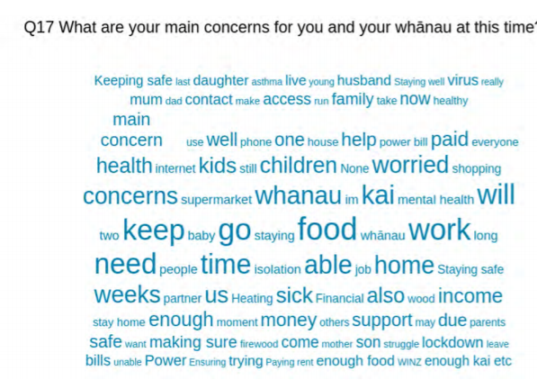
Word cloud of responses to the Manaaki20 Survey (Leahy, 2020)
Consistent with many of these challenges, Te Puni Kōkiri insights relating to tamariki Māori (quoted in OCC, 2020) included:
- the lack of food when schools were closed as they provided breakfast and lunch;
- stressed caregivers due to a lack of respite;
- the stress of the shift to online learning;
- high stress and anxiety due to virtual learning with an increased workload; and
- kaumātua hiding their mokopuna behind closed council unit doors knowing that they should not have them there
Increasing numbers in need: By the second month of the lockdown, a new cohort of whānau were presenting to Te Pūtahitanga o Te Waipounamu:
“those that had lost their jobs, utilised all of their annual leave and savings, and were whakamā (embarrassed) about seeking assistance. Our triage team had to flip whānau thinking around seeking support. We heard many stories of whānau having to make choices such as paying rent or putting food on the table; whānau who had extra members in the home due to COVID-19 and were not coping financially; whānau who had no transport, no local supports or lived rurally and were whakamā about coming forward for assistance; adult whānau members were going without kai for their tamariki (children); in essence the range of stories evidenced the need to have a Kaupapa Māori approach to make it easier in terms of access.” (emphasis added; Leahy, 2020)

Children with disabilities, and/or in households with a member with disabilities
Exacerbated income loss: Many with disabilities are considered particularly vulnerable to Covid-19, which meant that usual ways of receiving/earning income and support were not always available to families and whānau with disabilities, even those who may not have suffered financial distress prior to Covid-19.
“We delivered some vouchers to a mum this week who worked at [a supermarket]. She was expected to work throughout this week, but she has a daughter with cerebral palsy and auto immune deficiency. She left her job so she wouldn’t put her daughter at risk. Her job pay-out covered her bills over the next four-weeks but she was left with no money for food so, we were able to provide her with grocery vouchers as her daughter required certain foods.” Chief Executive of The South Waikato Pacific Islands Community Services Trust, Akarere Henry (Pasifika Futures, 27/03/2020)
Difficulties knowing about/accessing support: Accessing ostensibly available support is a challenge for many families with disabled children (Neuwelt-Kearns et al., 2020) and there were reports it continued to be a problem in lockdown. One busy working sole mother with five children, including a son with autism, didn’t find out until after lockdown that families could be sent paper-based learning packs and even devices. Moreover, she didn’t learn that, during lockdown only, funding originally designated to pay for respite or support workers could be spent on such things as games, activities, home renovations. Knowing this would have helped immensely, but in spite of being in touch with various services, the message was never received (Good & Lee, 2021).
Lack of PPE: Another concern was that carers required to go into people’s homes (for example, for personal cares such as showering) did not have the appropriate Personal Protective Equipment (PPE). Technically, it was up to the carer’s employer – who was often the disabled person – to provide it, but it was impossible for many to access. In the end, organisations often stepped up above and beyond to address this extremely urgent issue; one disability service staff member told CPAG that her employer:
“bought 20 ginormous boxes of PPE. Our branch manager in Dunedin did a drop-off tour with all these boxes rammed in the back of the branch car. It was really tricky.”
Impact on development: At the same time, there were reports that some children with disabilities (including but not limited to those in low-income families) were deeply affected by disruption of routine and/or anxiety:
“Understandably, during this uncertain time, my son with autism reverted back to co-sleeping with me, followed by his two neurotypical siblings. Emerging from my bubble, one year on, I have only just managed to get my son with autism back to sleeping in his own bed.” (Good & Lee, 2021)

Migrant families
People on temporary work visas were ineligible for many forms of Covid-related support, and this included some families with children, contributing to serious permanent consequences for some. At least one family with a young child was ordered to leave New Zealand because they used $1600 worth of food vouchers they were not entitled to during the initial lockdown. The father, a carpenter, had had his income halved by Covid-19. A judge turned down the family’s appeal to get the deportation notice overturned but noted the offending was due to the father being “desperate to provide for his family” (Loren, 16/3/21).

Children’s assessment of lockdown
Mixed assessment: Children’s assessment of life during the initial lockdown was mixed. According to the Office of the Children’s Commissioner’s ([November] 2020) online survey, even among demographics with relatively high instances of poverty, some still felt life was better or much better during Covid-19. This was the case for a significant proportion of Māori, Pacific and those who identified as having a disability (35%, 39% and 38% respectively, for all incomes, compared to 29% of overall responses).
Positive home learning experiences: Pacific secondary students in decile 1-3 schools were more positive about being able to learn from home than other groups, and more often reported having someone in their household who could help them with their learning under lockdown (ERO, 2021b).
However many children also found lockdown difficult. Children who identified as LGBTQI+, and those from refugee backgrounds (including but not limited to those in low-income areas) were slightly more likely than average to think life during lockdown was worse or much worse (33% and 31% compared to 29% of overall responses; OCC, 2020). Key challenges identified by children were difficult family dynamics, not seeing friends, and feeling lonely, as well as challenges with online learning.

Iwi, hāpū and community responses
During the initial lockdown, many iwi, hāpū and community organisations as well as service providers mobilised to respond to the immediate needs of whānau. While no one programme can reach everyone – and concerns remain about those who missed out due to the longstanding inadequacy of centrally-administered supports, in spite of community best efforts – community responses were relevant, agile and creative. As surfaced in the findings of an internal review of the leadership of Te Pūtahitanga o Te Waipounamu, a Commissioning Entity working on behalf of iwi in the South Island to support whānau:
“Te Pūtahitanga and its delivery partners, in their unwavering dedication to whānau wellbeing demonstrated a level of agility and purpose that naturally captured whānau who may have otherwise continued to fall through the cracks of a slow and fragmented national support system.” (Te Pūtahitanga o Te Waipounamu, 2020)
The following list is drawn largely from the collected articles in Ko tōku ara rā Aotearoa, Our Journey, New Zealand COVID19 2020, edited by Dr Kahu McClintock and Dr Amohia Boulton (2020), outlining the responses and experiences of Māori organisations in communities around the country. Here are a few of the thousands of responses throughout the country which explicitly addressed issues of poverty during lockdown:
- From Nelson to Invercargill, 25,000 hygiene packs (including soaps, shampoos and hand sanitiser) were distributed by Te Pūtahitanga o Te Waipounamu and its partners, including via kōhanga reo and kura. “Agreements were negotiated with sixteen different energy providers, mink blankets delivered; thermal underwear [and firewood] dispatched.” (Te Pūtahitanga also created an online platform to share tales of whānau resilience and innovation, portraying extraordinary examples of triumph over fear) (Leahy, 2020)
- Addressing Maori wellbeing through a Te Ao Māori lens of wairuatanga/ whanaungatanga/ hinengaro (uplifting spirits/ togetherness/ mental wellbeing, Ngāti Kahungunu iwi delivered 33,000 donated Easter eggs, as well as more ordinary food parcels, to help lift the spirits of whānau and children especially in lockdown over Easter. (Treacher, 11/04/2020)
- By 11 April 2020, Pasifika Futures – the Pacific Whānau Ora commissioning agency – were receiving calls for assistance from over 460 families a week, and had delivered 5,166 Covid-19 support packages providing support to 27,800 individuals (Pasifika Futures, 11/04/2020)
- Of schools responding to the ERO (2021b) survey, 23 percent distributed care packages during lockdown, including food parcels and clothing, to whānau in their community, often in conjunction with KidsCan or local marae.
- For tamariki and rangatahi with lived experience of mental distress, Te Hiku Hauora based in Kaitaia devised special packages including helpful resources compiled by mental health nurses of how to cope during Covid-19: “We bought all of the playdough, the colouring pencils, notebooks, balloons, handballs, cards, knucklebones all sort of things [out of the local shops]. For the mental health packages we included mindfulness activities, reflection journals” (Baker in McClintock & Boulton, 2020)
- Examples of traditional Māori methods in providing kai for the collective in iwi/hapū/whānau took place Te Tai Rāwhiti. Koha of beef was made available for whānau who had recently lost their jobs in forestry, and Ngati Porou Hauora answered a request to help distribute it (King in McClintock & Boulton, 2020).
- Whānau cared for and helped each other in unprompted reciprocity. Parents and caregivers went above and beyond – not only for their own tamariki but for those in their immediate neighbourhood:
“One of many magical moments of manaaki occurred when a young man asked why Te Pūtahitanga o Te Waipounamu had gifted him a hygiene pack. The man was 23 years old, with a toddler and another on the way. He had just lost his job as a salesman; but he initially declined the pack, suggesting there were more deserving whānau (family) than his. When his partner opened the pack and saw there was shampoo in it, she started to cry. This woman with the beautiful hair had not shampooed her hair for three weeks as they were prioritising food for their pēpē (baby) as well as kai (food) for the neighbour’s children. Later, we heard that the young man had gifted a couple of chickens to his neighbour, to say thank you for nominating him for the hygiene pack. This exchange then led to a kōrero (discussion) and eventually the young man was offered a job with the construction company his neighbour works for.” (Leahy in McClintock & Boulton, 2020)
- National iwi networks ensured best practice was shared: Waikato-Tainui iwi (2020) shared their pandemic plan with Te Pūtahitanga to inform Te Waipounamu response (Te Pūtahitanga o Te Waipounamu, 2020), and several iwi shared theirs online (Te Arawhiti, n.d.)
Covid-19 led government departments to work in higher-trust relationships with other organisations than previously, which achieved positive results. Te Pūtahitanga o Te Waipounamu staff found:
“A quick email to Wellington was able to achieve greater traction than anything we had experienced in pre-lockdown times.” (Leahy, 2020).
This Government approach empowered community organisations to deal with the crisis, as the delivery of contracts was put aside during the Covid-19 pandemic:
“[we were told] ‘Never mind about your targets, just focus on COVID-19’ - we found that helpful.” Ki A Ora Ngāti Wai (Māori hauora organisation) quoted by Baker in McClintock & Boulton (2020).
Nonetheless there were still issues in the relationships between government and iwi/communities; for instance, all six Māori self-governing hauora organisations surveyed in Te Tai Tokerau reported difficulty accessing PPE and flu vaccinations in the first phase of the Covid-19 response (Baker in McClintock & Boulton, 2020).

Income
Income: What were some of the ways in which already-disadvantaged children faced the most severe effects?
Likely increases in poverty, particularly for tamariki Māori and Pacific children
reflecting our piecemeal and inadequate social welfare system.
New debt to MSD
…is at record highs for benefit recipients, in spite of increased Special Needs Grants
Ineligibility for the Covid Income Relief Payment
Families already on inadequate incomes in the social welfare system were among those not eligible to receive this relatively generous temporary payment.
The income support offered to working New Zealanders (mostly via employers) during and after the first lockdown was unprecedented in our history. The wage subsidy covered more than 1.7 million jobs overall, supporting more than half the workforce at a total cost of over $13 billion (Robson, 2020b). In addition, the Government also supported people who had lost their jobs as a result of Covid-19 on a temporary payment of $490 per week. This was almost twice the rate paid to people receiving JobSeeker Support (JSS) and, in contrast to JSS, even people with partners earning up to $2000 a week could receive this Covid Income Relief Payment.
The Government’s commendable wage subsidy kept hundreds of thousands of children out of poverty. However, this care (and resourcing) stands in stark contrast to the little additional support given to those children already in poverty, or at high risk of poverty. A few tweaks to standard income support – a $25 per family benefit increase, and a doubled Winter Energy Payment – were so small that increasing numbers of people were left reliant on supplementary assistance to try and make ends meet.
The necessary measures taken to keep Covid-19 at bay, such as such as border closures and lockdowns, meant that loss of income for many people in New Zealand was probably inevitable. In contrast, however, loss of income to the point of (further) inadequacy was not inevitable. As detailed below, our low levels of income support are not enough for people to be able to live with dignity.

Income poverty rates
Official child poverty statistics which include post-Covid-19 data will not be available until February 2022, when figures for the year to June 2021 are scheduled to be released. In the meantime, our analysis suggests child poverty will likely have increased by around 18,000 children (around 10%) for the year to March 2021 on at least one of the primary target income measures (BHC 50% moving). This estimated figure is based on changes in numbers of households with children who are not in fulltime work (see Appendix 1 for workings) and is in contrast with analysis published by Treasury (2021) which suggests that child poverty on the same measure will reduce by what looks like ~10,000 – ~15,000 children in the year to June 2021. However, on both CPAG analysis and Treasury analysis, at least one of the three inaugural 3-year 2021 Government targets for child poverty reduction will not be met.
While margins of error are larger for child poverty figures for ethnicities than for the figure overall, our analysis suggests tamariki Māori and Pacific children likely suffered high relative increases in poverty in the year to March 2021: they are around 2.5 to 3 times as likely as Pākehā children to have been pushed into poverty, and children of other ethnicities are also around two times more likely than Pākehā to have been pushed into poverty. This suggestion of increasing inequity is based on increases by ethnicity of benefit-receiving households and assumes the number of children per household newly receiving benefits is the same across ethnicities (see Appendix 1 for workings).
As poverty is exacerbated by inadequate state welfare and employment support, an increase in inequity for tamariki Māori is at least in part an effect of multiple, ongoing breaches of Te Tiriti o Waitangi, in particular the Crown’s obligation of oritetanga in terms of providing and ensuring the ability for Māori to live as equal citizens in Aotearoa (see PHA, 2016, Te Raki, 2020). The finding that tamariki Māori and Pacific children are likely to have been burdened far more heavily than other children is deeply troubling and raises legitimate questions about the adequacy of policy responses. Recent decisions have been direct contributors to this outcome, including the strict eligibility criteria for the Covid-19 Income Relief Payment (discussed below) and inadequate benefit incomes. These are instances of ongoing colonisation and institutional racism.
At the same time, inequity has been entrenched for a long time via education and patterns of employment, as explained by Tokona Te Raki Māori Futures Collective:
Following the Canterbury quakes Māori disaster recovery expert Professor Regan Potangaroa, stated, “disasters don’t impact unequal people equally”. That was the case post quakes and it looks set to happen again with 66% of Māori workers being employed in industries negatively impacted by the response to COVID-19. Largely it’s because we have been pigeon-holed into blue-collar careers by the country’s decision-makers through successive generations. We were disproportionately harmed by Rogernomics, we were hit hard by the GFC and now here we are facing the brunt of the COVID-19 recession…. The underlying cause is systemic inequity — the inequalities in our education system create inequalities in our economic outcomes….(Te Raki, 2020)
This long-term inequity increased the likelihood, if there were no intervention, of increased acute disadvantage for tamariki Māori (and Pacific children) when Covid-19 hit – which should have been a motivator to focus further energy and resources on ensuring this increase in disadvantage did not happen. Over generations, our society and state systems have been set up in such ways that equitable outcomes require more than good intentions; and inequitable outcomes need to be proactively worked against if they are to be avoided. Avoiding policy which has the outcome of further disadvantaging tangata whenua relative to others is a state responsibility: policies which particularly disadvantage and deprive tamariki Māori are directly in opposition to Te Tiriti o Waitangi and the Child and Youth Wellbeing Strategy.

Increase in numbers of children in families receiving benefits
Job losses led to an increase in the number of children living in families receiving benefits. The number of children in households receiving main benefits was 12.6% higher in March 2021 than it was in March 2020, an increase of 23,000 from 183,000 to 206,000 (to the nearest 1,000). This increased the proportion of all children in Aotearoa NZ in benefit-receiving families from approximately 16% to 18% between March 2020 and March 2021 (MSD, 2021a).
Figure 2: number of children in benefit-receiving households, March quarters 2016-2021. Source: Benefit Factsheet National level data tables (Source: MSD, 2021a)

Within this broader increase in children in benefit-receiving households:
  - Sole parent families made redundant faced a reduction in income compounded by the loss of the In-Work Tax Credit, if they started receiving a benefit or if they lost all work hours (ie were eligible for the Covid Income Relief Payment or CIRP). In contrast, a partnered parent on CIRP after job-loss could continue receiving the In-Work Tax Credit as long as their partner had some paid work.
  - The number of children in households receiving JobSeeker Support increased 26% (by 10,900 to 52,750) between March 2020 and March 2021. Some of these children will be in two-adult households, for whom core entitlements were particularly inadequate (see Figure 3 below).
  - The number of children in households receiving Sole Parent Support increased 10% (by 12,100 to 132,100).
  - As at March 2021, of those households receiving Sole Parent Support, 46.5% were headed by a Māori parent, while 11.4% are headed by a Pacific parent.
  - The number of whānau Māori receiving Sole Parent Support increased 7.3% between March 2020 and March 2021 from 28,900 to 31,000. The number of Pacific families receiving Sole Parent Support increased 12% between March 2020 and March 2021, increasing from 6,777 to 7,596.
  - Not shown in Figure 2: following seasonal patterns, the total number of children in benefit-receiving households peaked in December 2020 (rather than March 2021) at 211,164, which is 12.7% (23,766) higher than December 2019.

Inadequacy of core income support
During year ending March 2021, core income support payments were inadequate to keep families above primary poverty lines without temporary and hardship assistance. Core benefit entitlements between April 2020 and March 2021 were lower than the after-housing-costs Government target poverty line for most families with children paying lower-quartile rent, even during the doubled Winter Energy Payment (WEP) period.
Modelling of income support for April 2020 - March 2021 showed that in the seven months without WEP, all model households were below the target line (50% median fixed after-housing-costs) and required between $31 and $205 more per week to meet it, with two-adult households requiring the highest amounts (Figure 3).
Figure 3: Dollars ($) per week difference between the 50% AHC equiv med income fixed line 2017-2018 and model household income: SPS or JSSCouple, plus full AS & WFF entitlements, paying lower-quartile rent, post 1 Oct 2020. “A” = Adult; “C” = Child; “B” = Bedroom (Source: McAllister, 2020)
Auckland Rural Areas Auckland Rural Areas
In the five months with WEP, only sole parent model households in rural areas had weekly income that was at or above this target poverty line (McAllister 2020). We expect that, in order to get by, families receiving benefits require supplementary and emergency assistance, live in shared households and/or increase debt.

Hardship and supplementary assistance
The ongoing inadequacy of core benefits means that families increasingly require hardship and supplementary assistance, an already existing trend which was exacerbated through the year following the pandemic. As the Child Poverty Monitor (2020) reported,
“Increases in the number of hardship grants since 2017, with a marked increase in 2020, show that many families and whānau in Aotearoa are living in precarious circumstances where there is little or no capacity to absorb sudden changes in income.” (Duncanson et al, 2020)
Lockdown: The volume of hardship and supplementary assistance granted was exceedingly high during the Level 4 lockdown. The 63,100 families receiving Sole Parent Support in April 2020 collectively received 82,500 hardship grants and benefit advances in the same month, an average of 1.3 successful requests per family (it is extremely likely some families received multiple grants/advances while others received none). This was a higher average than for JobSeeker Support (JSS) and Supported Living Payment (SLP) recipients (it is unclear whether it’s different for those JSS and SLP recipients who have dependent children). (MSD, 2020a&b) For all households, around 60% of the growth in Special Needs Grants in April 2020 was due to more grants per person (depth of need increasing), while 40% was due to more clients getting a grant (spread of need increasing) (Frischknecht, 2020).
Demand continues: Hardship assistance levels remained high throughout the year. MSD hardship assistance (to all households, both with and without children; and on- and off- benefit) totalled 2.7 million successful requests in the year to March 2021. Ministry of Social Development describes the need for Special Needs Grants in 2020 as “unlike anything MSD has experienced before” (MSD, n.d.). Grants spiked to 790,000 over the initial lockdown (June 2020 quarter), however the March 2021 quarter had the second-ever highest total at 670,000 (MSD, 2021a).
Financial value hasn’t dropped at all: While the number of successful requests spiked in the June 2020 quarter, the dollar amounts granted overall were remarkably similar for each of the four quarters to March 2021, ranging from $215.1m to $217.5m. The total value granted for year ending March 2021 was $860m.
Across the course of the year ending March 2021, the total value of Special Needs Grants (non-recoverable payments) decreased, while the value of new benefit advances (loans to benefit recipients) increased. Figure 4 below illustrates this trend. This increased reliance on recoverable assistance over the course of the year speaks to how the Government is giving benefit recipients inadequate income, and then consequently loaning them money – pushing them further into debt – to bridge some of this gap. While the total value of Special Needs Grants decreased since June 2020, it was still significantly higher in March 2021 than it was pre-Covid-19. The value of new benefit advances was at a record high of $87M in the January-March 2021 quarter, even after dropping between September 2019 and June 2020.
Figure 4: $ value of MSD hardship assistance incl loans (Source: MSD, 2021a)

Supplementary assistance trends continue: For all households (with and without children, on- and off-benefit), levels of supplementary assistance such as the Accommodation Supplement (AS) and Temporary Additional Support (TAS) were already increasing before Covid-19 hit: TAS recipients increased 19% in the March 2020 year, and Accommodation Supplement recipients increased 7% in the same period. After lockdown, the number of recipients for both payments peaked in late 2020, before reducing somewhat in the March 2021 quarter, although they were still 13%-15% higher than they had been a year before in March 2020. In March 2021, TAS recipient numbers were 88,200; AS recipients: 360,500.
Doubled Winter Energy Payment (WEP): This was a temporary 2020-only Covid-19 response from the Government: families with children received an extra $63 a week for five months from May 1, double the usual WEP amount. While it was not enough to pull most families out from under the key AHC poverty line (McAllister, 2020), it made some difference – one parent on Sole Parent Support noted she ran the heater sometimes in Winter 2020, which she could not afford to do in other years (Humpage & Moore, 2021).

The Covid-19 Income Relief Payment
The Covid-19 Income Relief Payment (CIRP) was much more generous than usual benefits. Take-up was relatively modest, peaking at about 25,000 in August 2020 before declining and finally ceasing altogether in early February 2021. It was set at $490pw for 12 weeks – almost double the usual JobSeeker Support rate, and not abated for those in relationships as long as their partner was earning less than $2,000 per week. However, its eligibility criteria were strict: recipients had to have lost work due to Covid-19 within particular timeframes, meaning that those most likely to be in severest poverty (i.e. in longer-term benefit receipt) were ineligible. Māori and Pacific applicants were much less likely to be awarded the Covid-19 Income Relief Payment than Pākehā (Cardwell, 3/11/2020). This was possibly partially due to different prevailing patterns of employment for different ethnicities:
“The Covid Income Relief Payment is a really good example of people working within their own cultural paradigm where their reality is them and their friends have one job, they do it full time and if they lost it the world would be a terrible place. But [they’re] not recognising that a lot of other people are in a different paradigm where they have two or three jobs and just losing one of them makes the world a terrible place because that'll be the one that puts food on the table.”
– benefit recipient advocate Kay Brereton, quoted in Cardwell (3/11/2020).
Policy development documents released publicly show no evidence that the potential impacts on different population groups were taken into account (MSD, 2020c). Race Relations Commissioner Meng Foon stated: "The disparities are causing injustice and a breach of human rights to the Pacifica and Māori communities"(Cardwell, 2020). As summarised by the Children’s Convention Monitoring Group (2021), including the Office of the Children’s Commissioner, and the Human Rights Commission:
“The COVID-19 payments raised issues of direct and indirect discrimination in the realisation of children’s rights with levels of financial support to parents varying according to when and why jobs were lost rather than children’s needs.”
The omission of benefit recipients from those eligible for CIRP “had a significant, negative impact on the mental health of main benefit recipients”, taking a toll on the mental wellbeing of many of those in severe poverty, as detailed in the Health section below (Humpage & Moore, 2021).

Sole Parents
In Stats NZ wellbeing surveys over several years, sole parents have consistently reported worse financial wellbeing than partners in 2-parent households and people with no dependent children. In March 2021, around 22% of sole parents reported not having enough money (compared to around 6%-7% of others) while around 27% sole parents – an even higher proportion – reported having received help from an organisation such as a church or foodbank in the last 12 months, at least four times as many as partnered parents (~4%-7%), and at least six times as many as those without dependent children (~3%-4%) (Stats NZ, 2021f). Unlike other groups, the proportion of sole parents who reported accessing a foodbank or similar help in the March 2021 year was higher than the proportion who self-assessed as not having enough money.
Figure 5: Adequacy of income to meet everyday needs, March 2021. Source: Stats NZ, 2021f

Overall, in line with other groups, sole parent self-assessments of not having enough money steadily reduced between 2014 and 2021, from around 30% to around 22% - still unacceptably high but a significant move in the right direction (Stats NZ, 2019; Stats NZ, 2021f). However, the proportion of sole parents assessing they have “only just enough money” (rather than the more comfortable categories of “enough money” or “more than enough money”) has increased since 2018 – in contrast to other groups – suggesting that there are a number of sole parent families who are only just scraping by (see graph below). In addition, while the margin of error is relatively high for sole parents (around 3%-4%), the wellbeing survey suggests more of them self-assessed as not having enough money in December 2020 and March 2021 (both around 22%) than in the preceding two quarters of June 2020 and September 2020 (both around 18%). This may be seasonal – pointing to the difficulties the Winter Energy Payment drop-off creates for sole parents receiving benefits – or it may indicate that financial distress among sole parents is increasing (Stats NZ, 2021f). As mentioned above, families receiving Sole Parent Support had high levels of need for hardship grants and benefit advances across lockdown.
Figure 6: Proportion of people by childcaring status self-assessing as having "not enough" or "only just enough" money, 2018 and March 2021 (Data source: Stats NZ 2019; Stats NZ 2021f)

Recent migrants
Overall, by September 2020, migrants were more likely to have lost work due to Covid-19 compared to those born in NZ, and recent migrants were more likely to be affected by job loss than migrants who had been in NZ for longer than five years (Belong Aotearoa, 2020). Belong Aotearoa’s September survey showed access to Covid-related information and support was a key challenge for migrants. Over a third of respondents (36%) weren't aware of Covid-19-related support available for migrants, and 54% of these respondents identified a lack of information and language barrier as a key challenge. Others cited visa status, shame and racism as barriers to accessing Covid-related support (there were reports of intensified racism and discrimination towards some Asian communities as a result of Covid-19; see Malatest International, 2021). Income was among key concerns for Belong Aotearoa survey respondents, as well as visa status, physical immobility, income, and not meeting financial obligations to family back home.

Food Insecurity
Food insecurity: What were some of the ways in which already-disadvantaged children faced the most severe effects?
Increased serious food insecurity
After a lockdown spike, demand at foodbanks settled at roughly double pre-Covid levels
However
Free school lunches became more available
While school lunches are not a substitute for adequate family incomes, they can assist with educational success
Increased demand at existing foodbanks: The initial lockdown led to a spike in emergency food distribution, but demand remained high even after lockdown was lifted. In April-June 2020 (across most of the initial lockdown) Auckland City Mission food parcel distribution rose to 270% of what it had been the previous year (from 4,250 to 11,750), while the Wellington City Missioner reported delivery of four times the usual number of food parcels in the first days of lockdown (Kronast, 06/04/2020). After the initial lockdown, food banks, such as Auckland City Mission and the South Auckland Christian Foodbank, reported that food parcel demand continued at roughly double pre-Covid-19 levels (Franks, 18/07/20). As discussed above, in March 2021, around 27% sole parents reported having received help from an organisation such as a church or foodbank in the last 12 months (Stats NZ, 2021f).
Increased food distributors: These foodbank figures are likely to under-indicate food insecurity due to an increase in the number of organisations distributing emergency food assistance. The number of registered foodbanks in Auckland increased from to five pre-Covid-19 to 29 by August 2020 (Theunissen, 20/08/2020). Further, community organisations that were not usually involved in distributing food stepped up in 2020 to provide food for families, such as Whānau Ora organisations (see chapter 1), schools and early childhood education (ECE) centres. In an Education Review Office survey (2020), 10% of ECE provider respondents reported they “helped whānau access food”.
First time presenters: Foodbanks reported increases in the number of “first time presenters”, including people who had lost their jobs, as well as people who usually lived overseas and were stuck in New Zealand due to Covid-19. At the Auckland City Mission, in the 2018 and 2019 calendar years, first-time food parcel recipients comprised 45 and 42 percent of total food parcel recipients, but in 2020, first-time recipients were 54 percent of all recipients. It seems increased numbers of families are now one financial shock or unexpected cost away from being unable to provide for their family. As Micaela Van der Schaaf, manager of Food Security at the Auckland City Mission, reported to CPAG:
“A woman we saw recently had to get two new tyres for her car. Tyres are expensive, that’s two weeks’ food. It messed up feeding her kids.”
Food in schools: In term 2 post-lockdown, KidsCan saw a 30% increase in demand for food support and was helping to feed almost 44,000 children in 787 schools and 57 early childhood centres nationwide – 10,000 more children than previously. (Te Ao-Māori news, 18/05/2020). Meanwhile, a key Government response to the rise in food insecurity following Covid-19 was the expansion of the Government’s Ka Ora, Ka Ako healthy school lunches programme. This expansion was gradually rolled out throughout the year to schools of high socio-economic disadvantage. By September 2020, over one million lunches had been served in 64 schools to over 13,700 students (Duncanson et al, 2020); by March 2021, 130,000 children were receiving lunches (Hipkins, 2021) and by April 2021, it was reported more than eight million lunches had been served to children at 542 schools (Williams, 08/04/2021). By the end of 2021, 964 schools and kura, and over 215,000 (25 percent) of Year 1-13 students across New Zealand are scheduled to be receiving free lunches (Hipkins, 04/03/2021).
Concerns about foodbank increases: In 2020 the Government also announced an investment of $32 million (across three years) in foodbanks to bolster the sector in responding to this heightened level immediate need (NZ Govt, 14/05/2020). However, concerns have been raised about the mushrooming of foodbanks (Theunissen, 2020). Ultimately, researchers and social services providers alike are clear that food security requires income adequacy; that is, families having sufficient income to absorb unexpected costs and economic shocks without compromising their ability to put food on the table (Carter et al., 2010; Parnell et al., 2001).
Even in spite of these initiatives, many families continue to report difficulties in feeding their kids, reflecting ongoing income inadequacy which emergency food assistance does not address:
“We have families who cannot provide food for their kids, and I’m not sure Government officials know what that feels like”
– Haley Milne, Principal, Kia Aroha College (Biddle, 2020)

Cost of living
Cost of living: What were some of the ways in which already-disadvantaged children faced the most severe effects?
Annual inflation
Annual inflation for beneficiaries was almost three times higher than for all households overall in the year to December 2020, a greater gap than in recent years, partly driven by higher rents
Stats NZ reports the reason for the inequity in impact of inflation is that benefit recipients spend almost a third of their income on rent on average, so rising rents have a much bigger impact on their cost of living, than on all other groups. In addition, benefit recipients spend relatively little on mortgage payments so generally do not benefit from lower interest rates.
Figure 7: Cumulative inflation June 2014 qtr- March 2021 qtr for select household groups (vertical Y- axis starts at 920) (Source: Stats NZ, 2021a)
Initial lockdown begins
Beneficiary households have consistently seen higher inflation rates than all households. Over the past 10 years, since December 2010, beneficiary households have never seen inflation lower than that of all households overall (Stats NZ, 2021a); cumulative inflation means the increase of the cost of living for benefit recipients was 5% greater than for the high spenders in the seven years to March 2021 (Figure 7). This remained true for the latest March 2021 quarter: inflation for beneficiary households increased by 1.1 percent, while for all households, quarterly inflation increased by 0.9 percent (Stats NZ, 2021b).
“A trend we are seeing coming through our applications is access to ‘buy now pay later’ schemes – we are seeing people using these payment options not for ‘luxury’ purchases but the basic life essentials like meat, and household items.”
- Natalie Vincent, Ngā Tangata Microfinance

Housing & Homelessness
What were some of the ways in which already-disadvantaged children faced the most severe effects of COVID-19?
Rent acceleration
disproportionately affected low-income whānau and families
Increased homelessness
for families with children in precarious situations
Government neglect of homeless youth
Young people who became homeless under the age of 18 were forgotten
Inhumane conditions
in some government-arranged emergency housing for children and their families
Long stays
in emergency housing
Apart from the risk of the pandemic itself, the housing squeeze and the Government response to it were the most serious issues of the Covid-19 year: they increased wealth inequality for many years to come, and increased absolute poverty in the immediate term in the form of homelessness and rent-related food insecurity. The dire conditions in emergency housing for vulnerable young people and children are an outrage. The lack of housing stock was an issue everywhere from Ōtepoti Dunedin to Te Whanganui-a-Tara Wellington to Tairāwhiti Gisborne:
"I'm pleading with the next government to give families in Gisborne more housing opportunities, because we don't have enough new houses here and the rent is very high."
–Pacific Island Community Trust Deputy chairperson Pauli Ma'afu, Tairāwhiti Gisborne (Hopgood, 13/10/2020)
The squeeze: A tightening rental market, as seen in 2020, increases housing costs and decreases the choices available for all private tenants, finally pushing those least able to afford rents and/or seen as undesirable tenants by landlords into emergency housing or informal arrangements, such as overcrowding and living in garages or – in the case of some young people under 18 – into sleeping rough. Prevailing landlord culture does not see low-income sole-parent households with children as desirable tenants, meaning sole parents and their children are over-represented among those who are homeless or in precarious housing situations (for example, they are more than three times as likely to be on the social housing waiting list as couples with children [MSD, 2021b]). Just over half the total waiting list (including those without children) are Māori, due in large part, to racism in the rental market (for example, see Dunlop, 23/07/2020).
Accelerating rents: Between Dec 2019 and Dec 2020, rents as geometric mean increased at roughly twice the rate of the two previous years, despite a six-month rent freeze (Figure 8). The Government froze rents in response to the Covid-19 pandemic for six months from 26 March 2020 but didn’t extend it into 2021 the way several states in Australia did. Across the country, average rents rose 11 per cent after rents were unfrozen on September 25 before the end of 2020 (Foneska & Newton, 27/01/2021).
Figure 8: Weekly national rent as geometric mean. (Source: Foneska & Newton 2021 (using MBIE data))
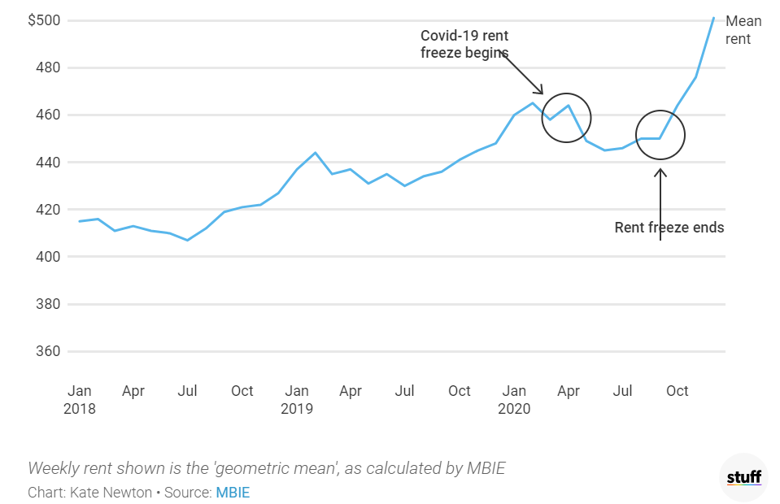
Even households with two incomes from paid employment no longer have housing security, due to rent increases. CPAG was told by one principal:
“Housing is really putting pressure on people. One family, the mother was a school teacher and the father was also in full-time work, five children, and their rent became too expensive so they ended up in a motel, and now live with her parents. I don’t know how many people are now in that house.” (Principal, Ōtepoti Dunedin)

Youth homelessness
Lockdown: Initially, following the March 2020 outbreak, young people under 18 were overlooked in the rush to house rough sleepers. While the Government swiftly moved to get rough sleepers into motels, these emergency housing providers did not have to take in people under 18 (Hendry, 28/07/20). As Aaron Hendry, Youth Housing Team Leader at Lifewise in Tāmaki Makaurau explained to CPAG:
“16- and 17-year-olds who weren’t care-experienced couldn’t access emergency accommodation, so the most vulnerable within this vulnerable group [the homeless] were excluded from support. This forced them to stay in environments where they were being sexually exploited, to continue couch surfing because they were too young to access emergency housing”.
These young people – who are usually on their own without family, often due to abuse and/or irrevocable family breakdown – are having their often-deep distress and trauma compounded by the State. This state neglect is deeply troubling.
While CPAG has not obtained statistics solely for people under 18, MSD tables show that 5340 people aged 16 to 24 accessed emergency housing grants (staying in emergency accommodation, usually motels) in 2020. Of these young people, approximately 60% are Māori, 10% Pacific and 15% Pākehā (MSD, 2021c). Access increased over lockdown (partially because criteria for Emergency Housing Grants changed to accommodate Level 4 lockdown rules): emergency housing grants for Māori young people to age 24 increased more than for other ethnicities, both in raw numbers and in percentage terms, over lockdown. Emergency housing grants increased by ~70% between March and June 2020 for Māori, and by ~60% for all ethnicities combined (48% for Pākehā and 34% for Pacific people) for 16-24 year olds. However, in the December 2020 quarter (reflecting further rule changes in October, which allowed people to have grants for three weeks rather than only one week), grant numbers were ~55% higher for both Māori and Pacific young people than in March 2020, but only 22% higher for Pākehā young people (MSD, 2021c). Again, racism within the private rental market is likely to be a factor.
Concerns re motels: With help from MSD, Lifewise worked to form relationships with some specific motels who were willing to accommodate 16- and 17-year-olds; however, as Hendry explained to CPAG, “These places aren’t guaranteed. They’re contingent on relationships with particular motels, and some issues have arisen.” In October 2020, Hendry reported that Lifewise had had nearly 120 requests for support over the previous few months from people under 18, of which they could house only four. They had had to turn away 89 and they were monitoring the rest (Corlett, 2020).
Further, without wrap-around support while living alongside vulnerable adults, young people aren’t necessarily safer in motels than on the streets – and young people report the motels are sometimes more dangerous. Reports of young people experiencing harassment, violence, abuse and exploitation in emergency accommodation facilities (Andelane, 2021) highlight the inadequacy of these facilities as a solution to youth homelessness.
Pre-Covid-19 government neglect: The Covid-19 pandemic exacerbated a pre-existing issue: the specific needs of rangatahi and young people are overlooked in responses to homelessness, despite estimates suggesting that half of the homeless population are aged under 25 (Amore, 2019). Homelessness is an issue for rainbow young people (since early 2020, Rainbow Youth in Tāmaki Makaurau has offered an Auckland Council-funded homeless support service). As Hendry and other members of the Manaaki Rangatahi collective (2020) have highlighted, young people and their housing needs have been long overlooked; Hendry explained:
“This [the lockdown blind-spot] happened because there wasn’t a strategy. We’d been working [to get a youth homelessness strategy in place] since 2018, and were told ‘not gonna happen’. The country swung into gear to provide housing and support, and young people were neglected because their voice hadn’t been at the table.”

Family homelessness and emergency housing
Housing waiting list: The number of households with children on the waiting list for social housing increased by 40% in the year to December 2020 to 9,599, representing an estimated 17,000 to 18,000 children (based on the numbers of bedrooms required). Three of every four families with children on the social housing waiting list are sole-parent families: over 7,500 sole-parent families were on the list in December 2020 (MSD, 2021b). While the need had increased in previous years – sometimes by higher percentages than in 2020 – some of the previous increases in the waiting list were most likely due to a recognition of suppressed demand, but recent increases are a symptom of rental housing shortages (Salvation Army, 2020).
Figure 9: Households incl dependent children on the social housing waiting list. (Source: MSD, 2021)

Emergency housing: There were 3885 children in emergency housing (mostly motels) in December 2020 (Coughlan, 28/04/21), with 45% of them having stayed there for more than 3 months, and 123 of them having stayed there for more than a year. By March 2021, that number had risen to 4368 children (an increase of 12% in three months) (Blake-Persen, 05/07/21). Families are having to stay longer in emergency housing, because other families are struggling to leave transitional housing. Social policy analyst Ronji Tanielu says families in Salvation Army transitional housing in Manurewa, Papakura and elsewhere are “meant to come in for 12 weeks, but often the families are staying in for 20-plus weeks because we can’t transition them from that house into a long-term housing solution so all of that means is that we’re falling behind, the need is increasing, we’re not building enough.” (Fa’afiu, 2021b)
Grave concerns have been raised about the “inhumane” state of emergency housing, which largely takes the form of motel rooms being rented by the Government at high prices. There are reports of criminal activity and intimidation, including of vulnerable families, women and children, leaving people too scared to venture out of their rooms. Concerns have been raised about families, or women leaving abusive relationships, being housed next to drug dealers (Patterson, 27/04/21).
Ramona’s story – published by RNZ in February 2021 – illustrates how families in emergency housing feel unsafe, ashamed, trapped and fearful of Work and Income – the very agency they are supposed to complain to if they feel unsafe. At the time, she and her partner and three children had been at the same motel for 11 weeks:
The family had been living in Melbourne when Covid-19 hit and with no support in Australia they decided to come home, but had no idea how hard the housing hunt would be.
"We were staying with my mother-in-law but she's also in a social housing house, which was overcrowded, so we were asked to leave and here we are."
She puts bars across her windows and her youngest isn't allowed to play outside because it doesn't feel safe. Her older kids are struggling too.
"I know for my oldest daughter she's nearly 15, she hasn't told any of her friends that she lives in emergency housing. It's hard as a mum because you feel like you've failed, my daughter is embarrassed to tell her friends the truth, but what else can you do?"
She's constantly searching for a rental while her partner works fulltime at a warehouse - but his wage isn't enough to get them into the hugely competitive market. "It's too expensive - there's too many other applicants and you feel overwhelmed but you have to do it. WINZ is telling me I have to apply for five to six houses a week and I've said to them that sometimes there's no houses within my price range and they're like - well you need to find something."
She said Work and Income had told her that if she didn't complete her obligations she would be obligated to pay the cost of the motel - which was $2800 for her family. "We've been here 11 weeks so that's over $30,000." (Blake-Persen, 18/02/21)
Tiny Deane, a housing advocate in Rotorua, told CPAG that witnessing violence is a “massive concern” for children in the motels. He has seen numbers in need increase since Covid-19, due to tourism-related job loss and rising rents leading to evictions:
“We see the families that have suffered through Covid but they were suffering before Covid as well. We are seeing the escalation of poverty.”
Other whānau, who are able to (with difficulty), are housing their whanaunga so that their loved ones, their mokopuna do not have to stay in motels and witness violence and intimidation. As one koro put it to CPAG:
“People talk about homelessness and overcrowding but they don’t talk about the families that are picking up the pieces. We’re keeping our whānau safe but we have no rights to anything [like financial assistance to help with the costs]…. I look at my auntie’s place, she’s got whānau populating her whare. At my other auntie’s place they’ve got people living in sheds. Bugger the overcrowding: it’s about the safety.”
Strategies are required to deal with the tension of living on top of one another – strategies and a lot of love and patience:
“How do we get through, living all together? Having hui is the main one, and humour. Weekly kai with the mokos. We ask them: what’s one good thing about staying here, one not so good thing about staying here, and one recommendation.”

Education
Education: What were some of the ways in which already-disadvantaged children faced the most severe effects of Covid-19?
Chronic absence
disproportionately affected children & young people in low-income communities
Covid-19 community outbreaks
disproportionately disrupted life and education for children & young people in low-income communities in South Auckland
However:
Learning from home
was most often viewed positively by Pacific secondary students in low-income communities, compared to other groups
NCEA results were good
Attainment improved for all qualifications, while the gap between low-decile and high-decile attainment shrunk for most qualifications
Schools and their staff helped their students and families
not just with learning but also in emotional and financial ways.

Attendance and Absence
Chronic absence: In low-decile schools (ie schools predominantly serving students from low-income households), chronic absence of students increased considerably in 2020 compared to 2019, while regular attendance increased only slightly. This is in contrast to trends for high-decile schools where regular attendance increased significantly in 2020 and chronic absence increased only slightly, or even decreased (Min. Ed., 2020).
Figure 10: Percentage of students with chronic absence in Term 2 by decile (source: Min. Ed., 2020)
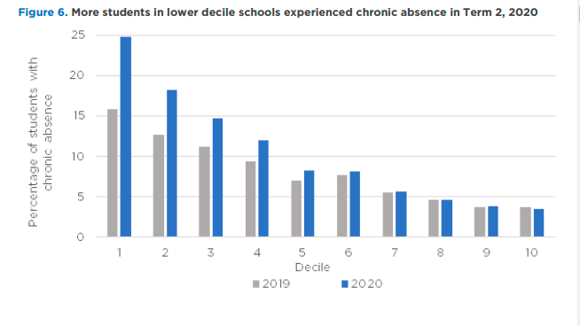
Regular attendance: Looking at regular attendance, in Term 2, 2020, decile 1 schools/kura experienced the smallest increase in the percentage of students attending school regularly compared to 2019, increasing 0.7 percentage points to 41.4%. In comparison, the percentage of students regularly attending decile 6 to 10 schools increased by 7.7 percentage points.
Figure 11: Proportion of students attending school regularly (Source: Min. Ed., 2020)
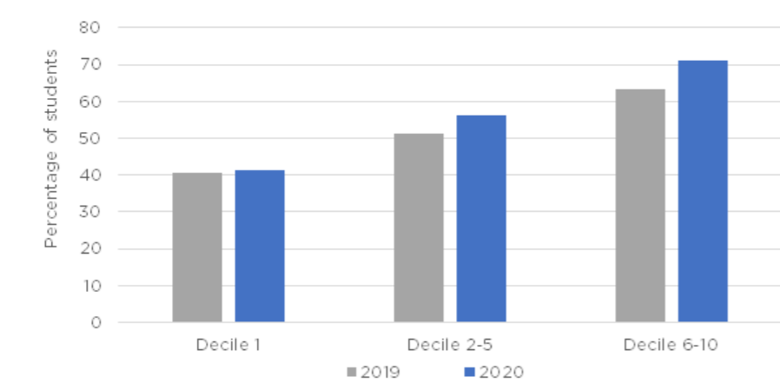
These increases in chronic absence were disproportionately experienced by Māori and Pacific students.
Figure 12: Chronic absence by ethnicity and decile (Source: Min. Ed., 2020)
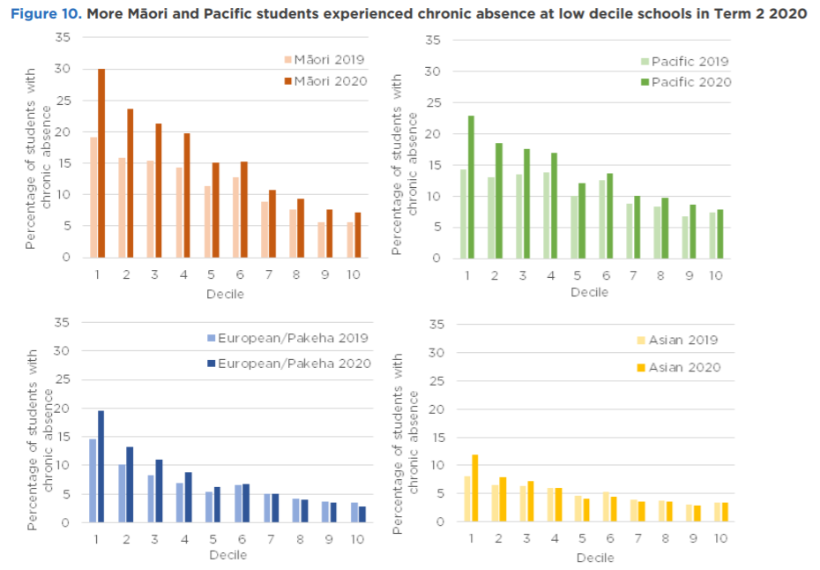
The increase in chronic absence was highest for Māori and Pacific students attending lower decile schools, with 30.1% of Māori students in decile 1 schools experiencing chronic absence in term 2, 2020 – an increase of more than a third (11 percentage points) compared to 2019. In decile 1 schools in 2019, Pacific and Pākehā students had almost the same rate of chronic absence (Pacific rates were 14.3%, Pākehā rates were slightly higher); however, in 2020, Pākehā rates increased by around five percentage points to just under 20%, while Pacific rates increased by 8.6 percentage points to almost 23%.
In Term 3, for deciles 1-3, chronic absences were still higher in 2020 than in 2019 – although the gap between 2019 and 2020 was smaller for term 3 than it was for term 2. In contrast, for deciles 4-10, chronic absence was actually lower in 2020 term 3 than it was in 2019.
Figure 13: Chronic absence in Term 3 of 2019 vs 2020 by decile (Data source: Min. Ed., 2020)
total
“The Ministry of Education will say we need better outcomes for Māori and Pacific children, and we will say, well, yes – of course. But we’re not going to get that until we address the issue of poverty.”

- Haley Milne, Principal, Kia Aroha College (quoted in Biddle, 2020)
Employment vs education: There have been reports of students leaving school in order to enter fulltime paid employment to assist financially-struggling families and whānau (1News, 2020; Quince, 2020; Fepulea'i-Tapua'i, 2020). We heard from youth workers that a widespread issue was students juggling both paid work and school at the same time. One school rugby coach at a low-decile school noticed team members were turning up to practice tired and drained because they were on night shifts before coming to school. This is not a new problem, but Covid-19 may have exacerbated it.
Compounding lockdown effects: The impact of Auckland’s second lockdown fell most heavily on low-decile schools, partially due to community outbreaks of Covid-19 being centred on border workers, many of whom lived in low-income communities. In September 2020, three-quarters of principals in low decile schools in Auckland were concerned about their students’ learning, compared to 58 percent of principals in low decile schools outside Auckland – a much greater Auckland/outside Auckland difference in concern than in mid and high decile schools (ERO, 2021b). Several South Auckland schools reported similar levels of absences after the March 2021 lockdowns as they did after earlier lockdowns – these recent lockdowns are likely to exacerbate the effect on student achievement. (Fa’afiu, 8/3/21).

NCEA attainment
For students completing a qualification in the same year as starting it (“current year” attainment), in 2020, Decile 1-3 schools combined had their best attainment rate for NCEA levels 2 & 3, and University Entrance, since records began in 2011, and the best for NCEA level 1 since 2013. Moreover, for most qualifications, the attainment rate gap closed between low and mid/high decile schools: the increase in the 2020 attainment rate compared to 2019 was bigger for low decile 1-3 schools than for mid and high decile schools for NCEA levels 1-3 (in terms of percentage points); only for University Entrance was the attainment rate increase higher for mid and high decile schools than for low decile schools. Pacific students (from all deciles) recorded particularly sizeable increases in 2020 attainment rates, compared to 2019 rates (NZQA, 2021). This coincides with the student survey showing that Pacific secondary students in decile 1-3 schools were more positive about being able to learn from home than others (see below; ERO, 2021b).
It is positive that NCEA results were assisted by a Covid-19 response: students were given the opportunity to earn an extra NCEA credit for every five they achieved, and the number of credits required for University Entrance was reduced. Without this, overall attainment rates for University Entrance and NCEA level 1 would have dropped by 8-9 percentage points; and NCEA levels 2 and 3, would have dropped by 4.5 per cent points (Wiltshire, 3/3/2021). Principals of several low decile schools in Auckland have said they were pleased with their 2020 results and/or they had improved their results on previous years (Gerritsen, 2021). Before the results came through, teachers in low decile schools were more likely to be concerned about their students falling behind than teachers in high decile schools were, with many estimating that their students who had regressed lost about a term’s worth of learning and may not be able to recover it (ERO, 2021b). Given the wide range of responses to the lockdown reported by children in the Office of the Children’s Commissioner survey (OCC 2020), we expect this concern reflects Covid-19’s range of effects on student learning rather than being misplaced.

Student perception
Pacific secondary students in decile 1-3 schools were more positive about being able to learn from home than other groups, and more often reported having someone in their household who could help them with their learning under lockdown. Pacific students and Māori (across all deciles) were also more likely to report that someone in their home had become more interested in their learning after the lockdown (ERO, 2021b)
"[My family] understand what it's like as a student to have a role at school and having to play that sibling role at home, so they just asked me to give them my schedule and so when I have any online calls, they'll just ask me to go to my room and join the online calls with my teachers." Taunese Leitufia, decile 1 Tamaki College head girl, (Fa’afiu, 2021)
Positivity about school was slightly different: when the OCC compared mid-2020 answers to 2018 baselines, high-decile students were more likely to have increased their feelings of school belonging and safety at school since 2018 than low-decile students (OCC, 2020). ERO found that some Māori and Pacific students may have encountered extra challenges related to lockdowns. As well as digital access issues (see next chapter), principals identified that “due to anxiety around health in the context of having extended family living together” some Māori and Pacific students were slower to return to school, and in some cases, there were language barriers between schools and Pacific families (ERO, 2021b).
Figure 14: Increase in agreement with the statement “I feel I belong at school” between Nov 2018-June 2020, by school level and decile (Source: OCC, 2020).

Figure 15: Increase in agreement with the statement “I feel safe at school” between Nov 2018-June 2020, by school level and decile (Source: OCC, 2020)

Digital access and exclusion
Digital access: what were some of the ways in which already-disadvantaged children faced the most severe effects of Covid-19?
Digital exclusion
was severe in some low socio-economic areas; roll-out was slow
Work and Income
access to financial support now often requires digital connection
Feeling safe online
The gap is increasing between high decile and low decile students
However:
Some determined students were able to mitigate the issue
“Access to technology needs to be seen as an essential communication and learning tool, not a luxury item for some” – OCC, 2020 Life in Lockdown report
Estimates of digital connection for children vary somewhat, partially because multiple components (most of which require financial outlay) need to be in place for access to be in place: device, wifi connection and know-how. Official estimates were that 82,000 New Zealand households “did not have any access to the internet and/or fit-for-purpose education devices” (Biddle, 16/08/21). The OCC survey (2020) found that approximately 3% of children had no access to a device with access to the internet during lockdown (which would equate to approximately 34,000 children), with another 22% indicating they had to share a device.
For many students, having to share a device with someone else could still make their learning more difficult (ERO, 2021b). Pulse Check – a non-weighted mid-2020 survey of people aged 12 to 24, 80% of whom were school students – found that 29% of respondents with a disability experienced some difficulty accessing a device or didn’t have access, as well as 27% Māori and 28% Pacific respondents. More than a third of refugee respondents (36%) experienced difficulties accessing wifi at least some of the time (MYD, 2020). These answers were from respondents participating in an online survey: exclusion and partial exclusion may be even more widespread than these answers suggest.
Lack of digital access is highly concentrated in some areas: Two thirds of low-decile school staff reported they were very aware of inequitable levels of student and whānau access to digital devices and connectivity, compared to only a third of high-decile staff (ERO, 2021b). Kia Aroha College principal Haley Milne found that 97% of her Ōtara students did not have online access (Biddle, 16/08/21). Māori and Pacific children and young people were less likely to have their own device during lockdown. Tamariki and rangatahi Māori were more likely not to have access to any device (OCC report, 2020).
In terms of feeling safe online, there was no change between 2018 and mid-2020 for low decile 1-5 students, whereas high decile 6-10 students increased their feelings of safety by 8% for primary students and 16% for secondary students (OCC report, 2020).
Responses to challenges: Teachers and community members have told CPAG that affected students also used creativity and resilience to tackle the problem: sitting outside libraries to tap into the free wi-fi, using hotspots to upload their handwritten essays for assessment, and tapping their assessments out on their phones. Children should not have to take these measures to complete basic learning tasks. Some teachers tried to bridge the communication gap with phone calls, and by creating physical learning packs:
“Some households were in rural areas with poor internet coverage. In these situations, kaiako said that they phoned parents regularly, often initiating the phone calls because some parents may not have had enough credit on their phone”. (ERO, 2021a)
The Ministry of Education distributed more than 230,000 packs of printed learning materials and more than 25,000 laptops and Chromebooks to students, and arranged for 53,000 households to have internet connected (Biddle, 16/08/21).
“Our families appreciated the resource packs as many of them did not have toys or play resources at home.” Service leader (ERO, 2021a)
Inadequate response by agencies: However, resources were slow to arrive in some areas – sometimes the areas most in need – and the Ministry of Education “admitted there had been gaps in its resourcing” (Biddle, 16/08/21). For example, with more than 500 students without a device, decile 2 Manurewa High School gave out more than 240 laptops before they received their first Ministry devices, and reported that rollout was slow. Meanwhile, the Ministry delivered $70,000 worth of modems to decile 10 Auckland Grammar School which were neither requested nor required (Chisholm, 2021).
Devices are one thing; wifi access is another necessary expense for digital access. Work and Income requires online access, but does not reimburse its costs:
“Ngaire, a Sole Parent Support recipient, however noted the irony that she was told by Work and Income that it cannot reimburse wifi costs; this was frustrating given reliable internet was necessary during lockdown to manage home schooling and stay sane, but also since many aspects of Work and Income’s service had to be accessed online.” (Humpage & Moore, 2021)
Benefits of a more digital world: For those young people who did have digital access (including those in low-income households), the increasingly online world could be a boon. For example, Rainbow Youth’s peer support team launched an online chat support service during lockdown that they are planning to continue for the foreseeable future. New people could join digital Rainbow Youth support groups no matter where they were:
“Our facilitator hui are much more accessible online – you can join in your own safe space. There are so many reasons why rainbow young people couldn’t leave the house.” – Rainbow Youth (conversation with CPAG)
As a mitigation of digital exclusion, Rainbow Youth paid for facilitator hui participants to get a wifi pack with more than enough data for the hui.

Whānau, community & friends
Whānau, community and friends: what were some of the ways in which already-disadvantaged children faced the most severe effects of Covid-19?
Loneliness
was disproportionately high, at least among adults, in low-income households
Lack of whānau/family time
Feelings of having enough time with whānau/family decreased for low-decile students
Feeling unsafe
Groups likely to be financially disadvantaged were also more likely to feel unsafe in their bubble
However:
Many children who could spend time with their family and whānau loved it

Whānau and family enjoyment: Parental activity (working longer or shorter hours) seems to have had an effect on how much students liked lockdown:
“At the focus groups, some Pacific students talked about the family support they received. One Pacific student reported that she has two younger siblings who attend primary and intermediate school. Their parents work long hours and the siblings usually do not see their father during the weekdays. She and her siblings liked the lockdown because they could ‘hang out’ with their parents at home: “We cooked together, played games, watched movies, went for walks, laughed and talanoa. It was really nice to spend time with my dad.” (ERO 2021b)
Unfortunately, surveys indicated inequities increased between low-income and high-income children in terms of feeling like they got enough time with their family/whānau: in 2020, students at high decile secondary schools were 19% more likely to agree they did get enough family/whānau time than they had been in 2018, while students at low-decile schools were 4% less likely to agree than they had been in 2018.
Figure 16: Percentage change in agreement with the statement "I get enough time with my family/whānau" late 2018 vs mid 2020 (OCC, 2020)

Increasing inequities: Unfortunately the differences in experiences between high and low decile students increased between 2018 and 2020, across a range of social perceptions, from fun, to safety to friends and whānau:
Figure 17: Percentage change in agreement between 2018 and mid 2020, for various statements, for secondary school students. (Source: OCC, 2020)

Loneliness: Inequity of loneliness also increased for the adults in children’s lives. In the June 2020 quarter, 3.8% of the total population reported feeling lonely “most/all of the time” – but for for sole parents, the rate was 11.4%, almost double what it had been for sole parents in 2018 (6.1%). An additional 23.8% of sole parents in June 2020 reported feeling lonely some of the time (compared to 15% of the total population). Rates of loneliness declined steadily throughout 2020, but remained higher than in 2018. Unemployed people, those with disabilities and those with incomes under $30,000 were also more likely than average to feel lonely all or most of the time. (Walker, 2021).
Community: in spite of potential difficulties, many low-income young people threw themselves into helping their communities and each other, throughout 2020 (Latif, 21/08/2020). For example, of the Southseas Bubblegum crew – peer support workers aged 17 to 24 in South Auckland – their coordinator told us:
“The sense of responsibility that young people in this community have, not just for their family but for the community in general – that’s something they and their community can be really proud of.”
Community leaders were concerned that Covid-exacerbated poverty and inequity, and related isolation, induced shame and stress, would make criminal gangs more attractive to young people in poverty. For example after a gun-related incident, Otara-Papatoetoe Local Board Chair Lotu Fuli said:
“We have people that are desperate and Covid-19 has made things worse for lots of our families, so they are turning to that lifestyle and gangs as alternative to get out of that poverty." (Moala &Faigaa, 23/1120)
Family violence: Those affected by physical and mental violence within the family include children in all demographics, and there is evidence to suggest that low-income children are more likely to be affected than other children. For example, distrust of authorities – often for good reason, particularly for Māori – is a barrier to receiving assistance.
The data presented below should be used with caution:
- The reported family violence statistics below are for households overall, not just those with children, and not just those which are low-income
- The correlation between family violence, and reports of family violence is unclear and may change over time.
Nationwide, the increase in reports of family violence between 2019 and 2020 was not as high than the increase between 2018 and 2019. Police believe 2018 changes in their responses to family violence are encouraging more people to come forward, so this does not mean that numbers of incidents of violence themselves grew more slowly in 2020 than in 2019 (Burrell, 17/05/21). Reports of family violence to the police were 9% higher (13,430) in 2020 compared to 2019, increasing from 151,609 to 165,039 (the previous year, the increase was 14%) (Policedata.nz, 2021). Police statistics showed a 21 per cent spike in family violence cases on the first Sunday after the lockdown started (29 March), compared with the Sunday three weeks before (Johnson, 12/04/20) and indeed, with 650 incidents reported, 29 March was the second most dangerous day in 2020, after 1 January (always the most dangerous day), in terms of family violence reports (Policedata.nz, 2021). More reported family violence incidents took place in April 2020 (under lockdown level 4) than in April 2019: the day with the fewest incidents reported in April 2019 had 271 incidents; in April 2020, the least-reported day still had 356 incidents (Policedata.nz, 2021).
Auckland, which underwent an additional 18 days of level-3 lockdown (12 August to 30 August), had a higher percentage annual increase of reported family violence incidents than the country overall: an increase of 15% (compared to 9% nationwide) or 6915 incidents from 44048 in 2019 to 50963 in 2020. (Policedata.nz, 2021)
Figure 18: Daily family violence occurrence trends, Dec 2017-2020. (Source: Policedata, 2021)
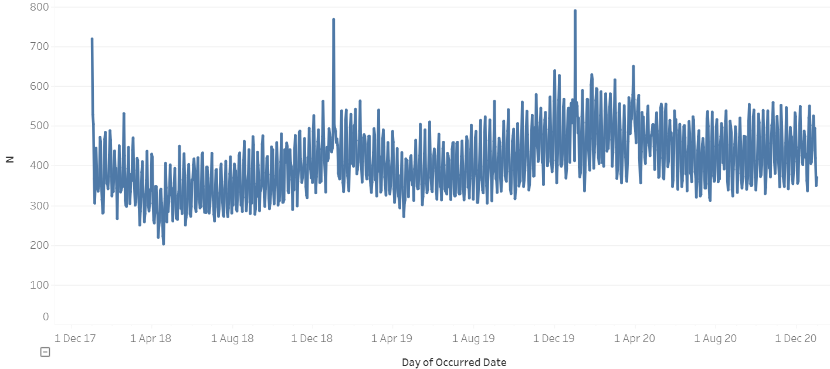
Sun 29 March
Indicators that lockdowns triggered more reports of family violence to the police dovetails with the surge in demand for Women’s Refuge services of about 30 per cent more than normal during lockdown. Refuge policy advisor Natalie Thorburn said it was likely children unable to access school would have been exposed to more violence at home than usual as
“Mothers are very good at acting protectively with children at home and manage to engineer the impacts of that violence so that those are mostly concealed while children are at school.” (Franks, 07/10/20)
Although family violence increased, the reporting of harm to other agencies went down (as it does during holidays), as schools and other community agencies did not have usual sight of children (Franks, 07/10/20). Community members still often tried to look out for vulnerable families. For example, Frank Haimona – who runs Mātātoa, a company which delivers kaupapa Māori hākinakina (sports) and pūtaiao (science) programmes in kura Kaupapa and reo Māori school units, delivered healthy kai packages to whānau during lockdown – and not just to ensure physical health:
“We all knew some kids who don’t have the best upbringing and that they might struggle. We wanted to ensure they would get to see us once or twice a week so we could see they were all still good. We’re not seen as teachers as such. We’re just the cool mātua or whaea who do all the tākaro Māori. We’d pick up on something if it was going on.” - Frank Haimona, (Dewes, 26/05/20)
While the reasons for the answers below are not stated (for example, people could be feeling unsafe due to COVID-19 or physical or mental violence, or some other reason), a concerning 19% of 15-18 year olds and 14% of 12-14 year olds (all incomes) reported feeling unsafe in their bubble during lockdown some, most or all of the time in the unweighted, young-woman-skewed Pulse Check survey. Māori, Pacific, LGBTIQ+ respondents, and respondents with disabilities were more likely than others to feel unsafe (MYD, 2020). On the other hand, the OCC (2020) survey found an inequitable difference in feelings of safety: Decile 1-5 students’ feelings of safety at home had reduced by 3% between 2018 and mid-2020, while Decile 6-10 students’ had increased by 10%.
*
In general, stresses for children and their parents increased:
The resilient Pacific PhD candidate job description: COVID-19
Must know how to
go hard and go fast
go hard or go home
Must know how to navigate
time constraints
extra caring duty constraints
cramped space constraints
vulnerable elderly parents constraints
intermittent internet constraints
on-line learning ‘instant teacher support’ for your kids’ dramas constraints
job income insecurity how you gonna pay your mortgage and bills constraints
bank statement requests to prove you’re struggling constraints
Must know how to navigate
missed time-lines
missed dead-lines
new frown-lines
fear filled head-lines
uncertain brow-lines
Must know how to
go hard and go fast
go hard or go home
- Yvonne Ualesi (in Akuhata-Huntington et al, 2020)
The article “COVID-19 and Indigenous resilience” (Akuhata-Huntington et al, 2020), which starts with the poem above, concludes with a collective poem stating:
“We found strength in each other.”

Health
Health: What were some of the ways in which already-disadvantaged children faced the most severe effects of Covid-19?
Child immunisation rates
Decreased most for the most deprived 20% of children
Rheumatic fever
Hospitalisations increased for this disease exacerbated by poor housing
Feeling fit and healthy
Inequities look like they have increased
However:
Respiratory illnesses reduced temporarily

Health issues for low-income children: A paediatrician working with mostly low-income Pacific communities told us that her impressions across the year were that children had less access to developmental screening and intervention, and less access to disability support services while more young people were being seen for self-harm and suicide attempts. Some healthcare was delayed, deferred or even not available (such as dental care).
Separately, a disability service provider told us there are reports that waitlists for child disability health support understandably increased due to lockdowns in 2020. The problem is worse in Auckland due to the multiple lockdowns.
Regarding mental health, a youth health sector worker in a low-income area told us that isolation was a huge thing for young people: “the idea of being stuck in your home, and not all homes are safe homes, so that was a trigger for some people.” There was “heightened anxiety, in terms of the unknown, and people staying, not so much on edge but being alert all the time.”
Youth suicide: Child Poverty Action Group acknowledges the mamae and pain that any suicide represents, for the victim and for whānau, friends and community.
The provisional numbers of people dying by suicide are available for the year ending June 2020 (MoJ, 2020a), which includes the initial lockdown period, although not the following nine months to March 2021 (due for release in August/September 2021). As it is still too early to know the provisional annual post Covid-19 numbers, or seek robust, evidence-based, causal explanations for their eventual levels, we report the 2019/2020 statistics (including March-June 2020) below without comment. The annual statistics are released by ethnicity and age, but not by socio-economic situation – however, research suggests that lower socio-economic situations during childhood are associated with incidents of self-harm in adolescents aged 16 to 18, particularly for those who experienced a consistently lower socio-economic situation in childhood (Page et al., 2014, cited in Gibson et al, 2017). Half of the young Māori that died from suicide 2007-2011 came from the most deprived quintile in New Zealand (Suicide Mortality Review Committee, 2016).
For the year to June 2020, overall (all ages combined) there was a small drop in suicides. It is not reported what proportion of the suicides during the year happened after the initial lockdown started, however the suicide rate during alert level 4 was lower than the rate for the same period from 2008 to 2019 (MacManus, 21/08/2020). Suicides of children under ten are not reported, but for 10-14 year olds, there were six suicides in the year to June 2020, and for 15-19 year olds, there were 59 suicides – a rate of 18.69 per 100,000 population for ages 15-19. For 15-19 year olds, the 2019/2020 number and rate are lower than for the previous year, but higher than for the June years 2014-2018. For 10-14 year olds, the June 2020 number is the lowest since 2014 (MoJ, 2020b).
Rates of suicide for Māori are particularly high due to complex interactions of multiple factors, including colonial trauma, historical trauma and the inter-generational transfer of collective suffering, as well as cumulative stressors including regular exposure to racism, daily micro-aggressions, structural violence, stereotyping and internalised oppression (Lawson-Te Aho, 2017; Pihama et al, 2017).
Tamariki Māori and rangatahi Māori aged 10 to 19 suffered 23 suicides in the June 2020 year, over a third of all suicides for this age group. This is the same number as in the June 2017 year, but lower than in 2018 and 2019 (when 30 and 35 suicides were recorded respectively) (MoJ, 2020b).
Kaupapa Māori suicide prevention research (and research into Māori health more generally) emphasises “reclaiming the healing potential of cultural sovereignty [that is], self-determination based on the positioning of Māori in a cultural frame which acknowledges ancestral descent lines and mana (authority)” (Lawson-Te Aho, 2017; see also de Lore et al, 2020, regarding tino rangatiratanga), as well as Māori approaches to trauma-informed care (Pihama et al, 2017) and “whenua as the key determinant of health and wellbeing” (Moewaka-Barnes & McCreanor, 2019).
Where to get help
- 1737 Free call or text 1737 any time for support from a trained counsellor
- Lifeline – 0800 543 354
- Youthline – 0800 376 633, free text 234 or email talk@youthline.co.nz
- Suicide Crisis Helpline – 0508 828 865 (0508 TAUTOKO)
- Kidsline – 0800 54 37 54 (0800 kidsline) for young people up to 18 years. Open 24/7.
- thelowdown.co.nz
- What's Up – 0800 942 8787 (for 5–18 year olds; afternoons/evenings)
Student perceptions: The reduced access to healthcare may have exacerbated the growing inequality in feeling fit and healthy. Inequality between high and low decile schools grew between 2018 and mid-2020, particularly for secondary school students: decile 1-5 secondary students were five percent less likely to agree with “I feel fit and healthy” in 2020 than they were in 2018, while decile 6-10 secondary students were 22 percent more likely to agree in 2020 than 2018.
Figure 19: Percentage change in agreement with the statement "I feel fit and healthy" late 2018 vs mid 2020 (Source: OCC, 2020)

Immunisations: While child immunisation rates decreased in general, timely delivery of immunisation for infants decreased the most in very low income areas (NZDep9&10) and more for tamariki Māori than for children in general (MoH, 2021). The pattern of most decrease in overall coverage affecting those in poverty holds across all age ranges – 6-months to 5 years – yet variability is quite marked by DHBs, indicating that the issue is particularly one of service delivery, and can be ameliorated within the health system. With Covid-19 stretching resources and attention in the health and vaccination sector, careful management is required to ensure we do not see resurgence in preventable diseases, particularly among children in deprived areas.
The 6-month coverage is a measure of getting the primary course in on time: after an initial lockdown drop, 6-month rates started to pick up again – but there was another drop-off in late 2020 and by March 2021, rates were the lowest they had been for at least five years. Very worryingly, the most deprived quintile rates were 12% lower in March 2021 than they had been in March 2020. The gap between most-deprived and least-deprived quintile had also widened: rates for the least-deprived quintile also dropped but only by around 4%.
Figure 20: Percentage of children fully immunised at 6 months, Jan 2016- Apr 2021 (MoH 2021) (Y axis starts at 45%); green line is most deprived quintile
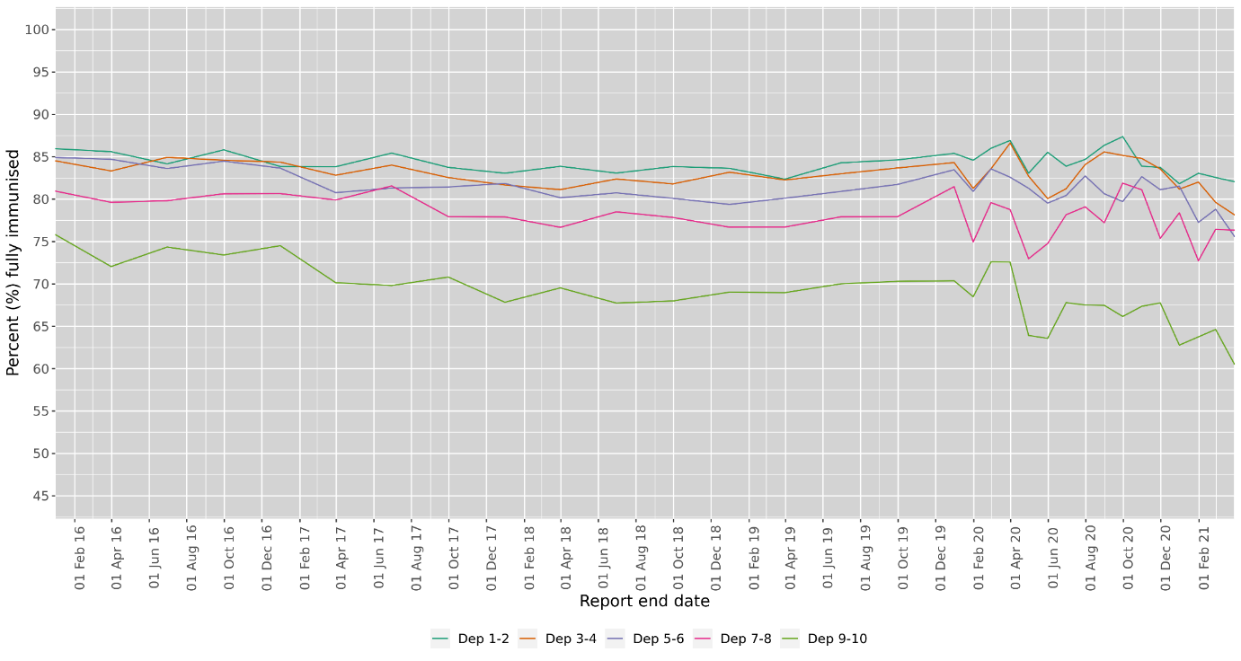
24 months is a measure of completeness of the primary course – the data here includes some ‘noise’ because there was a schedule change in 2020 which added a second visit into the second year of life, but the data still show both a drop-off and a rise in the inequity gap, with the drop-off worse for the most deprived quintile (5.3%) than for children overall (2.1%).
Figure 21: Percentage of children fully immunised at 24 months, 2020 (MoH 2021) (Y axis starts at 80%)

Hospitalisations: Hospitalisations of babies and toddlers with respiratory infections – many of which are associated with poverty – reduced during the winter of 2020 throughout New Zealand. For example, Middlemore Hospital would usually admit about 1000 under-two year olds with respiratory infections each winter; in 2020 there were fewer than 200 such admissions. The Child Poverty Monitor (Duncanson et al, 2020) identified several possible contributing factors including virus transmission being reduced due to the autumn lockdown, social distancing, increased hand hygiene and people staying home when sick, as well as border closures potentially reducing imported pathogens (see also Trenholme, 2021). (Unfortunately this effect seems to have been temporary: there is evidence of particularly high rates of hospitalisations with flu and viruses for babies in 2021 (Russell, 25/06/21))
On the other hand, hospitalisations of children with rheumatic fever increased in 2020. The Child Poverty Monitor (Duncanson et al, 2020) identified several possible contributing factors including possible household crowding, poor access to primary care and inability to have appropriate testing of sore throats.
Effects on mental wellbeing of perceived government disrespect: Not being eligible for the higher Covid-19 Income Relief Payment was perceived by those already receiving income support as a sign that the government perceived them to be of lesser worth:
“It was a kick in the gut. It — I think I’m gonna cry — it was a huge kick in the gut …. I wouldn’t begrudge [the CIRP recipients], but that was just a total kick in the gut that we were just devalued, as people. As human beings. And I really, really felt that.” [Karen, Supported Living Payment, Humpage & Moore 2021]
This blow came on top of the toxic stress of the stigma and inadequate incomes that many parents and caregivers had to deal with already, as identified by the Welfare Expert Advisory Group (2019). Being able to live with dignity has been pushed out of reach for many, for many years:
“When asked how living on benefit felt, a Sole Parent Support recipient called Josie said: “Ah. I’m gonna get emotional, [Laughter, then a pause] I try and take each day as it is [crying] only because if I didn’t, I don’t even know if I’d be here still, just cos it’s real draining, mentally [crying]. Like, I look at my kids and I’m like, I didn’t bring them into this world for them to see this ….”” [Humpage & Moore, 2021]

Conclusion and Looking Ahead
“The ultimate health aspiration of Māori is tino rangatiratanga, as set out in Te Tiriti. The ability to determine your own future. The ability to be in control of your life. Health is the ability to control your life. Health is tino rangatiratanga.”
– Dr Danny de Lore (2021)
An accountable system of public policy means the gaze is shifted. Instead of relentlessly scrutinising individual whānau, it is now the policy and decision makers who are required to demonstrate how their policies and practices are actively supporting the wellbeing of whānau
– “Precariat Māori Households Today”, Rua et al (2019)

Through bold, evidence-based policy, the New Zealand Government avoided one massive humanitarian health and economic crisis from March 2020. However, through omission and oversight, it enabled another one – that of homelessness, food insecurity and inequality – to grow rapidly, almost unchecked, for the year to March 2021. If prior to Covid-19, virtually no children had been experiencing food insecurity, and it had only been after Covid-19 hit that one in every five families sometimes or often ran out of food (an indicator of serious income inadequacy), then we expect there would have been rapid evidence-based policy response to reverse that situation. Was this endemic chronic emergency allowed to continue, just because families had already been suffering for longer? The longer the deprivation, the deeper and more long-lasting the detrimental effects on young bodies and minds.
As discussed in the introduction, officials warned in November 2020 that the effects of Covid-19 on children were likely to include “increased anxiety and mental distress, financial and family stress, increased social isolation, and long-term effects on the education and employment of young people” (Ward, 2020). The data, research and experiences that we have gathered here confirm these fears were well-founded. By the end of the first year of Covid-19, financial and family stress, isolation and educational effects were already clear, and homelessness will be affecting mostly those who were already disadvantaged – in many cases, disadvantaged by decades of government policy. The effects of the first 12 months of the pandemic are ongoing, particularly for those with fewer resources to weather the shocks. Debt interest continues to rise for those with no loan options other than fringe lenders; the RSV virus resurged in winter 2021 with record numbers of children in hospital (NZHerald, 13/07/21). Given the pandemic is also ongoing, the cumulative effects are likely to be considerable, and it is families in poverty who are both hit hardest, and have less financial resilience to recover.
In the medium term, however, there is some hope that – due to upcoming Government interventions – the crisis and further causes of distress will not grow worse, and for some families, the situation may even ameliorate a little. The Ka Ora Ka Ako food in schools programme will assist, but it is no substitute for income adequacy. In the 2021 Budget, the Government indicated future increases in benefit rates, but not at levels adequate to cover shortfalls on current rents (CPAG, 2021a), let alone on future housing costs. Child poverty forecasts published by Treasury (more conservative than CPAG’s) indicate that the Government will not meet at least one of its own self-set child poverty reduction targets, not even a year late, once the benefit increases are bedded in (Treasury, 2021). This does not bode well for the achievement of future targets, unless the Government refocuses its energy toward this flagship commitment with a clear, adequate plan. The Government’s neglect of policies addressing home rental cost increases must shoulder some of the responsibility.
In the long term, CPAG is seriously concerned about Government plans to introduce social unemployment insurance with payouts proportional to previous work income (up to a ceiling) (CPAG, 2021b). This is highly likely to repeat the human-rights problems of the Covid-19 Income Relief Payment on a grand scale, and introduce other injustices. It runs serious risks of introducing user-pays, two-tier welfare and entrenching stigmatisation of benefit recipients. Compared to a welfare system based on Welfare Expert Advisory Group (2019) recommendations – or even the current system – we expect social insurance (rejected by WEAG) would favour able-bodied Pākehā men without children, receiving above-average-pay for stable, fulltime work. It would be difficult for social insurance to avoid further disadvantaging children, women, Māori, Pacific people, people with disabilities and refugee families; te Tiriti o Waitangi would likely be breached again.
Meanwhile, although homelessness is indeed accelerating rapidly, there is little evidence that the Government is prioritising the safe care and wellbeing for families and young people who require emergency housing. Personal interventions are not enough; there needs to be systemic organisation, planning, implementation and quality control, including a specific focus on the needs of homeless rangatahi Māori and other young people.
In the background – and hardly touched on by a report focussing only on the outcomes of the first 12 months of Covid-19 – structural disadvantages are deepening with astonishing speed. The Covid-related sudden increases in wealth of the already wealthy via the little-taxed property market will entrench serious rising long-term inequity. We urge the Government to widen the income tax base with the Fair Economic Return method so that an individual’s money invested in real estate (minus any mortgages and an individual exemption) is treated as if it had been invested at the bank generating a taxable income (St John and Baucher, 2021). This would both raise revenue and slow the runaway housing market, enabling the Government to divert resources to provision of more state and social housing. This, in turn, would support the Government in its aspirations to ensure Aotearoa New Zealand is the best place in the world to grow up – for all children.
We support the growing calls to ensure rights of tamariki, rangatahi and whānau Māori. The Children’s Convention Monitoring Group (hosted by the Office of the Children’s Commissioner) (2021) is recommending centring children, and their own voices, when creating policy, particularly in emergencies and explicitly says “more work is needed to ensure the rights of tamariki and rangatahi Māori under both Te Tiriti and the Children’s Convention, are upheld, including in times of crisis.”
It’s clear the current policy-making systems let down tamariki, rangatahi and whānau Māori – all policies need to “actively support the wellbeing of whānau”, not just some. As Dr Danny de Lore (2021) put it at CPAG’s 2021 post-budget breakfast, regarding all decision-making: “We should keep talking about the continual active process that is colonisation and the role that privilege, so often invisible to those who enjoy it, plays in our society.” Regarding the current benefit system, Lady Tureiti Moxon is explicitly calling for tino rangatiratanga, stating “The only way we can change the whole [welfare] system is by allowing Māori to take care of themselves and by sharing resources by splitting it 50-50.” She has filed a case with the Waitangi Tribunal on behalf of the National Māori Urban Authority (Te Wake, 1/04/2021), for which CPAG contributed evidence early in 2021.
Further disasters will come – will the State learn the lessons from this one, and ensure whānau Māori, and families with dependent children are not left in the cold?
Māori thought leaders have generously offered principles from te ao Māori to guide the Government, including via the WEAG (2019), which recommended foundational Māori principles for the Social Security Act. In other examples, in May 2020, Laura O’Connell-Rapira outlined four values for government decision-making (listed below), and earlier, in 2019, a multi-discipline team of researchers stated:
it is critically important that our overarching paradigm, service delivery frameworks and whānau outcomes are founded upon core Māori values… Frameworks founded upon and driven by Māori cultural principles that prioritise care, relationship, unity, service and kindness can act as a starting point for the structural shifts necessary for addressing inequity, which in turn open up significant possibilities for whānau. These principles become the signposts, markers and indicators of healthy public policy. An accountable system of public policy means the gaze is shifted. Instead of relentlessly scrutinising individual whānau, it is now the policy and decision makers who are required to demonstrate how their policies and practices are actively supporting the wellbeing of whānau. (Rua et al, 2019)
Values for government decision-making
Whakapapa
Ensuring all decisions work for Papatūānuku and all the generations to come
Rangatiratanga
Ensuring whānau, hapū and iwi have the decision-making power and resources to look after all their members
Manaakitanga
Uplifting people’s mana
Kotahitanga
Bridge building; bringing people together
(paraphrased from
O’Connell-Rapira, 2020)

Principles to address inequity via service delivery frameworks
Manaakitanga
caring relationships
Whanaungatanga
engaged relationships
Kotahitanga
unity through consensus
Whakaiti
service to others with humility
Hūmārie
act with gentleness and kindness
(Rua et al, 2019)

Finally, we leave you with the vision of 4TK (4 Tha Kulture), a South Auckland-based indigenous environmentalist group of young people who are committed to advocating against climate change – another disaster waiting in the wings – through a lens that considers minorities, as reported by thecoconet.tv (2020):
“It’s important for our Pacific and wider community to understand how COVID-19 and climate change are directly related, the future of our people depends on it.” Says 17-year-old South Auckland 4 Tha Kulture (4TK) Organiser Aigagalefili Fepulea’i-Tapua’i.
….4 Tha Kulture’s new demand… [is] for a Green COVID-19 Response. They demand that, as Aotearoa now begins to offset the economic impacts of COVID-19, the Government must invest in building a renewable and regenerative economy. This must be done through meaningful partnerships with communities, Tangata Whenua and Pasifika, and youth to ensure a just transition and that no one is left behind.

Reference list
1News (2020). Too many students forced to leave school as 'act of sacrifice and love' for families - head girl. TVNZ 26/08/20. https://www.tvnz.co.nz/one-news/new-zealand/too-many-students-forced-leave-school-act-sacrifice-and-love-families-head-girl
Akuhata-Huntington, Z. (Ngāti Tūwharetoa, Tūhoe, Ngāi Te Rangi, Ngāti Kahungunu ki Te Wairoa), Foster, S. (D’harawal Saltwater Knowledge Keeper), Gillon, A. (Ngāti Awa), Merito, M. (Ngāti Pikiao, Ngāti Whakaeu, Ngāti Awa), Oliver, L. (Gomeroi Nation), Parata, N. (Ngāti Toa Rangatira, Ngāti Ruanui, Ngāti Kahungunu, Rongowhakaata), Ualesi, Y. (Mulivai Safata, Pu’apu’a, Savalalo Samoa, Fakaofo Tokelau, Ovalau Fiji) & Naepi, S. (Natasiri) (2020) COVID-19 and Indigenous resilience, Higher Education Research & Development, 39:7, 1377-1383, https://www.tandfonline.com/doi/full/10.1080/07294360.2020.1823327
Belong Aotearoa (2020). Migrant Experiences in the Time of Covid: Survey Report 2020. https://static1.squarespace.com/static/5cca54599e483d0001fff53b/t/6036e88e787d37136315aa1e/1614211227802/Migrant+Experiences+in+the+time+of+COVID_Belong+Aotearoa+Survey+Report+2020.pdf
Biddle, D. (2020). The Covid Diaries: Kia Aroha College, the students forgotten during lockdown.
Stuff 16/08/20. https://www.stuff.co.nz/national/122188758/the-covid-diaries-kia-aroha-college-the-students-forgotten-during-lockdown
Blake-Persen, N. (2021a). Housing crisis: More than 4,000 NZ children living in motels. 18/02/21. RNZ. https://www.rnz.co.nz/national/programmes/checkpoint/audio/2018784185/housing-crisis-more-than-4-000-nz-children-living-in-motels
Blake-Persen, N. (2021b). NZ children living in motels reaches record high. 5/7/21. RNZ. https://www.rnz.co.nz/national/programmes/checkpoint/audio/2018802675/nz-children-living-in-motels-reaches-record-high
Burrell, M. (2021) Family violence investigations soar: Abuse survivor urges victims to call police. NZ Herald 17/05/21. https://www.nzherald.co.nz/nz/family-violence-investigations-soar-abuse-survivor-urges-victims-to-call-police/EUSDDYYOPD7DVTYQOC5YWZ675Q/
Cardwell, H. (2020). ‘Unfair outcomes’ for Māori seeking Covid income support. RNZ 3/11/20.
https://www.rnz.co.nz/news/te-manu-korihi/429746/unfair-outcomes-for-maori-seeking-covid-income-support
Children’s Convention Monitoring Group (2021). Getting It Right Children’s Rights In The Covid-19 Response. Children’s Convention Monitoring Group.
https://www.occ.org.nz/assets/Uploads/CMG-2021-Pages.pdf
Chisholm, D. (2021). Sugar Rush: How Covid-19 exacerbated inequality in Auckland. Metro: Autumn 2021. https://www.metromag.co.nz/society/society-society/sugar-rush-how-covid-19-exacerbated-inequality-in-auckland
Clark, T.C., Drayton, B., Ball, J., Schwenke, A., Crengle, S., Peiris-John, R., Sutcliffe, K., Fenaughty, J., Groot, S., & Fleming, T. (2021). Youth19 Housing Deprivation Brief. University of Auckland & Victoria University of Wellington, NZ. https://static1.squarespace.com/static/5bdbb75ccef37259122e59aa/t/60b5f75cbe5ecf21b37bb414/1622538079252/Youth19-housing-deprivation-brief-FINAL.pdf
Coughlan, T. (2021a). Emergency housing costs weigh on Government books, costing hundres of millions a year. Stuff. 28/04/21. https://www.stuff.co.nz/national/politics/300287391/emergency-housing-costs-weigh-on-government-books-costing-hundreds-of-millions-a-year
Coughlan, T. (2021b). Government marking its own homework on housing. Stuff. 02/06/21.
https://www.stuff.co.nz/national/politics/300322441/government-marking-its-own-homework-on-housing
CPAG – Child Poverty Action Group (2021a). Budget Summary: Income support rises welcome but not liveable or transformational. Child Poverty Action Group. https://www.cpag.org.nz/assets/CPAG-Budget-2021-Analysis-Summary-Amended.pdf
CPAG – Child Poverty Action Group (2021b). Social Unemployment Insurance: Concerns From Equity And Anti-Poverty Perspectives. Child Poverty Action Group. https://www.cpag.org.nz/assets/CPAG_social_insurance_concerns_regarding_inequity_and_poverty_web.pdf
Davison, I. (2020). Covid-19 coronavirus: Some single parents faring badly under lockdown, Salvation Army says. NZ Herald 09/08/20. https://www.nzherald.co.nz/nz/covid-19-coronavirus-some-single-parents-faring-badly-under-lockdown-salvation-army-says/BW5WX4XZNLJXURKPAQICSKTMSU/
de Lore, D. (2021). "Health is the ability to control your life. Health is tino rangatiratanga." Presentation CPAG Post-Budget Brunch (Auckland) 21/05/21. Child Poverty Action Group. https://www.cpag.org.nz/resources/presentations/dr-danny-de-lore-health-is-the-ability-to/
de Lore, D., Asher, I., Edmonds, L., Francis, J., Hawkins, S., Kennedy, N., Moore, G., Robson, A. & Wilson, B. (2020). Indigenous child health in Australia and Aotearoa New Zealand. Royal Australasian College of Physicians (RACP). https://www.racp.edu.au/docs/default-source/advocacy-library/indigenous-ch-statement-on-ich.pdf
Dewes, T. (2020). Helping communities recover from the effects of Covid-19. Te Ao Māori News
26/05/20. https://www.teaomaori.news/helping-communities-recover-effects-covid-19
DPMC, Department of the Prime Minister & Cabinet (2021). Child Poverty Related Indicators Report (2019-20). Child Poverty Unit, Child Wellbeing Unit. https://dpmc.govt.nz/publications/child-poverty-related-indicators-report-2019-20
DPMC, Department of the Prime Minister and Cabinet (2019). Child and Youth Wellbeing Strategy 2019. Retrieved from https://childyouthwellbeing.govt.nz/sites/default/files/2019-08/child-youth-wellbeing-strategy-2019.pdf
Duncanson, M., Richardson, G., Oben, G., Wicken, A., van Asten, H., and Adams, J. (2020). Child Poverty Monitor 2020. New Zealand Child and Youth Epidemiology Service, University of Otago, Dunedin. Retrieved from http://www.nzchildren.co.nz/
Education Review Office (2021a). Learning in a Covid-19 World: The Impact of Covid-19 on Early Childhood Education. https://ero.govt.nz/our-research/learning-in-a-covid-19-world-the-impact-of-covid-19-on-early-childhood-education
Education Review Office (2021b). Learning in a Covid-19 World: The Impact of Covid-19 on Schools. https://ero.govt.nz/our-research/learning-in-a-covid-19-world-the-impact-of-covid-19-on-schools
Fa’afiu, E. (2021). South Auckland schools struggle with attendance and learning after fourth lockdown. Pacific Media Network 08/03/21. https://pacificmedianetwork.com/articles/south-auckland-schools-struggle-with-attendance-and-learning-after-fourth-lockdown
Fa’afiu, E. (2021b). Pasifika caught up in 'vicious housing cycle'. Pacific Media Network
15/01/21. https://pmn.co.nz/articles/pasifika-caught-up-in-vicious-housing-cycle
Fepulea'i-Tapua'i, A (2020). Aigagalefili Fepulea'i-Tapua'i: Speaking up for South Auckland students.
03/10/20. Saturday Morning, RNZ. Retrieved from: https://www.rnz.co.nz/national/programmes/saturday/audio/2018766737/aigagalefili-fepulea-i-tapua-i-speaking-up-for-south-auckland-students
Foneska, D. & Newton, K. (2021). Rents soar after Covid-19 freeze ends. Stuff 27/01/2021. https://www.stuff.co.nz/life-style/homed/renting/124052014/rents-soar-after-covid19-freeze-ends
Franks, J. (2020a). Coronavirus: Demand for food banks double pre-Covid levels, and still growing.
Stuff 18/07/20. https://www.stuff.co.nz/national/122093506/coronavirus-demand-for-food-banks-double-precovid-levels-and-still-growing
Franks, J. (2020b) Covid-19: Family violence spiked after news of level 4 lockdown, new data shows. Stuff 7/10/20. https://www.stuff.co.nz/national/health/coronavirus/300126009/covid19-family-violence-spiked-after-news-of-level-4-lockdown-new-data-shows
Franks, J. (2021). Covid-19: Food banks brace for ‘flood’ of demand in Auckland’s fourth lockdown.
Stuff 02/03/21. https://www.stuff.co.nz/national/health/coronavirus/124391525/covid19-food-banks-brace-for-flood-of-demand-in-aucklands-fourth-lockdown
Frischknecht, D. (2020). Evidence Brief: The impacts of COVID-19 on one-off hardship assistance.
Ministry of Social Development. https://www.msd.govt.nz/documents/about-msd-and-our-work/publications-resources/statistics/covid-19/the-impacts-of-covid-19-on-one-off-hardship-assistance.pdf
Galicki, C. (2020). Impact of the covid-19 crisis on financial wellbeing in New Zealand: Preliminary data from an international study. Presentation for National Strategy for Financial Capability partners, 20/05/ 2020. Commission for Financial Capability. Retrieved from: https://cffc-assets-prod.s3.ap-southeast-2.amazonaws.com/public/Uploads/Research-2020%2B/COVID-19/CFFC-COVID-19-research-slides-detailed.pdf
Gerritsen, J. (2021). NCEA results ‘some of the best’ despite pandemic – principals. RNZ 22/01/21.
https://www.rnz.co.nz/news/national/434955/ncea-results-some-of-the-best-despite-pandemic-principals
Gibson, K., Abraham, Q., Asher, I., Black, R., Turner, N., Waitoki, W., & McMillan, N. (2017). Child poverty and mental health: A literature review (Commissioned for New Zealand Psychological Society and Child Poverty Action Group).
https://researchcommons.waikato.ac.nz/bitstream/handle/10289/11484/170516%20CPAGChildPovertyandMentalHealthreport-CS6_WEB.pdf?sequence=2
Good, G. & Lee, J. (2021) Parenting during a pandemic 2: Emerging from our bubbles. What professionals did that worked. What didn’t work. What needs to change. Massey University presentation at Michigan AER annual conference.
Hendry, A. (2020). “Without access to emergency housing, our young homeless are left out in the cold”. The Spinoff, 28/07/20. Retrieved from https://thespinoff.co.nz/society/28-07-2020/without-access-to-emergency-housing-our-young-homeless-are-left-out-in-the-cold/
Hickey, B. (2021). “How hope for a generation was lost”. The Spinoff, 25/06/21.
https://thespinoff.co.nz/business/25-06-2021/bernard-hickey-how-hope-for-a-generation-was-lost/
Hipkins, C. (2021). Hundreds more schools join free lunch programme. NZ Government.
https://www.beehive.govt.nz/release/hundreds-more-schools-join-free-lunches-programme
Humpage, L. and Moore, C. (2021). Income in the wake of Covid-19: interviews. The University of Auckland, Child Poverty Action Group, Auckland Action Against Poverty and First Union. Retrieved from https://www.cpag.org.nz/assets/Covid-19%2520INTERVIEW%2520report%2520FINAL%252012%2520April%25202021.docx%2520%25281%2529.pdf
Johnston, K. (2020). Covid 19 coronavirus: Domestic violence is the second, silent epidemic amid lockdown. NZ Herald 12/04/20. https://www.nzherald.co.nz/nz/covid-19-coronavirus-domestic-violence-is-the-second-silent-epidemic-amid-lockdown/5ZUPUGT2MBITLISTC4RVGOCK24/
Kronast, H. (2020). Coronavirus: Foodbank demand soars during COVID-19 pandemic.
Newshub 06/04/20. https://www.newshub.co.nz/home/new-zealand/2020/04/coronavirus-foodbank-demand-soars-during-covid-19-pandemic.html
Latif, J. (2020). How South Auckland youth are helping each other through the stress of Covid. The Spinoff 21/08/20. https://thespinoff.co.nz/society/21-08-2020/how-south-auckland-youth-are-helping-each-other-through-the-stress-of-covid/
Lawson-Te Aho, K. (2017). The case for re-framing Māori suicide prevention research in Aotearoa/New Zealand: Applying lessons from indigenous suicide prevention research. Journal of Indigenous Research, 6(1), 1-16.
Leahy, H. (2020.) “#Manaaki!20: A Te Waipounamu response to COVID–19” in McClintock, K. & Boulton, A. (Eds) (2020). Ko tōku ara rā Aotearoa, Our Journey, New Zealand COVID19 2020. Te Kīwai Rangahau, Te Rau Ora & Whakauae Research Centre, Aotearoa, New Zealand. https://terauora.com/wp-content/uploads/2020/11/Ko_toku_ara_ra_18_11_20_FINAL_Interactive.pdf
Loren, A. (2021). “Family to be deported after wrongly claiming food vouchers during Covid-19 lockdown.” Stuff 16/03/21. https://www.stuff.co.nz/national/crime/124546633/family-to-be-deported-after-wrongly-claiming-food-vouchers-during-covid19-lockdown
MacManus, J. (2020). Suicide rate shows slight drop after record-high year. Stuff 21/08/20.
https://www.stuff.co.nz/national/122519593/suicide-rate-shows-slight-drop-after-recordhigh-year
Malatest International (2021). Ngā take o nga wheako o te kaikiri ki ngā manene o Aotearoa. Drivers of migrant New Zealanders' experriences of racism. Wellington: New Zealand Human Rights Commission. Retrieved from http://www.communityresearch.org.nz/research/nga-take-o-nga-wheako-o-te-kaikiri-ki-nga-manene-o-aotearoa-drivers-of-migrant-new-zealanders-experiences-of-racism/
McAllister, J. (2020). Sheltering our children from COVID-19 fallout: New Zealand must raise incomes for the financially vulnerable instead of cutting their incomes on 1 October2020 as planned.
Child Poverty Action Group. Retrieved from https://www.cpag.org.nz/assets/Sheltering%20Our%20Children%20from%20COVID19%20Fallout%2028%20Aug.pdf
McClintock, K. & Boulton, A., (Eds.) (2020). Ko tōku ara rā Aotearoa, Our Journey, New Zealand COVID19 2020. Te Kīwai Rangahau, Te Rau Ora & Whakauae Research Centre: Aotearoa, New Zealand https://terauora.com/wp-content/uploads/2020/11/Ko_toku_ara_ra_18_11_20_FINAL_Interactive.pdf
McKenzie, P. (2020) NZ’s Perverse Ethnic Wealth Gap. Newsroom.co.nz 27 July 2020. https://www.newsroom.co.nz/pete-mckenzie-on-the-ethnic-wealth-gap
Min.Ed. Ministry of Education (2020). Education Indicator: Student Engagement/Participation. Retrieved from Students/ākonga attending school/kura regularly (educationcounts.govt.nz)
MoH, Ministry of Health (2021). National and DHB immunisation data. Retrieved from https://www.health.govt.nz/our-work/preventative-health-wellness/immunisation/immunisation-coverage/national-and-dhb-immunisation-data
MoJ, Ministry of Justice (2020a). Annual provisional suicide statistics for deaths reported to
the Coroner between 1 July 2007 and 30 June 2020. https://coronialservices.justice.govt.nz/assets/Documents/Publications/2020-Annual-Provisional-Suicide-Statistics.pdf
MoJ, Ministry of Justice (2020b). Annual Suicide Statistics Since 2011. Retrieved from: https://coronialservices.justice.govt.nz/suicide/annual-suicide-statistics-since-2011/
MSD, Ministry of Social Development (2020a). April 2020 monthly benefit data table. Retrieved from https://www.msd.govt.nz/about-msd-and-our-work/publications-resources/statistics/monthly-reporting/archive/
MSD, Ministry of Social Development (2020b). 08/10/2020 - Request data on the number of hardship grants given to people from 1/3/2020 - October broken down by Income Relief Payments, Jobseeker, Supported Living Payments and all other Benefits (data). OIA response. Retrieved from: https://www.msd.govt.nz/about-msd-and-our-work/publications-resources/official-information-responses/2020/responses-to-oia-requests-october-2020.html
MSD, Ministry of Social Development (2020c). 01/12/2020 - Request for all correspondence provided to the Minister about COVID income relief payments and the benefit levels for people becoming unemployed due to COVID from Nov 2019 – Current OIA response.
https://www.msd.govt.nz/documents/about-msd-and-our-work/publications-resources/official-information-responses/2020/december/20201201-request-for-correspondence-provided-to-the-minister-about-covid-income-relief-payments-and-the-benefit-levels-for-people-becoming-unemployed.pdf
MSD, Ministry of Social Development (2021a). Benefit Fact Sheets. Retrieved from
https://www.msd.govt.nz/about-msd-and-our-work/publications-resources/statistics/benefit/index.html
MSD, Ministry of Social Development (2021b). Housing Register. Retrieved from
https://www.msd.govt.nz/about-msd-and-our-work/publications-resources/statistics/housing/index.html
MSD, Ministry of Social Development (2021c). 03/05/2021 - Request to know the month to month
cost to MSD and number of distinct clients aged 16-24 receiving EHSNG from Jan 1 to Dec 31
2021 (data). OIA response. https://www.msd.govt.nz/about-msd-and-our-work/publications-resources/official-information-responses/2021/responses-to-oia-requests-may-2021.html
MSD, Ministry of Social Development (n.d.) Covid-19 Evidence [landing page].
https://www.msd.govt.nz/about-msd-and-our-work/publications-resources/statistics/covid-19/covid-19-evidence.html#TheImpactofCOVID19ononeoffhardshipassistancegrants5
MYD, Ministry of Youth Development (2020).Youth Pulse Check Survey. https://www.myd.govt.nz/documents/young-people/youth-voice/final-youth-pulse-check-survey-slides.pdf
Moala, R. & Faigaa, P. (2020). Armed Police Presence in Otara Following Gang-Related Shootings. Pacific Media Network 23/11/20. https://pmn.co.nz/articles/armed-police-presence-in-otara-following-gang-related-shootings-
Moewaka Barnes, H., & McCreanor, T. (2019). Colonisation, hauora and whenua in Aotearoa. Journal of the Royal Society of New Zealand, 49(sup1), 19-33.
Neuwelt-Kearns, C., & Asher, I. (2020). What happened to ‘welfare overhaul’? Child Poverty Action Group: Auckland. Retrieved from www.cpag.org.nz/publications
Neuwelt-Kearns, C., Murray, S., Russell, J. & Lee, J. (2020). ‘Living well’? Children with disability need far greater income support in Aotearoa. Child Poverty Action Group: Auckland. Retrieved from www.cpag.org.nz/publications
NZ Govt (2019). Child and Youth Wellbeing Strategy. Department of the Prime Minister and Cabinet (DPMC). https://childyouthwellbeing.govt.nz/sites/default/files/2019-08/child-youth-wellbeing-strategy-2019.pdf
NZ Govt (2020). Supporting our people as we rebuild the economy. 14/05/20.
https://www.beehive.govt.nz/release/supporting-our-people-we-rebuild-economy
NZHerald (2021). RSV virus outbreak: 'Record-breaking' numbers flock to after hours and emergency departments as winter illness takes hold. NZHerald 13/07/21 https://www.nzherald.co.nz/nz/rsv-virus-outbreak-record-breaking-numbers-flock-to-after-hours-and-emergency-departments-as-winter-illness-takes-hold/BJJUXWTB4INJIZZZDIQYEWQMCY/
NZQA (2021). Secondary Statistics Consolidated Data Files for 2020.
https://www.nzqa.govt.nz/studying-in-new-zealand/secondary-school-and-ncea/find-information-about-a-school/secondary-school-statistics/data-files-for-4/
O’Connell-Rapira, L. (2020). Kōrero with Laura O’Connell-Rapira. Online presentation, Auckland Women’s Centre, May 2020. https://awc.org.nz/korero-with-laura-oconnell-rapira/
Office of the Children’s Commissioner (2020). Life in Lockdown: Children and young people’s views on the nationwide COVID-19 level 3 and 4 lockdown between March and May 2020.
https://www.occ.org.nz/assets/Uploads/LifeinLockdown-OCC-Nov2020.pdf
Pasifika Futures (2020). Covid-19 Support Packages received by over 1000 Pacific families in NZ, with more to come. http://pacifichealth.org.nz/covid-19-support-packages-received-by-over-1000-pacific-families-in-nz-with-more-to-come/
Patterson, J. (2021). 'Inhumane conditions': Green Party minister condemns some emergency housing. RNZ 24/4/21. https://www.rnz.co.nz/news/top/441256/inhumane-conditions-green-party-minister-condemns-some-emergency-housing
Pihama, L., Smith, L. T., Evans-Campbell, T., Kohu-Morgan, H., Cameron, N., Mataki, T., Te Nana, R., Skipper, H. & Southey, K. (2017). Investigating Māori approaches to trauma informed care. Journal of Indigenous Wellbeing, 2(3), pp. 18-31.
Policedata.nz New Zealand Police (2021). Daily Occurrences of Crime and Family Violence Investigations. https://www.police.govt.nz/about-us/statistics-and-publications/data-and-statistics/daily-occurrences-crime
PHA Public Health Association (2016). Inequality and Health Policy statement. Public Health Assoc. https://www.pha.org.nz/resources/Documents/PHA%20policy%20statement%20%20Inequality.pdf
Prickett, K., Fletcher, M., Chapple, S., Doan, N. & Smith, C. (2020). Life in lockdown: The economic and social effect of lockdown during Alert Level 4 in New Zealand. Wellington, New Zealand:
Victoria University of Wellington. Retrieved from https://www.wgtn.ac.nz/__data/assets/pdf_file/0010/1865512/WP-20-03-covid-19-life-in-lockdown.pdf
Quince, K. (2020). Coronavirus: Covid inequities are showing up in school leaver figures.
Stuff 22/08/20. https://www.stuff.co.nz/national/education/122517212/coronavirus-covid-inequities-are-showing-up-in-school-leaver-figures
Robson, S. (2020a). ‘It’s Christmas on steroids’ – foodbanks in huge demand across NZ. RNZ
22/04/20. https://www.rnz.co.nz/news/national/414809/it-s-christmas-on-steroids-foodbanks-in-huge-demand-across-nz
Robson, S. (2020b). More than $13 billion paid out under government's wage subsidy scheme. RNZ
25/07/20. https://www.rnz.co.nz/news/political/421993/more-than-13-billion-paid-out-under-government-s-wage-subsidy-scheme
Rua, M., Hodgetts, D., Stolte, O., King, D., Cochrane, B., Stubbs, T., Karapu, R., Neha, E., Chamberlain, K., Te Whetu, T., Te Awekotuku, N., Harr, J., Groot, S., (2019). Precariat Maori Households Today (Te Arotahi Series Paper, May 2019 No. 02). Auckland: N.Z. Ngā Pae o te Māramatanga New Zealand’s Māori Centre of Research Excellence.
http://www.maramatanga.ac.nz/sites/default/files/teArotahi_19-0502%20Rua.pdf
Russell, E. (2021) Winter illnesses surge: Babies with burning temperatures forced to wait on hospital floor. NZ Herald 26/06/21. https://www.nzherald.co.nz/nz/winter-illnesses-surge-babies-with-burning-temperatures-forced-to-wait-on-hospital-floor/UBCSFIXR5UTKJBETXTJOQAQDQY/
St John, S. and Baucher, T (2021). The Fair Economic Return: Restoring equity to the social fabric of New Zealand. RPRC working paper 2021-1 30th June. https://cdn.auckland.ac.nz/assets/business/about/our-research/research-institutes-and-centres/RPRC/publications/WP%202021-1%20Fair%20Economic%20Return%20St%20John%20and%20Baucher.pdf
Stats NZ (2019). Wellbeing Statistics 2014-18 (time series). Retrieved from: https://www.stats.govt.nz/information-releases/wellbeing-statistics-2018
Stats NZ (2020). Almost 1 in 9 people live in a crowded house. 22/04/20.
https://www.stats.govt.nz/news/almost-1-in-9-people-live-in-a-crowded-house
Stats NZ (2021a). Annual inflation almost three times higher for beneficiaries. 05/02/21.
https://www.stats.govt.nz/news/annual-inflation-almost-three-times-higher-for-beneficiaries
Stats NZ (2021b). Transport prices drive up quarterly inflation for all household groups. 03/05/21.
https://www.stats.govt.nz/news/transport-prices-drive-up-quarterly-inflation-for-all-household-groups
Stats NZ (2021c).Household Labour Force Survey. Retrieved from https://www.stats.govt.nz/topics/labour-market
Stats NZ (2021d). Measuring Child Poverty: Concepts and Definitions. https://www.stats.govt.nz/methods/measuring-child-poverty-concepts-and-definitions
Stats NZ (2021e). Child Poverty Statistics: Year Ended June 2020 – corrected https://www.stats.govt.nz/information-releases/child-poverty-statistics-year-ended-june-2020
Stats NZ (2021f). Wellbeing Statistics March 2021 quarter. Retrieved from: https://www.stats.govt.nz/information-releases/wellbeing-statistics-march-2021-quarter
Suicide Mortality Review Committee (2016) Ngā Rāhui Hau Kura, Suicide Mortality Review Committee Feasibility Study 2014-15. The Health Quality & Safety Commission, Wellington. https://www.hqsc.govt.nz/assets/SUMRC/PR/SuMRC-full-report-May-2016.pdf
Taylor, P (2020). New Zealand house prices soar despite Covid recession, worsening affordability crisis. Guardian 29/10/20. https://www.theguardian.com/world/2020/oct/29/new-zealand-house-prices-soar-despite-covid-recession-worsening-affordability-crisis
Te Pūtahitanga o Te Waipounamu (2020). Te Pūtahitanga o Te Waipounamu Annual Report: 1 July 2019 to 30 June 2020. https://static1.squarespace.com/static/548669c2e4b0e9c86a08b3ca/t/5fd2ca2f61e42a1f6ca7c5e6/1607649895622/Annual+Report+2020+2021+Print+File+%281%29.pdf
Te Raki, H. (2020). Future Ready or Shovel Ready? Tokona Te Raki, Māori Futures Collective. http://www.maorifutures.co.nz/future-ready-or-shovel-ready/
Te Wake, W. (2021). Great dames set their sights on social welfare ministry. Te Ao Māori News.
1/04/21. https://www.teaomaori.news/great-dames-set-their-sights-on-social-welfare-ministry
thecoconet.tv (2021). Blog: 4TK - 4 Tha Kulture; South Auckland Youth Changing the World.
https://www.thecoconet.tv/coco-talanoa/blog/4tk-4-tha-kulture-south-auckland-youth-changing/
Theunissen, M. (2020). Thousands of Aucklanders turning to food banks. RNZ 20/08/20. https://www.rnz.co.nz/news/national/423952/thousands-of-aucklanders-turning-to-food-banks
Te Arawhiti (n.d). COVID-19 Response Plans. Webpage. https://www.tearawhiti.govt.nz/support-for-iwi-on-covid-19/covid-19-response-plans/
Treacher, A. (2020). Ngāti Kahungunu make special Easter deliveries to lift whānau spirits. Te Ao Māori News 11/04/20. https://www.teaomaori.news/ngati-kahungunu-make-special-easter-deliveries-lift-whanauspirits

Treasury (2021). What does this mean for our goals of reducing child poverty? Child Poverty Report 2021. https://budget.govt.nz/budget/2021/wellbeing/child-poverty-report/goals-reducing-child-poverty.htm
Trenholme, A. (2021). “Understanding Respiratory Synctical Virus”. Better Breathing: Autumn 2021, p.4. Retrieved from: https://www.asthmafoundation.org.nz/our-work/better-breathing-magazine/better-breathing-archive
Waitangi Tribunal (2019). Hauora: report on stage one of the Health Services and Outcomes Kaupapa Inquiry WAI 2575. Waitangi Tribunal: Wellington. https://forms.justice.govt.nz/search/Documents/WT/wt_DOC_152801817/Hauora%20W.pdf
Walker, H. (2021). Still Alone Together: How loneliness changed in Aotearoa New Zealand in 2020 and what it means for public policy. Post Pandemic Futures Series: IV. Helen Clark Foundation: NZ. https://drive.google.com/file/d/1KAJoLNdE4EQgGfQfZYHvKhrff1pII8UP/view
Ward, C. (2020). Briefing to the Incoming Minister for Child Poverty Reduction. Department of the Prime Minster and Cabinet. https://dpmc.govt.nz/sites/default/files/2020-12/bim-2020-childpoverty-4317593.pdf
Welfare Expert Advisory Group (2019). Whakamana Tāngata: Restoring Dignity to Social Security in New Zealand. Welfare Expert Advisory Group. http://weag.govt.nz/assets/documents/WEAG-report/aed960c3ce/WEAG-Report.pdf
Williams, C. (2021). Auckland's North Harbour Stadium kitchen will help feed 9000 school kids per day. Stuff 08/04/21. https://www.stuff.co.nz/national/300272083/aucklands-north-harbour-stadium-kitchen-will-help-feed-9000-school-kids-per-day
Wiltshire, L. (2021). Covid-19 NCEA credits boost save thousands of students from missing out on university entrance. Stuff 03/03/21. https://www.stuff.co.nz/national/education/124417146/covid19-ncea-credits-boost-save-thousands-of-students-from-missing-out-on-university-entrance

Appendix 1: Estimating child poverty rates - methodology and results
The child poverty estimates offered in this paper are based on one of the Government’s primary relative income poverty measures: BHC50-moving (see Stats NZ, 2021d, for an explanation of child poverty measures). Our estimates are for March 2021 and are based on two approaches using two different data sets:
- estimated changes in employment and labour market participation (taken from the Household Labour Force Survey (HLFS) Stats NZ, 2021c)
- changes in numbers of children in benefit-recipient households (as per MSD benefit fact sheets, MSD, 2021a)
i. Labour market participation changes
The estimates here consider how many additional children were likely to be living in income poverty as a result of (a) their parents or caregivers losing their jobs in the COVID-19 related recession and (b) the ongoing inadequacy of the social security (see Neuwelt-Kearns & Asher, 2020; McAllister, 2020; Humpage & Moore, 2021). The comparison is between the official Stats NZ figure for the 2019/2020 year (Stats NZ, 2021e; collected pre-COVID) and the year to 31 March 2021 (COVID).
There are a number of variables which influence child poverty figures including the median annual household equivalised disposable income. Our analysis assumes that the BHC variable median income movements between 2020 and 2021 are not out of line with previous years, as recovery is stronger than had been expected so we expect household incomes have not been impacted in any significant way. In this, our analysis differs to that most recently published by Treasury (2021), which assumes slower growth in household median incomes than in previous years.
To estimate changes in child poverty numbers, we considered the changes in employment status of households with children, as reported in the Household Labour Force Survey (HLFS) (Stats NZ,2021c). For this analysis, households likely to have children living in poverty have been termed ‘financially vulnerable households’ and include the following:
- two parent households with dependent children and with no paid work
- single parent households with dependent children and with no paid work
- single parent households with dependent children and with part-time paid work.
The graph below reports changes in the total numbers of such households since 2016. Between 2020 and 2021 the numbers of ‘financially vulnerable households’ with children grew by almost 9000 to just under 160,000.
Figure 1: Numbers of financially 'vulnerable' households Mar 2008- Mar 2021. Source: Stats NZ, 2021
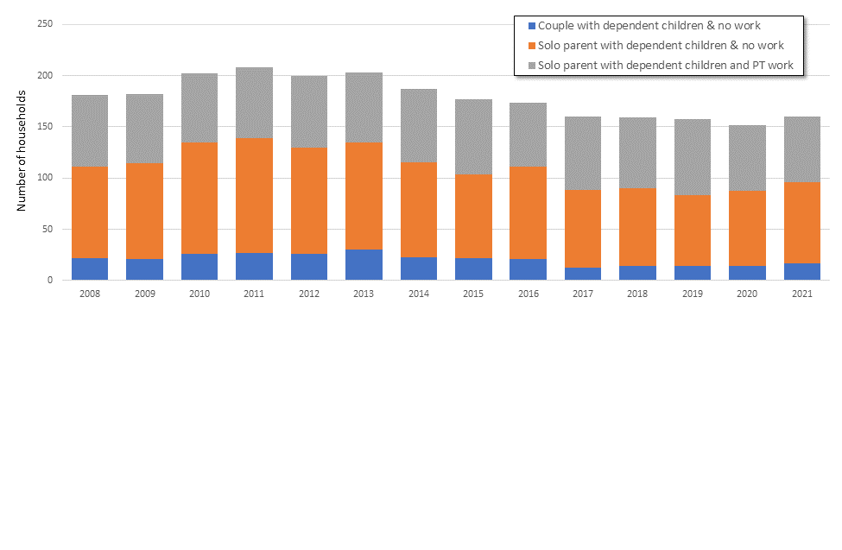
# of households ( ’000s)

MSD (2021a) benefit fact sheets report that the average number of dependent children in a household receiving a Sole Parent Support Payment is two, and this remains constant across the years. If we assume that this average applied to all vulnerable households, the increase in the numbers of children living in such households would be just under 18,000.

ii. Children in benefit-recipient households:
The following graph reports the numbers of children living in benefit dependent household on a quarterly basis. In March 2021 there were 206,000 such children or 18% of all children, an increase of 23,000 children on March 2020 numbers of 183,000 and 16% respectively. The annual average for the year to March 2021 is the highest number and proportion of children in benefit recipient households since 2013 (in the wake of the GFC).
Figure 2: Quarterly numbers of children in benefit recipient households, Mar 2016-Mar 2021. Source: MSD, 2021.
Lockdown starts

The following graph shows Stats NZ child poverty estimates (to March 2020) on two measures, and the reported numbers of children living in benefit dependent households (annual averages). The relationship between children in benefit dependent households and those living in relative income poverty is complex and not always a direct one: not all children in poverty are in benefit-dependent households (and not all children in benefit-receiving households are in poverty on all measures). However, there is considerable overlap: the majority of children living in poverty, particularly in severe poverty, are reliant on benefits as a key source of family income.
Figure 3: numbers of children in benefit recipient households vs government target child poverty reduction indicators. Source: Stats NZ, 2021a; MSD, 2021.
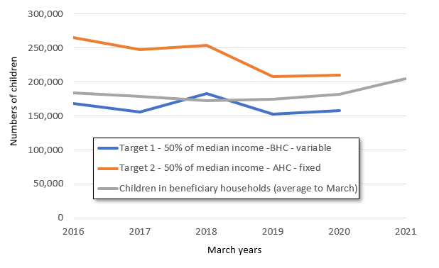
Govt Targets (to be reported Feb 2022)
Reductions in child poverty estimates reported by Stats NZ 2018-2019 seem largely due to the increases in Working for Families payments introduced in the Families Package 2018 rather than any changes in benefit take-up or families’ employment positions. In 2019 and 2020 the relationship between numbers of children in benefit-recipient households and child poverty numbers stabilised somewhat, in the absence of any large new policies. Child poverty numbers on the Target 1 (BHC 50 moving) measure were the equivalent of 86%-89% of the numbers of children in benefit recipient households in 2019 and 2020.
If this ratio remained in the year to March 2021 (of 100:86 or 100:89 for children in benefit households: children in poverty), then approximately 20,000 to 25,000 more children have been living in relative income poverty. It is possible, however, the proportion of children in benefit recipient households living in poverty (as measured) may have been lower in the year to March 2021 due to the $25 increase in benefit rates per household and the temporary doubling of the Winter Energy Payment (McAllister 2020). If the ratio is as low as 100:84, then the increase in children in poverty will be approximately 15,000 since the initial COVID-19 lockdown. Thus our estimate, based on benefit numbers, is that the number of additional children in poverty on the BHC50 moving line is between 15,000 and 20,000. This supports the analysis of the HLFS above that suggests 18,000 additional children will be experiencing relative income poverty.
Child poverty increases by ethnicity
Sample sizes mean annual changes are less clear for specific ethnicities: Stats NZ 2020 child poverty estimates by ethnicity on the BHC50 moving measure have a margin of error of 2.0 percentage points for Māori, 3.5 for Pacific and 1.4 for Pākehā. However, some of the changes in inputs (benefit receipt, for example) are so large that particular directions of changes in child poverty rates by ethnicity seem likely even if quantifying those changes is more difficult. Of particular concern is that the increase of child poverty is likely to be higher than average among whānau Māori and Pacific families, for whom child poverty is already high due to historical and ongoing effects of colonisation, institutional racism (Waitangi Tribunal, 2019) and wealth inequities (McKenzie, 2020). Thus the gap of financial advantage looks to be growing, between Pākehā children on one hand, and Māori and Pacific children on the other.
The following table shows potential increases in child poverty by ethnicity, assuming:
  - a 100:82 or 100:84 ratio of children in benefit recipient households to children in BHC 50% median poverty, for all ethnicities (more conservative than the assumption in the modelling above, to mitigate the possibility of over-estimates for ethnicities, meaning an overall total increase of ~11,000 - ~15,000).
  - the Sole Parent Support household average number of children (2) remains the same across all ethnicities, and
  - the JobSeeker (JSS) recipient increases by ethnicity (as reported by MSD) are the same for children in JSS recipient households.
If these assumptions are correct, as the table below shows, tamariki Māori and Pacific children are around 2.5 to 3 times as likely as Pākehā children to have been pushed into poverty, and children within the MSD category of “all other ethnicities” are also around two times more likely than Pākehā to have been pushed into poverty. These findings hold for both the 11,000 and 15,000 totals.
Table 1: Estimates of increases in child poverty by ethnicity from March 2020 to March 2021, BHC 50 moving measure (‘unspecified’ ethnicity of ~1000 increase not included), based on estimated increases in children in benefit recipient households
 | Total number of all children | # of additional children in poverty, at ~82% of children in benefit-receiving households (11,000 in total) | # of additional children in poverty, at 84% of children in benefit-receiving households (15,000 in total) | Estimated additional propor-tion of all children in poverty on 82% | Estimated additional propor-tion of all children in poverty on 84%
Māori | 288,800 | 3,100 | 4700 | ~1.1% | ~1.6%
Pacific | 146,000 | 1,900 | 2300 | ~1.3% | ~1.6%
Pākehā | 770,000 | 3,200 | 4300 | ~0.4% | ~0.6%
All other ethnicities | 235,000 | 2,100 | 2500 | ~0.9% | ~1.1%

The Budget 2021 benefit increases are out of scope for this report but even those increases are not enough to ensure people living in ordinary circumstances have enough to live on (CPAG, 2021a) and they are predicted by government officials to reduce child poverty only minimally: from 18.4% to 17% of all children on one primary measure (AHC 50 fixed; Treasury, 2021).
Numbers of students attending regularly and students chronically absent (attending less than 70 % of the school term) can both rise, as numbers between the two categories, with moderate absences, are decreasing.
“[T]he majority of those who are living with the most harmful levels of family violence and who experience the highest levels of entrapment are those sitting at the intersection of multiple axes of disadvantage – poverty, racism and sexism” FVDRC, 2016
The year was clarified from the reported “2020” to the actual “2019” in a CPAG phone call with Ministry of Justice, 25 June 2021.
Due to the first Covid-19 lockdowns, StatsNZ child poverty data for the year ended June 2020 only covers the period to the end of March 2020.

