The Fair Economic Return tax – a summary
Child Poverty Action Group background paper, August 2021
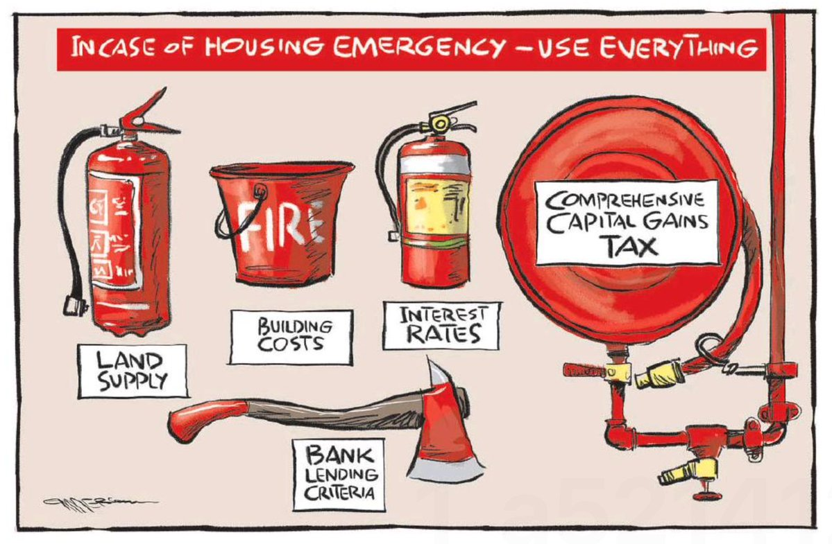
(Source: Rod Emmerson, NZ Herald)
Perversely, Aotearoa New Zealand (NZ) is currently a world-leader in housing unaffordability. Since the late 1980s, the design of tax policy has over-incentivised the use of housing as a passive investment asset. Currently, income from housing is mostly untaxed and therefore treated differently to personal income from employment. The tax-free nature of capital gains has meant that that investment in housing has become the primary means through which wealth is accumulated, and without inheritance tax or death duties, this accumulation of wealth is passed on intergenerationally.
This incentive has created significant injustices, not least for those squeezed out of the rental market, and forced to crowd in their homes or left homeless. There are growing concerns about widening wealth inequality in NZ, particularly in light of the significant untaxed gains for property owners through the Covid-19 period. Doing nothing to address the primary driver of this wealth divide is no longer tenable. There is evidence that the housing market is cooling, but not by much; the scale and depth of the issue requires that all tools including the tax hose are used, leaving “no stone unturned” as the Prime Minister told media in January.
The Fair Economic Return tax (FER) – discussed at length in Associate Professor Susan St John and Terry Baucher’s working paper Fair Economic Return: Restoring equity to the social fabric of New Zealand – is a mechanism designed to address the current distortion that incentivises over-investment in housing. The FER includes the currently untaxed housing income in the general tax base, so that all personal income, regardless of its source, is treated the same for tax purposes. The income is taken as the minimum income that would be generated if the net equity (ie market value less any mortgages) was invested in a low-risk bank deposit. Net equity for an individual is calcuated as the sum of the government property valuations (CVs) of all residential real estate owned less any mortgages.
Under the FER, the first $1 million of net equity for each individual would be exempt. This means that roughly 80% of residental property owners would be exempt from any tax, instead targeting the wealthiest top 20% of residential housing owners. It is therefore tightly targeted, yet would still open up a significant, steady source of revenue for Government to further invest in its state housing build to address the challenge of supply or in other areas of social need.
The FER is preferable to a Capital Gains Tax for a range of reasons, principally because it is simpler and accounts for accumulated gains. Given that the Capital Gains Tax is calculated by selling price less the purchase price, it does not accommodate for the significant untaxed capital gains in housing that have accumulated over decades of policy neglect. Moreover, the Capital Gains Tax is also complicated definitionally due to the ‘family home’ exemption.
By taxing the deemed income on net equity over $1 million at the marginal tax rate of the individual, the FER captures this accumulated wealth. A $1 million per person net equity exemption is fairer than just providing an exemption on the family home (eg a person who owns one house but does not choose to live in it is treated no differently to someone who owns one house and does live in it). The following worked example illustrates what an FER could look like in practice:
Worked example
A couple own:
Home, CV =$5m
Bach, CV =$2m
A rental property, CV =S600,000
Total net equity = $7.6m
Individual equity =$3.8 m
After $1m exemption each, taxable equity =$2.8m
FER taxable income @ 1% = $28,000
(The 1% rate is set as a policy tool at a range sitting below mortgage rate (2-3.5%).

https://www.theguardian.com/world/2021/jul/11/pressures-have-built-up-how-can-new-zealand-solve-its-social-housing-crisis

