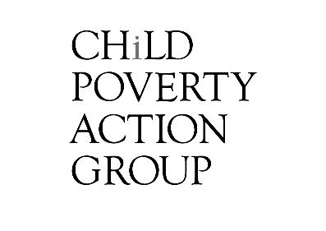

2020 Briefing to the Incoming Minister:

Income Support

To: Hon. Carmel Sepuloni
Minister of Social Development & Employment
Minister for Disability Issues
Cc:
- Jacinda Ardern, Minister for Child Poverty Reduction
- Priyanca Radhakrishnan, Associate Minister for Social Development & Employment; Minister for Youth
- Andrew Little, Minister of Health
- Kelvin Davis, Minister for Children
- Willie Jackson, Minister of Māori Development
- Aupito William Sio, Minister for Pacific Peoples; Assoc Minister, Health (Pacific Peoples)
- Peeni Henare, Associate Minister of Health (Māori Health)
- Jan Tinetti, Minister for Women

The vision of Child Poverty Action Group is
An Aotearoa where all children flourish free from poverty.
About Child Poverty Action Group
Child Poverty Action Group (CPAG) is an independent, registered charity founded in 1994 which works to eliminate child poverty in New Zealand through research, education and advocacy. We envisage an Aotearoa where our society shows respect, generosity and care for all children.
We focus on eliminating poverty for children because:
- Overall effects of poverty are worse for children: Child development is adversely affected by poverty, & can lead to detrimental effects for an entire life. (Appendix 1)
- Children are more likely to experience poverty: Children are over-represented among those in deprived households (Appendix 2)
- Children don’t get a say: Decisions affecting children are made without their input; democracy involves only adults.

Tēnā koe Minister Sepuloni,
Congratulations on your reappointment to the important ministerial portfolios of social development & employment, and disability issues.
Through these responsibilities, you have a key leadership role to play in freeing children from the burden of poverty and ensuring Aotearoa New Zealand is a good place to be a child.
In this briefing, we offer evidence-based recommendations for you and your team, indicating which policies and approaches in your portfolio will be the most effective and efficient in assisting in the reduction of child poverty in this term of government, in the difficult policy environment of the ongoing economic fallout and uncertainty of COVID-19.
We hope you find them useful, and would be very happy to meet with your and/or your staff to discuss any of the points in further detail.
Nā mātou noa, nā
Child Poverty Action Group
www.cpag.org.nz

Current context – December 2020
- Since COVID-19 hit, rates of child poverty will have increased (estimates: ~ 30% for AHC income poverty), while many who were already in poverty are in increasingly dire and desperate situations (for example youth homelessness). Details and evidence in Appendix 3.
- Income support is woefully inadequate, despite 2018-2020 increases. (Appendix 3)
- The Waitangi Tribunal (2019) recommends the Crown commit itself to achieving equitable health outcomes for Māori. Income is widely recognised as an important social determinant of health, particularly for children (Appendix 1), and currently tamariki Māori experience high levels of poverty (Appendix 2).
- The Health & Disability System Review (2020) found: “The health and disability system is not the main factor in determining health outcomes. If New Zealand does not significantly reduce intergenerational poverty and act on the social determinants of health, little that happens in the health and disability system would have a lasting impact. Inherent in a population health approach is an explicit focus on equity” (emphasis added). The Review goes on to identify “implementing comprehensive strategies to eliminate or ameliorate upstream factors” – such as inadequate incomes – is a requirement to eliminate systemic inequities.

CPAG Policy Recommendations

- The urgent, first priority is to offer permanent adequate income security to all children and their whānau and families.

There are many ways to do this, but the most efficient would be to:
  - Extend full Working For Families assistance to families receiving benefits, most notably the In-Work Tax Credit (IWTC, current minimum $72.50pw); and
  - Increase benefits where required, so that the incomes for all families who (i) receive benefits and Accommodation Supplement and (ii) who are paying lower-quartile rent, for appropriate accommodation, are at or above the primary AHC (50, fixed) poverty line; and
  - Increase income support for whānau with disabilities so that children with disability are no longer more likely to live in material hardship than other children (Neuwelt-Kearns, Murray, Russell & Lee, 2020).
Re 1i: Adding the IWTC to the Family Tax Credit (FTC) is the most efficient, cost-effective way of reducing the numbers of children in severest poverty:
- It is tightly targeted to the worst-off who currently are excluded from the IWTC. This means it will not incur increased expenses further up the income ladder; there won’t be a “knock-on” effect for those on high incomes.
- It would reduce the (record high) numbers of families relying on Temporary Additional Support (TAS), and remove a barrier to paid work for those caregivers for whom the combined IWTC/FTC would replace TAS (as currently their income abates by 100% as soon as they start earning).
- It would ensure that families for whom paid work disappears in the current recession don’t also lose vital government income assistance for their children at the same time as their paid-work earnings reduce.
There has been reluctance in the past on behalf of governments to remove the current policy on IWTC because of a belief that the gap between paid-work income and benefit income is necessary as a paid-work incentive. But the Government’s commendable minimum wage increases mean the financial gap between working a paid job and not doing so has greatly increased. For example, our preliminary research indicates that once the promised $20 minimum wage is implemented in 2021, the families of sole parents working 40 hours minimum wage would be $279 better off a week than the families of sole parents would be were they to receive both their core benefit entitlements and the current IWTC but not be undertaking paid work.
Child Poverty Action Group is planning a policy paper for you and your team on this point early in the New Year – and we would heartily welcome any discussion with your team on this beforehand, about what points would be most useful.
Re 1ii: Increasing core benefits
The extension of the IWTC does not solve the problem that adult benefits are too low, especially adult couple rates. As Figure 1 shows, even with the IWTC, all our eight model households of couples on Jobseeker with children paying lower quartile rent would still be between $54 and $132 a week below the primary AHC poverty line (50% fixed). For example if the IWTC is extended to benefit recipients but core benefits are not raised, a couple with one child renting a low-cost 2-bedroom house in Auckland would see their income increase from 33% to only 39% of the fixed AHC measure, not getting them near the 50% poverty line.

Fig 1: $ required to get to the estimated current primary (50% fixed) AHC poverty line for couples with 1-3 children: current entitlements (with standard not doubled WEP) vs the same plus the IWTC (CPAG rec 1i)

*Annual After Housing Costs income for model households receiving JobSeeker Couple (2A), plus AS, FTC & WEP entitlements (non-doubled, as doubling was COVID-related), paying lower-quartile rent (Sep19-Feb20 rates), as % of estimated 2017/18 equivalised median fixed line (base year adjusted by the household
living-costs price index income quintile 1 (after removing housing costs)). C=Child/ren; B=Bedrooms

Re 1iii: As detailed in Neuwelt-Kearns, Murray, Russell & Lee (2020), in order to alleviate the particularly egregious hardship faced by children with disability in Aotearoa New Zealand, we recommend you:
  - more than double the rate of the Child Disability Allowance (CDA) and index it to wages
  - simplify the Disability Allowance – which is a separate payment, also accessible by children – by making it an indexed fixed-rate payment. The current system requires people to claim back expenses, which is particularly cumbersome and difficult, especially for people with disabilities.
- promote the CDA to groups that are underrepresented, such as Pacific people.
- Increase the Out of School Care and Recreations (OSCAR) subsidy rate for those children also receiving the CDA, and widen its uptake.
Increasing the 2021 Winter Energy Payment (WEP) instead of ensuring liveable incomes is not the best option to relieve poverty. WEP is helpful and appreciated – however:
- On its own, WEP is not large enough to release most whānau and families from poverty (even when doubled);
- WEP is temporary where people need permanent increases;
- WEP is too blunt (a family of 6 receive the same amount as a family of 2);
- WEP does not discern between people living in income poverty and those who are not (we recommend it becomes “opt-in” rather than “opt-out” for those receiving NZ Superannuation);
- An increased WEP poses a barrier to paid work, by suddenly cutting out once a benefit is fully abated.
We also urge the government to:
- Rewrite the purposes and principles of the Social Security Act
to reflect the six values set out in the Welfare Expert Advisory Group’s 2019 Whakamana Tangata report: manaakitanga, ōhanga, whanaungatanga, kotahitanga, takatūtanga, and kaitiakitanga.
- Individualise benefits
As a first step to much-needed individualisation, allow a partner’s income of up to at least the average wage to be disregarded. Those on the Supported Living Payment, and full time carers should retain their payments regardless of the working status of their partner.
- Index all Working for Families
Link tax credits and abatement thresholds to wages annually, similar to the indexation of NZ Superannuation
- Reduce the rate of abatement of Working for Families
Because the current rate of abatement for Working for Families is 25%, once family income exceeds $42,700, the effective marginal tax rate rises to at least 42.5%, or 52.5% if there is a student loan repayment. When families face an additional 25% abatement rate for the Accommodation Supplement, their effective marginal tax rate can be around 80% for every additional dollar they earn.
- Remove all sanctions for parents of dependent children
This is in order to improve outcomes of affected children and halt the current punitive approach to social security.
- Ensure all low-income families are made aware
  - of all the income support they are entitled to, and have ready access to it
  - of free budgeting services and low- and no-interest credit options.
- Implement a process of forgiveness of existing MSD debt
The overhang of debt is keeping families impoverished and in large part is the result of inadequate state support.
- Increase hardship/special needs grants to an adequate level
We expect a welfare system offering adequate incomes will sharply reduce the demand for hardship/special needs grants, but when families suddenly find themselves in extraordinary circumstances, hardship grants (rather than recoverable advances) appropriate to the level of need should be forthcoming.
- Avoid social insurance approaches
We strongly support reform of the current system rather than a new second-tier arrangement that links a user’s contributions to their level of support. We do not see how equitable outcomes and income adequacy can be guaranteed for all (including those excluded from any such scheme), and we are fearful that children, Māori, Pacific peoples, women and low income workers will become even less visible and supported. CPAG is concerned that such schemes carry a high risk of increasing inequality: they can quickly become complex and cumbersome, with the risk that those most affected by poverty will implicitly be treated as less deserving and forced to fall further behind.

Appendix 1: The effects of poverty on children:
Poorer wellbeing is more likely in all areas for an entire life

- Poverty causes poor outcomes. Poor outcomes for children are not only correlated to lack of family income, they are caused by them. The Rapid Evidence Review (RER) on the impact of poverty on life course outcomes for children prepared by the Ministry of Social Development (2018) for the Welfare Expert Advisory Group is a good introduction to the large body of evidence that supports this.
- All aspects of life are affected by deprivation, from physical development and physiological functions to social inclusion and educational attainment. Deprivation can have detrimental effects on the physical, mental and social wellbeing of children. For example, in Aotearoa, high school students in most deprived areas (NZDep1-3) have four times the suicide rate of those in least deprived areas (NZDep8-10) (Youth19 survey, 2020).
- Effects can be long-term, lasting (and shortening) a child’s entire life. For example, the longitudinal University of Otago study found that children born 1972-1973 who grew up in low socioeconomic status families had poorer cardiovascular health, poor dental health and more substance abuse as adults, regardless of adult socioeconomic conditions (Poulton et al., 2002)
- Dealing with deprivation, and with the stigmatisation of deprivation, creates toxic stress and disempowerment. Inadequate income prevents children from accessing goods, services and opportunities that support their positive development; and, in addition, poverty also increasing parental/caregiver stress, depression and shame (exacerbated by stigmatisation, including by government agencies), and places greater demands on adult decision-making, all of which may affect children as well as adults. (Orchard, 2018)
When you’re in a low socio sort of environment, your head’s not looking up and looking at what the future looks like for you next year. Or what your dreams and aspirations are looking over there or “what I wanna do”. Your head’s looking down and it’s looking around in that pool of just trying to survive day by day.
Tahu, Te Whakaruruhau Service Worker & whānau advocate, quoted in Rua et al (2019)
- Poor outcomes for the few affect the many. Depriving children of essential resources to actively participate in society, and disempowering their whānau and families, generates poor outcomes for individuals, whānau, and ultimately whole communities, who cannot reap the benefits of people reaching their full potential.

To enable our children to flourish, and to empower them to contribute to their communities throughout their lives, we need to ensure families have guaranteed adequate incomes

Appendix 2: Children are the most likely age group to live in poverty;
Most affected include Māori & Pacific children, & children with disabilities.
- Children are almost twice as likely as those aged over 65 to live in poverty and 1.5 times more likely than those aged 25-64, when housing costs are taken into account. Children with disability in NZ are 1.5 times more likely than other children to live with caregivers who report not having enough. This is not the case elsewhere, for example, in the UK (Neuwelt-Kearns, Murray, Russell & Lee, 2020).
Fig 1: % of all individuals in low-income households by age (AHC 50, moving line, relative) 2018

- Māori children, and other children of non-Pākehā ethnicity, are even more likely than Pākehā children to experience income poverty (Fig 2; rates for MELAA & “other” ethnicities are likely highest but not shown, as sampling error is very high). For Māori, this is an effect of multiple, ongoing breaches of te Tiriti o Waitangi. For others as well as Māori, it is an issue of systemic discrimination and has effects on equity: entire communities will bear the burden of the potential lost due to poverty-impacted health and educational outcomes.
- Proportionally far more Pacific and Māori children suffer material hardship than Asian and Pākehā children (Fig 3; MELAA rates are unclear). Pacific children suffer severe hardship (as defined by StatsNZ) at 4 times the rate of the national average.
Fig 3: The three official material hardship measures for children, by ethnicity, as a proportion of rate for Māori (= 1), 2019

Fig 2: The six official income poverty measures for children, by ethnicity, as a proportion of rate for Māori (= 1), 2019
Source: StatsNZ (2020)

Appendix 3: Since COVID-19 hit, rates of child poverty will have increased;
Reports indicate many already in poverty are in dire situations
- A further estimated 70,000 children are likely to be living in income poverty by June 2021 due to inadequate policy responses to the economic fallout of COVID-19 (AHC, 50%, fixed line measure; CPAG, 2020). That 70,000 figure is equivalent to ~30% of the children who were found to be living in poverty on the same measure in the 2018/19 HES survey (StatsNZ, 2020). As Fig 1 shows, our 70,000 estimate may need to be revised upwards if demand for income support (red line) continues to flatline (or increases) rather than decrease as our scenario expected.
Fig 1: CPAG scenario for demand for benefits and children living in benefit dependent households vs actual demand for benefits and the Covid Income Relief Payment (CPAG, 2020c; MSD, 2020)
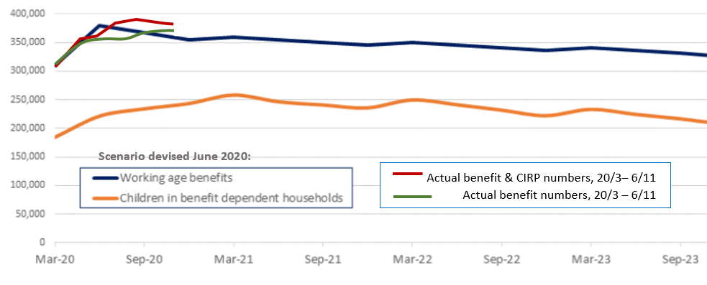
- Youth homelessness appears to have increased dramatically; services are not currently designed to address this problem. For example, Lifewise youth housing reports nearly 120 people requesting support over recent months, of which they could only house four, having to turn 89 away due to lack of resourcing, and monitor the rest. Lifewise also reports 16 and 17 year olds living on the streets after being turned away from Work and Income (Corlett, 2020; see also Manaaki Rangatahi, 2020).
- Educational inequity – already high – is likely to have been increased by COVID-related poverty, according to anecdotal reports: more young people may be having to leave school to work (1news, 2020) – a pathway that can lead to lifelong precarious work and further intergenerational poverty (Rua et al, 2019) – and others may be working longer hours while struggling to keep up at school, including during lockdowns (supermarket workers are ‘essential’ workers for example). Digital exclusion remains a deep and ongoing concern (Biddle, 2020).
- Food insecurity and rheumatic fever – a childhood disease of deprivation – have also increased dramatically in 2020 (Martin, 2020; TVNZ, 2020; Quinn, 2020).

Income support is still woefully inadequate, despite 2018-2020 increases

Families are just on their bones. Just surviving. So, the system, it’s just getting harder and harder for them. It can get really deflating when you’ve been declined or rejected or judged or looked at a certain way when you’ve walked in there [Work and Income offices].
- Tahu, Te Whakaruruhau Service Worker and whānau advocate, quoted in Rua et al (2019)

- Income support levels leave families receiving benefits facing entrenched, chronic poverty. Our research strongly indicates that current core entitlements for families receiving benefits in typical situations are mostly below the primary poverty line after housing costs (the AHC 50% fixed line measure, for government child poverty reduction targets) and, in some cases, core entitlements are well below even the lowest officially-recorded poverty line (StatsNZ’s 40% AHC moving line measure).
Fig 2: 2020/21 core entitlement for selected families receiving benefits vs poverty measures*
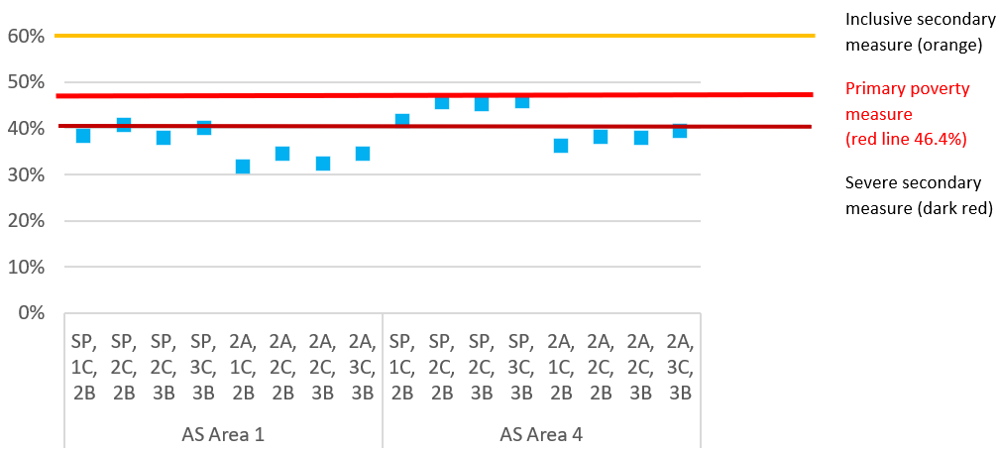
*Annual AHC income for model households receiving Sole Parent Support (SP) or JobSeeker Couple (2A), plus AS, FTC & (2020 doubled) WEP entitlements, paying lower-quartile rent (Sep19-Feb20 rates), as % of estimated 2020/21 equivalised median moving line. Primary poverty measure of AHC 50% 2017/18 fixed line (equivalent to 46.4% moving line). See McAllister (2020) Appendix 2 for explanation of median income estimates. C=Child/ren; B=Bedrooms
- Trying to fill the gaping holes with piecemeal measures is not working and it wasn’t working even before COVID hit. All the following points indicate that support designed for extraordinary circumstances is increasingly relied on by Government to provide everyday support in typical situations, meaning many will be missing out:
  - Every one of MSD’s ~2.5 million approved hardship assistance transactions this year overall costs whānau and families in effort, time, emotional labour (eg recounting trauma in an effort to make success more likely) and very often embarrassment. If income supports were adequate for typical circumstances, much of this waste of energy and wellbeing would be avoided. Even with a generous regime, it is unclear how many people who require hardship assistance do not receive it, whether due eg to difficulties with technology, call centres, trespassing, and/or despair (not attempting to request in the first place).
  - Temporary Additional Support recipients have increased by 60% from 60,800 to 97,100 in the two years to the September 2020 quarter, including an increase of 20,000 alone since the March 2020 quarter (MSD, 2020).
  - Accommodation Supplement recipients increased 25% in the two years to the September quarter 2020 from 292,000 to 366,200, including an increase of 48,600 since the March quarter. Two-thirds of AS recipients also receive benefits, and this proportion has held steady (MSD, 2020).

- Some families will be receiving all of the following, and still not be able to make ends meet:
  - Main benefit
  - Working for Families
  - AS
  - TAS
  - Special Needs Grants
  - Benefit Advances (recoverable)
  - Child Disability Allowance
  - Disability Allowance
  - Grants from other government ministries
Others will be missing out on various of the piecemeal elements – for example, due to stringent eligibility criteria, sanctions, lack of awareness, or receiving the message loud and clear not to ask for more any more – very often with dire results.
- Despite the doubled 2020 Winter Energy Payment, in a survey conducted in August-September 2020 (before the WEP period ended), nearly half of the respondents receiving main benefits (44 percent) reported that the frequency with which they were unable to meet basic household costs had increased since the Covid-19 lockdown; only 12% reported their ability to meet those costs had decreased (Humpage & Neuwelt-Kearns, 2020). This is in line with StatsNZ’s household living-costs price index (HLPIs) for beneficiaries, which rose at 2.5 times the rate for all households in the year ended September 2020 (2% vs 0.8%; Fallow, 2020).

References
1news (2020) “Children's Commissioner says too many Kiwi kids leaving school to help whānau with Covid-19 financial burdens” 19 August 2020, TVNZ. https://www.tvnz.co.nz/one-news/new-zealand/childrenscommissioner-says-too-many-kiwi-kids-leaving-school-help-wh-nau-covid-19-financial-burdens
Biddle, D.L. (2020) “The Covid Diaries: Kia Aroha College, the students forgotten during lockdown” 16 August 2020, Stuff. https://www.stuff.co.nz/national/122188758/the-covid-diaries-kia-aroha-college-the-students-forgottenduring-lockdown
Corlett, E. (2020) Homeless youth 'not able to get the support they need'. RNZ. https://www.rnz.co.nz/news/national/428193/homeless-youth-not-able-to-get-the-support-they-need
CPAG (2020c). “A scenario for changes in child poverty rates from the COVID-19 recession.” Child Poverty Action Group. https://www.cpag.org.nz/assets/Backgrounders/CPAG%20Child%20Poverty%20Forecasts%20background%20paper%20June%202020%20FINAL.pdf
Fallow, B. (2020) “Government could help the kids - and hit the landlords” NZ Herald. https://www.nzherald.co.nz/business/brian-fallow-government-could-help-the-kids-and-hit-the-landlords/Q7ZSYTMNESB5GD64R5EGO7WT6E/
Health and Disability System Review (2020). Health and Disability System Review – Final Report – Pūrongo Whakamutunga. Wellington: HDSR https://systemreview.health.govt.nz/assets/Uploads/hdsr/health-disability-system-review-final-report.pdf
Humpage, L. & Neuwelt-Kearns, C. (2020) Income support in the wake of Covid-19: survey. University of Auckland, CPAG, AAAP and First Union. https://www.cpag.org.nz/assets/Covid%2019%20survey%20report%2012%20October%20final.pdf
Poulton, R. et al., 2002. Association between children’s experience of socioeconomic disadvantage and adult health: a life-course study. Lancet, 360(9346), pp.1640–1645.
Manaaki Rangatahi (2020) “Manaaki Rangatahi Finds Youth Left Out In The Cold” 18 August 2020, Scoop Media. https://www.scoop.co.nz/stories/PO2008/S00227/manaaki-rangatahi-finds-youth-left-out-in-thecold.htm
Martin, H. (2020) “Coronavirus: Auckland City Mission faces 175% rise in demand for food parcels” 10 August 2020. Stuff. https://www.stuff.co.nz/national/300077507/coronavirus-auckland-city-mission-faces-175- rise-in-demand-for-food-parcels
McAllister, J. (2020) ‘Sheltering our children from COVID-19 fallout: New Zealand must raise incomes for the financially vulnerable instead of cutting their incomes on 1 October 2020 as planned. Child Poverty Action Group https://www.cpag.org.nz/assets/Sheltering%20Our%20Children%20from%20COVID19%20Fallout%2028%20Aug.pdf
Neuwelt-Kearns, C., S. Murray, J. Russell & J. Lee (2020). "‘Living well’? Children with disability need far greater income support in Aotearoa.” Child Poverty Action Group. https://www.cpag.org.nz/assets/Living%20Well%20Children%20with%20disability%20need%20far%20greater%20income%20support%20in%20Aotearoa%20Sept%202020%20%281%29.pdf
Quinn, R. (2020) “Spike in rheumatic fever cases in Wellington” 25 May 2020, RNZ. https://www.rnz.co.nz/news/national/417429/spike-in-rheumatic-fever-cases-in-wellington
MSD (2018) “Rapid Evidence Review (RER) on the impact of poverty on life course outcomes for children” Ministry of Social Development. https://www.msd.govt.nz/documents/about-msd-and-our-work/publications-resources/information-releases/weag-report-release/rapid-evidence-review-the-impact-of-poverty-on-life-course-outcomes-for-children-and-the-likely-effect-of-increasing-the-adequacy-of-welfare-benef.pdf
MSD (2020). Benefit Fact Sheets National level data tables – September 2020, Ministry of Social Development, https://www.msd.govt.nz/about-msd-and-our-work/publications-resources/statistics/benefit/index.html
Orchard, S. (2018) #We Are Beneficiaries Report. http://www.thesamorchard.com/wp-content/uploads/2018/03/WAB-Report.pdf
Rua, M et al (2019) “Precariat Māori Households Today”. Ngā Pae O Te Maramatanga. http://www.maramatanga.ac.nz/sites/default/files/teArotahi_19-0502%20Rua.pdf
StatsNZ (2020). Child Poverty Statistics for the year ending June 2019. StatsNZ. https://www.stats.govt.nz/information-releases/child-poverty-statistics-year-ended-june-2019
TVNZ (2020). Breakfast – Charity KidsCan inundated with calls for support from low decile schools. TVNZ https://www.tvnz.co.nz/shows/breakfast/clips/charity-kidscan-inundated-with-calls-for-support-from-low-decile-schools
Waitangi Tribunal (2019). Hauora: report on stage one of the Health Services and Outcomes Kaupapa Inquiry WAI 2575. Waitangi Tribunal: Wellington. https://forms.justice.govt.nz/search/Documents/WT/wt_DOC_152801817/Hauora%20W.pdf
Welfare Expert Advisory Group (2019). Kiro, C., I. Asher, K. Brereton, H. Huhanna, T. McGlinchy, N. Ganesh, P. O'Reilly et al. Whakamana Tangata: Restoring Dignity to Social Security in New Zealand. Welfare Expert Advisory Group, 2019. http://www.weag.govt.nz/weag-report/
Youth19 survey (2020): Fleming, T., Tiatia-Seath, J., Peiris-John, R., Sutcliffe, K., Archer, D., Bavin, L., Crengle, S., & Clark, T. (2020). Youth19 Rangatahi Smart Survey, Initial Findings: Hauora Hinengaro / Emotional and Mental Health. The Youth19 Research Group, The University of Auckland and Victoria University of Wellington, New Zealand. https://static1.squarespace.com/static/5bdbb75ccef37259122e59aa/t/5f338e4cfb539d2246e9e5ce/1597214306382/Youth19+Mental+Health+Report.pdf

